Education and Children’s Services

Bullying & Equalities: Recording and Monitoring Bullying Incidents in Schools (RAMBIS)

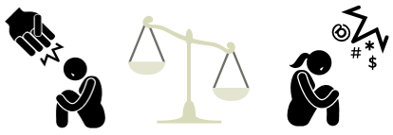

SEEMiS Click+Go

1. VERSION CONTROL

Version | Status | Issue Date | Last Modified By | Reason
0.1 | 2018 Initial Draft | 09/07/2018 | W Carstairs | First draft of 2018 Guidance
1.0 | 2018 Published | 08/10/2018 | W Carstairs | Published Guidance.
1.1 | 2019 Update | 21/05/2019 | I Fitzgerald | Refresh for SEEMiS B&E module national rollout final phase June 2019.
1.2 | 2022 Update | 23/2/2023 | L Pratt | Refresh for SEEMiS B&E module national rollout final phase June 2022.

CONTENTS |  |  | PAGE
1. | VERSION CONTROL |  | 2
2. | OVERVIEW OF BULLYING & EQUALITIES MENU |  | 3
3. | ADDING A NEW INCIDENT |  | 4
 | 3.1 | Creating an Incident | 4
 | 3.2 | Alleged Incident Information | 5
 | 3.3 | Nature of Incident | 5
 | 3.4 | Monitor/Review Incident | 6
 | 3.5 | Action Progressed | 7
 | 3.6 | Delete an Action | 7
4. | MAINTAIN AN EXISTING INCIDENT |  | 8
5. | REPORTS |  | 8
 | 5.1 | Pupil Incident Reports | 8
 | 5.2 | Staff Incident Reports | 9
 | 5.3 | Full Incident Reports | 10
Appendix A |  | B&E DROP-DOWN CATEGORIES AVAILABLE | 11

Key to symbols used:
 | Please note |  | Tips

2. OVERVIEW OF BULLYING & EQUALITIES MENU

The Bullying & Equalities (B&E) module within SEEMiS Click+Go is the main recording mechanism for incidents, following a letter from the First Minister in May 2018, to local authorities.

To ensure relevant school users can access the B&E module their user profile should be reviewed in Application> Data Utilities> Access Control> Edit User Profiles:

- Highlight a profile from left-hand menu folder (e.g. Teacher, SMT, etc). The access menu will appear on the right-hand side of the screen.

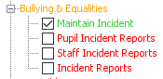
- Click on the plus-sign at Management to open the menu area and scroll down to Bullying & Equalities (red text if no access).

- Click on Bullying & Equalities to open the menu and click the relevant profile(s) required (e.g. Maintain Incident) (text will turn green if selected), and then click the Save Changes icon on the top menu bar.

The Bullying & Equalities module enables schools to enter and maintain details of any incidents of bullying or prejudice-based discrimination reported to them. Schools can enter the details of the incident, including the nature of the incident along with motivations identified. Any actions progressed can also be recorded, reviewed and monitored within this module. The on-screen B&E form can be updated at appropriate stages throughout the process, although all mandatory fields (outlined in red) require to be completed prior to saving.

Once an incident has been recorded and saved in the B&E module, the following automated items will also be created in SEEMiS:

- A Bullying & Equalities document listing details of the incident.
This is visible in Application> Records> Pupil Profile> Documents, however only members of staff who have the Document Management Profile for Bullying Incidents can access these stored documents.

- A pastoral note in Latest Pastoral Notes.
This will be an automated note stating only that the child or young person has been involved in a B&E incident and the relevant incident reference number but will not include any of the incident details.

- Note: Additional information on the RAMBIS recommendations is available on the Scottish Government website.

3. ADDING A NEW INCIDENT

The purpose of the Bullying & Equalities menu within Click+Go is to enter and maintain details of any incidents that are reported to the school. The nature of the incident and the motivations are recorded along with any actions taken.

- Note: Once an incident has been recorded within the B&E module it cannot be deleted. If an incident has been entered in error, please contact MIS Support who can arrange for this to be put into the background to reduce the visibility of the incident within Click+Go.
3.1 Creating an Incident

To create an incident, users should navigate in Click+Go to Application> Management> Bullying and Equalities> Maintain Incident.

- Note: All screen shots in this document were taken from the Click+Go training database.

To enter a new incident, complete the on-screen form or edit/update an existing incident using the magnifying glass icon at the top left-hand side of the screen. All fields outlined in red are mandatory and must be completed before the incident can be saved.

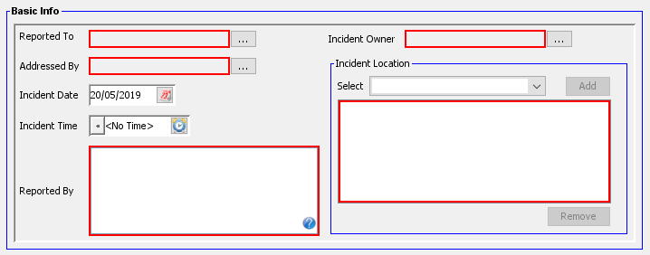

- Click the ellipsis button (3 dots) to the right of the Reported To field, and filter to select the appropriate member of staff, then click OK.
- Now click the ellipsis button to the right of Incident Owner, and filter to select the appropriate member of staff, then click OK.
- To change this information, repeat the above steps.
- Update the Addressed By field in the same way.
- Select the Incident Location from the drop-down list and click Add.
- Select Incident Date and Incident Time by clicking on the selection icons.
- The Reported By field is free-text. Details of who reported the incident can be entered here.

- When typing in a free-text box a green bar will appear at the bottom to indicate how many character spaces remain available. A check-spelling option is also available on right-click within the text box.
- The Incident Location categories available are provided in Appendix A.
3.2 Entering Alleged Incident Information

The information recorded within the Alleged Incident part of the on-screen form is captured within two sections, Person(s) Experiencing and Person(s) Displaying. Within each section, at least one of the fields requires to be completed.

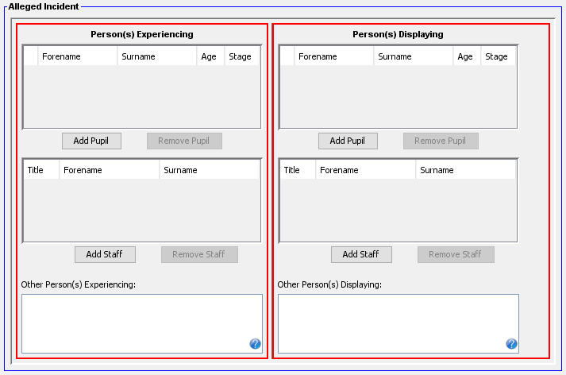

- More than one pupil can be selected if required by holding the Ctrl keyboard key.

- Note, once a pupil has been selected an ellipses button displays to the left of the pupils’ name. Clicking on this will show a preview of any previously saved incidents for this pupil.

If other people other than pupils or staff within your establishment are involved in an incident, they can be added by entering their details within the Other Person(s) Experiencing/Displaying free-text boxes.

3.3 Nature of Incident

When entering information regarding the Nature of Incident, if ‘Other(Please specify)’ is selected from the drop-down list, on clicking Add an additional text box will display to enable details of the ‘Other’ incident to be recorded.

The Perceived Reason(s) for Incident section is entered similarly, however if ‘Other: please specify’ is selected please include relevant details within the Incident Detail free-text box when entering the description of the incident in more detail.

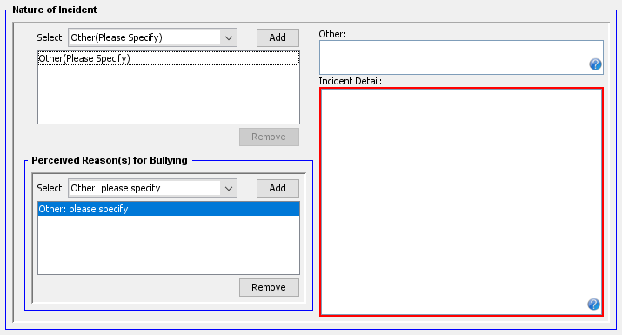

- The Nature of Incident and Perceived Reason(s) for Bullying categories available are provided in Appendix A.
3.4 Action Progressed

Details of the investigative process carried out, as well as the conclusion, can be entered for an incident.
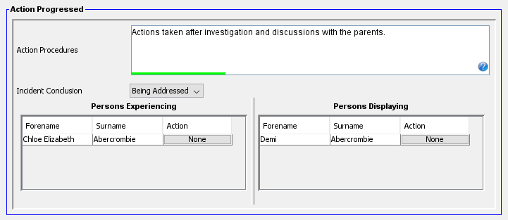

- Enter the relevant details of the action progressed in the Action Procedures free-text box.
- Select the appropriate option from the Incident Conclusion drop-down list: Being Addressed | Resolved | Not Resolved | Unfounded.
- Save.

- Note, the summary Persons Experiencing and Persons Displaying tables will display on-screen once the incident has been saved using the Save button at the bottom of the screen.

- Click the None button next to the pupil name in the Person(s) Experiencing and Person(s) Displaying fields. This will open a Person Experiencing Actions or Person Displaying Actions box.
- Click on the appropriate option from the drop-down list, then click Take Action to select.
- Where applicable tick that the action has been taken and enter any notes as necessary, then click Save and then Close once all actions have been added to the pop-up screen.
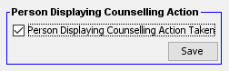
- The Actions categories available are provided in Appendix A.

3.5 Delete an Action

- To delete an action, click the button under the Action column to view the actions assigned to that pupil.
- The action(s) assigned will now be listed. Click the double arrows icon to expand an action, this will display the Delete button to remove the action displayed.
- Click Close once review complete.
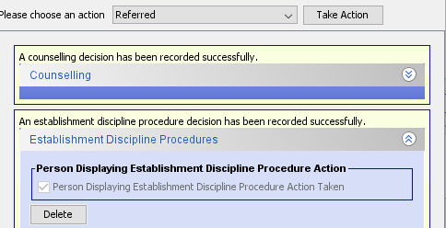

- Note, a Please Confirm Deletion pop-up will appear once the Delete button has been clicked. Select Yes or No as appropriate.

3.6 Monitor/Review Incident:

The Monitor/Review section can be completed at the appropriate stage (please also refer to section 4 below). There are four questions intended for the Person(s) Experiencing and the Person(s) Displaying.

- In Application> Management> Bullying and Equalities> Maintain Incident filter and select the appropriate incident to be monitored and/or reviewed using the magnifying glass icon at the top left-hand side of the screen.
- Select the relevant member of staff from the drop-down list Reviewer.
- Enter the Due date using the date picker when appropriate.
- Enter the Complete date using the date picker when appropriate.
- Select the appropriate responses from the drop-down options to each of the four questions for the Person(s) Experiencing and the Person(s) Displaying fields: Yes | No | N/A.
- Save.
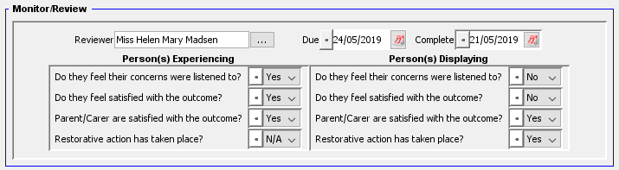

4. MAINTAIN AN EXISTING INCIDENT

Similar to section 3.6 above, there is also the facility to update or amend an existing incident within Application> Management> Bullying and Equalities> Maintain Incident.

- Click on the magnifying glass icon at the top left-hand side of the screen.
- Incidents can be filtered by Date or by incident ID from the drop-down list, or by Staff or Student using the tick-box options. The default is All Incidents.
- Click New List then click on the incident to be viewed.
- Click to the right of the screen or double click the incident to close the filter screen.
- Make the necessary changes.
- Save.

- Any Bullying & Equalities incident information stored can be viewed in other areas of Click+Go, including Pupil Profile and Latest Pastoral Notes. Those members of staff who have access to the Document Management Profile can only access the stored documents.

5. REPORTS

5.1 Pupil Incident Reports:

It is possible to produce a Condensed or Full Detail Report of Bullying & Equalities incidents entered in Click+Go for the selected pupil. These reports are available in PDF format through Application> Management> Bullying & Equalities> Pupil Incident Reports

Example of a Condensed Report:
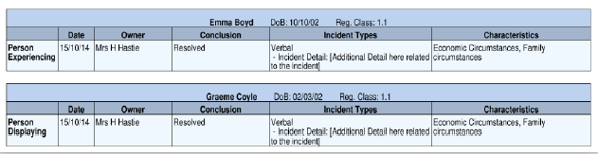

Example of a Detailed Report
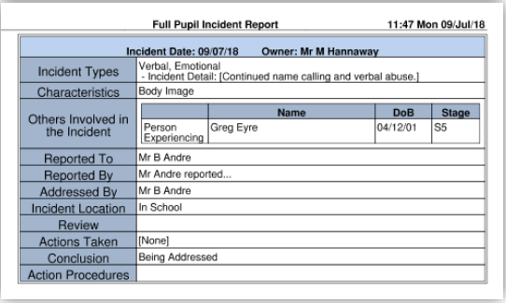

The reports can be viewed on screen using the zoom icons along the top ribbon, and also saved or printed. A description of the icons will display in the B&E reports screens by hovering the mouse pointer over them.

When the report has been previewed, the Back button at the bottom right of the screen can be used to return to the selection screen.

5.2 Staff Incident Reports

Staff reports can be produced for Staff Responsible for an incident or Staff Involved in an incident, using the tabs at the top left of the screen to select the relevant option.

Similar to the Pupil Incident Reports outlined in section 6.1 above, these staff reports can also be produced in Condensed or Full Detail report formats, and can be viewed on screen using the zoom icons, and also saved or printed, however these are accessed through: Application> Management> Bullying & Equalities> Staff Incident Reports.

Example of a Condensed Report

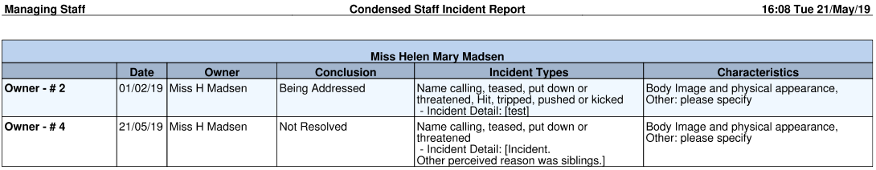

Example of a Detailed Report
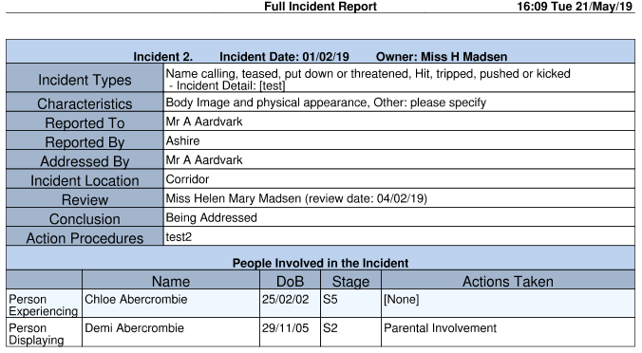
When the report has been previewed, the Back button at the bottom right of the screen can be used to return to the selection screen.

5.3 Full Incident Reports

This will display full details of the incidents that have been entered through the Maintain Incident screen with the option to print if required, accessed through: Application> Management> Bullying & Equalities> Incident Reports.

These can be filtered by Date or by incident ID, however the default is to display All Incidents once New List has been selected. The reports provide details on an individual incident as selected from the filter screen list.

Example of a Full Incident Report
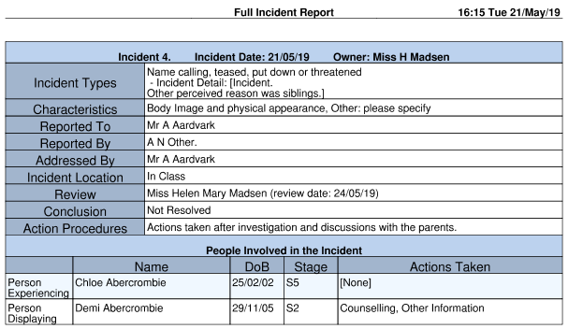

Appendix A: B&E DROP-DOWN CATEGORIES AVAILABLE

The following drop-down options are listed in the order they currently display in SEEMiS Click+Go:
Incident Location
Changing Rooms
Corridor
In Class
In School
In the Community
Lunch Hall
Online / phone / gaming
Playground
School Grounds
School Transport
Toilets

Nature of Incident
Name calling, teased, put down or threatened
Hit, tripped, pushed or kicked
Belongings taken or damaged
Being ignored
Spreading rumours
Abusive messages online/phone/gaming/social media
Targeted because of who they are/perceived to be
Racism or Racist Incident
Gender Based Vilence
Other(Please Specify)

Perceived Reason(s) for Incident
Actual or perceived Sexual orientation (e.g. homophobic, bi-phobic)
Additional support needs
Asylum seekers or refugee status
Body Image and physical appearance
Disability
Gender identity or Trans identity
Gypsy/travellers
Care Experience
Marriage/civil partnership of parents/carers or other family members
Mental health
Pregnancy and maternity
Race and racism including culture
Religion or belief
Sectarianism
Sexism and gender
Socio-economic prejudice
Young carer
Not known
Other: please specify

Person Experiencing Actions | Person Displaying Actions
Involve other agency | Referred
Interview | Record serious incident
Letter | Exclusion
Counselling | Remove from register
Peer Support | Involve other agency
Agency Involvement | Interview
Other Information | Letter
Parental Involvement | Counselling
 | Establishment Discipline Procedures
 | Agency Involvement
 | Other Information
 | Parental Involvement

It is recommended the SMT profile has access to all the areas listed under Bullying & Equalities.
This profile can also be managed through Application>Data Utilities>Access Control>Edit User Profiles.
https://www.gov.scot/publications/rambis-recommendations/
MIS Support can be contacted through askFred (Business Support Systems | MIS Support).
The Reported To and Addressed By lists display all staff records within the establishment; the Incident Owner list displays only those staff which have Confidential Notes selected within their User Profile.
You can toggle between morning and afternoon times by clicking on the AM or PM at top of time pop-up.
It is recommended that the B&E module is used only for recording ‘pupil’ incidents.
A text box may appear for additional notes to be entered, depending on the action selected.
The Reviewer list displays only those staff which have Confidential Notes selected within their User Profile. This can be amended in Applications>Data Utilities>Access Control>Edit Data Settings.
This profile can be managed through Application>Data Utilities>Access Control>Edit User Profiles.

