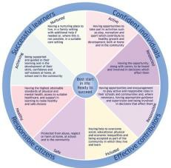
This form is for us to gather your views and opinions about your child which can help us plan to meet their needs in the best way possible.
On the opposite side we need you to complete the information so that we can check that we have all of the correct details about your child.
Over the page is a map which we would like to complete filling in all of the boxes with your views and opinions. This will help us when we come to discuss and plan how we can support your child’s Additional Support Needs.
Additional Support Needs – your views are important!
I understand and give permission for the information in this form to be shared with people who are helping my child at school.
Signed date
School
My name is
My child’s name is His/her birthday is He/she lives at
He/she goes to

He / she is learning to: What helps my child to learn is:

What helps my child to learn is:
Helping my child to learn

Other important things I would like others to know about my child are:

20

Everyone will know that my child is doing really well because:

