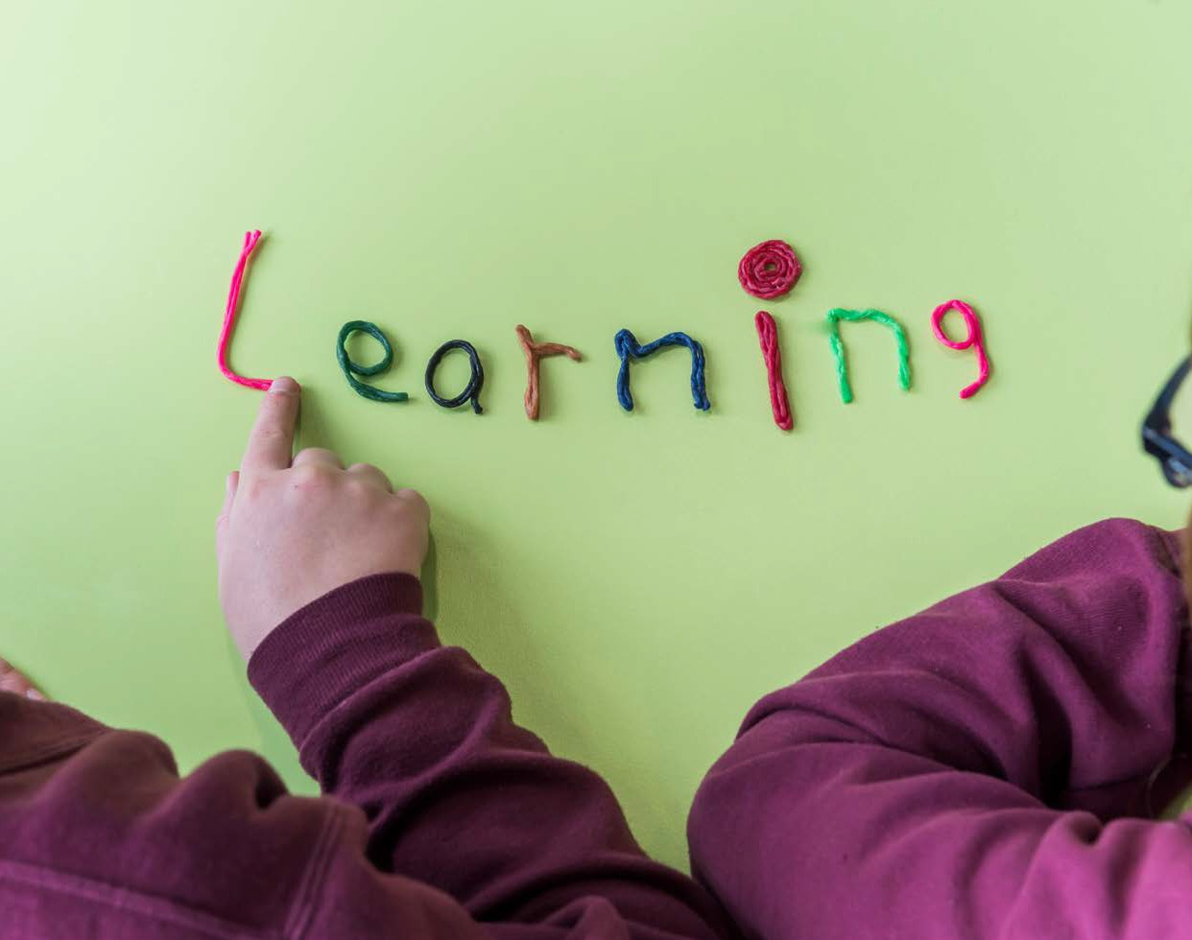

From mountain to sea

Whole School
Dyslexia Reflective Tool

Guidance updated by a steering group including teaching staff, ASPECTS and Educational Psychology Service

Version | Status | Issue date | Reason
0.1 | Initial Draft | 31/08/2015 | Update of existing  guidance
0.2 | Working Draft | 22/12/2015 | Further update following  consultation
1.0 | Published | 18/10/2016 | Final version
Guidance to be reviewed in July 2017

The following checklist is designed to support schools in assessing their dyslexia friendly status. This can be used alongside Education Scotland’s Learning Trail. The British Dyslexia Association (2006) defines
a dyslexia friendly school as one which “is able to identify and respond to difficulties that pupils with dyslexia may encounter”. However, dyslexia friendly practice also enhances the learning of all children and young people, whether they are dyslexic or not, because the techniques are rooted in the psychology of learning and epitomise best practice (MacKay, 2003).
The checklist should be completed yearly by the Senior Leadership Team along with Additional Support for Learning staff after responses from the ‘Dyslexia in the Classroom Reflective Tool’ (completed by classroom teachers) have been collated.
The whole school tool should be used to identify strengths and actions that need to be taken to develop the school’s dyslexia friendly practice.

Whole School Dyslexia Reflective Tool version 1.0 October 2016

3

Never
No
Yes
Whole-school policy & practice | All teaching staff are familiar with and know how to access the ‘Addressing Dyslexia Toolkit’. | All teaching staff are familiar with the Aberdeenshire’s ‘Guidelines to Support Literacy’. | Senior Leadership Team demonstrate a firm commitment to supporting children/young people with dyslexia across the curriculum. | The school improvement plan includes targets for focusing, developing, establishing and enhancing the dyslexia friendly status of the school. | Induction procedures for new staff and supply staff make explicit reference to expectations relating to the school’s aim to be dyslexia friendly. Staff should be given time to access the ‘Addressing Dyslexia Toolkit’ and the dyslexia support materials on ALDO. | Guidelines for meeting the needs of children / young people with dyslexia are contained within whole-school key policy documents (e.g., Assessment and Monitoring; Learning and Teaching; Additional Support Needs; Differentiation and Inclusion). | All teaching staff have completed the ‘Dyslexia in the Classroom Reflective Tool’ and their Professional Learning forms from the tool have been collated and used to inform the school’s professional learning programme. | Training, policy documentation and guidance provides all staff with an awareness of the issues surrounding the needs of children/young people with literacy difficulties at all ages and stages. | Effective systems are in place to communicate the needs of children/ young people with additional support needs, including dyslexia,  to relevant staff within the school and to staff in other educational  establishments prior to transitions.
A | 1. | 2. | 3. | 4. | 5. | 6. | 7. | 8. | 9.
Whole School Dyslexia Reflective Tool version 1.0 October 2016
4

Whole School Dyslexia Reflective Tool version 1.0 October 2016
5
Never
No
Yes
 | An emphasis is placed on raising awareness of dyslexia amongst all children/young people in order to remove the stigma. This could include the use of materials available on the ‘Addressing Dyslexia Toolkit’ section ‘Children and Young People’. | Effective measures are in place to ensure legislative responsibilities for equalities, disabilities and additional support needs are understood. | The role of Additional Support for Learning staff in relation to supporting the school in being dyslexia friendly is clearly defined. | Staff are aware of and actively use the process for alerting Additional Support for Learning staff if they have concerns regarding learner’s progress and possible indicators of dyslexia. | Additional Support for Learning time is set aside for the above. | Career Long Professional Learning | All staff have received basic awareness training on dyslexia through the Authority Career Long Professional Learning (CLPL) programme and Aberdeenshire Learning and Development Online (ALDO). | Staff are aware of how they can access relevant information on dyslexia through the ‘Addressing Dyslexia Toolkit’ CLPL section. | Teachers are given opportunities to share good practice in relation to supporting children / young people with dyslexia through staff focus groups involving Head Teacher /Depute Head Teacher. | The knowledge and expertise of key staff is kept up to date and is regularly disseminated across the school. | Involvement of children / young people | The school recognises the need for pastoral support for children/ young people with dyslexia including support with self-esteem and social/emotional issues. | Children / young people are taught about the nature of their difficulty where appropriate, including areas of strength and preferred learning. | Children / young people are involved in setting their own personal learning targets and reviewing their progress.
 | 10. | 11. | 12. | 13. | 14. | B | 15. | 16. | 17. | 18. | C | 19. | 20. | 21.

Never
No
Yes
 | Children / young people are involved in identifying and implementing their own learning strategies. | Children/young people are encouraged to focus on strengths and achievements. | Staff encourage children/young people to be confident about discussing their concerns. | Children/young people are aware of how they can access relevant information on dyslexia. | Partnership with parents | Parents are involved in developing the school’s dyslexia friendly policy. | Parents are made aware of the ‘Addressing Dyslexia Toolkit’ | Parents are involved in their child’s personal learning planning. | Effective communication is in place for parents to understand dyslexia and the basis on which the school teaches and supports their child. | Parents are given the opportunity to be included in receiving basic awareness raising training on dyslexia. | Parents are encouraged to express concerns as they occur, and the school ensures that parents know who best to express concerns to.
 | 22. | 23. | 24. | 25. | D | 26. | 27. | 28. | 29. | 30. | 31.
Whole School Dyslexia Reflective Tool version 1.0 October 2016
6

Whole School Dyslexia Reflective Tool Summary and actions
School: _________________________ Date of completion: ___________
Staff members involved:
Name: Designation:

____________________________ ______________________________

____________________________ ______________________________ Areas of strength identified:
1.___________________________________________________________

2.___________________________________________________________

3.___________________________________________________________ Areas prioritised for development:
1.___________________________________________________________

2.___________________________________________________________

3.___________________________________________________________

Actions to be taken: | By whom: | By when:
____________________________ | _______________ | ___________
____________________________ | _______________ | ___________
____________________________ | _______________ | ___________
____________________________ | _______________ | ___________
Whole School Dyslexia Reflective Tool version 1.0 October 2016 | 7

Yearly review
“Self-evaluation should be an integral part of the improvement planning process by helping to identify strengths and areas for development. Effective professional learning is the result of a cycle of self-evaluation (teacher and/or school), planning for improvement, identifying appropriate professional learning activities and evaluating impact.”

Education Scotland
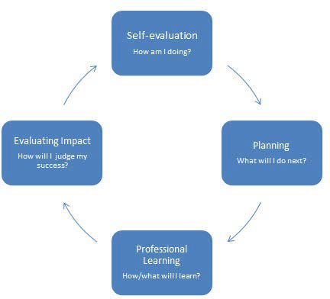

Whole School Dyslexia Reflective Tool version 1.0 October 2016

8

This section should be completed a year after the previous whole school review. Based on the areas outlined for development in the previous review, use the section below to evaluate and reflect on your school’s journey towards excellence’

What were our areas for development? | What did we do to make improvements? | How are we doing now? | Next steps

Review date: __________________

Whole School Dyslexia Reflective Tool version 1.0 October 2016

9

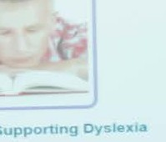

General Information

Working In partnership
Ass s ng & Suppon ng Dys x

addressing
<ib

DYSLEXIA
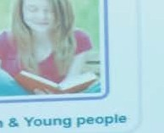
Ch ldren &Young people

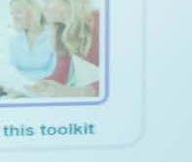
Us ng th s too t

Parents

xia Toolk1t Website Red evelopmen t Ouest1onnaire

Produced by Aberdeenshire Council GDT24038 October 2016

