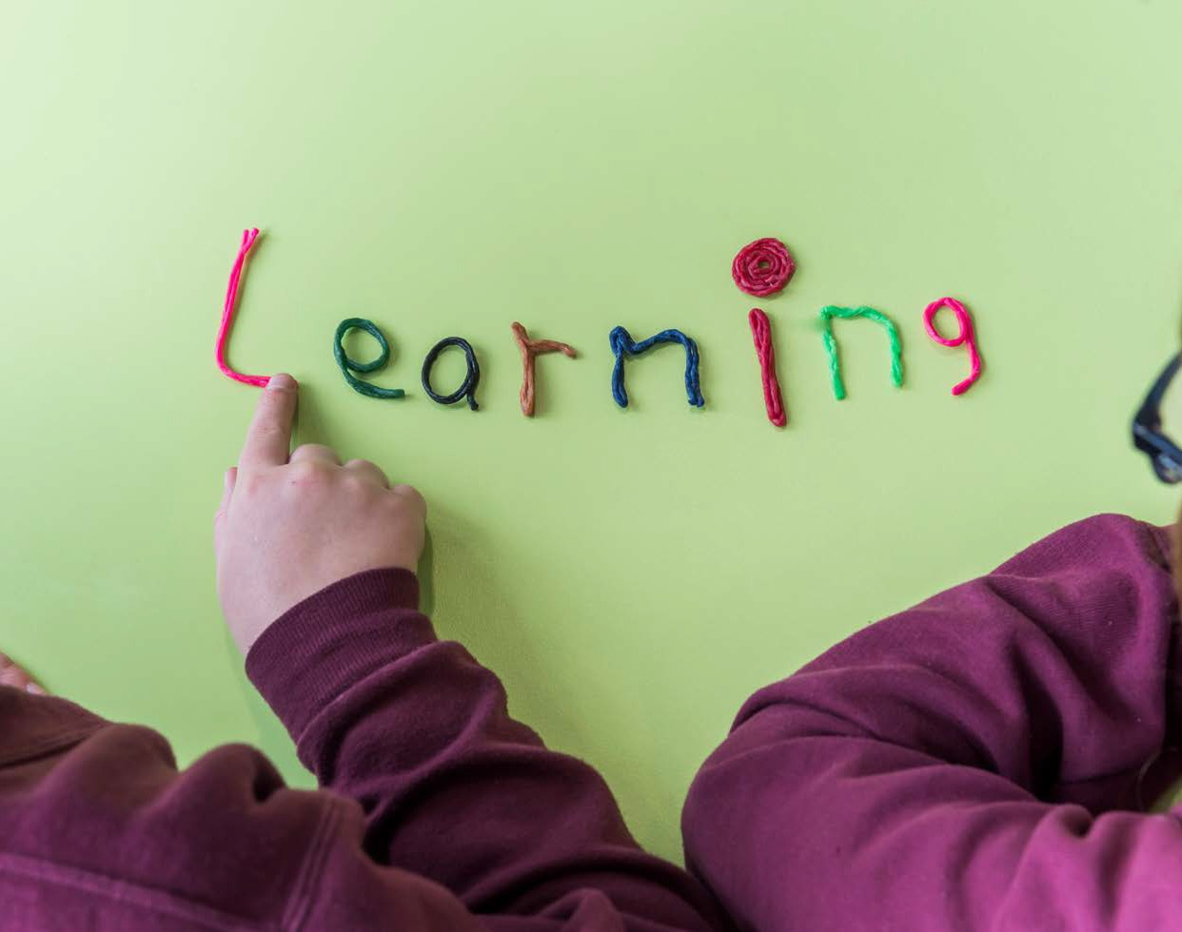

From mountain to sea

Dyslexia in the Classroom Reflective Tool

Guidance updated by a steering group including teaching staff, ASPECTS and Educational Psychology Service

Version | Status | Issue date | Reason
0.1 | Initial Draft | 31/08/2015 | Update of existing  guidance
0.2 | Working Draft | 22/12/2015 | Further upate following  consultation
1.0 | Published | 18/10/2016 | Final version
Guidance to be reviewed in July 2017

Dyslexia in the Classroom Reflective Tool
“Long term and sustained improvement which has a real impact on the quality of children’s learning will be better achieved through determined efforts to build the capacity of teachers themselves to take responsibility for their own professional development, building their pedagogical expertise, engaging with the need for change, undertaking well-thought through development and always evaluating impact in relation to improvement in the quality of children’s learning. That is the message from successful education systems across the world.”
‘Teaching Scotland’s Future‘ (Scottish Government, 2011)

This reflective tool is designed to help you think about your knowledge and understanding of the challenges faced by dyslexic learners, evaluate your classroom practice and identify areas of strength and for development.
It should be answered as honestly as possible, revisited each year as part of your career long professional learning and can contribute towards completion of your Professional Update with the GTCS.
Use the Professional Learning feedback sheet at the end to share your identified areas for development with your school’s management team or additional support for learning teacher(s) so that they can include this in their whole school Professional Learning programme, advise on sources of professional reading and/or suggest suitable strategies/resources to use.

Dyslexia in the Classroom Reflective Tool
Use this reflection tool to evaluate your current classroom practice. After completion use the scoring sheet to identify current strengths in practice and areas for development.

Dyslexia in the Classroom Reflective Tool 2016

2

Dyslexia in the Classroom Reflective Tool 2016
3
Always
Often
Sometimes
Rarely
Never
 | Teaching plans highlight the proactive use of strategies to meet the needs of children/young people with dyslexia. | Children/young people are encouraged to use personal word books for difficult spellings and new vocabulary. | Awareness of the suitability of multi sensory teaching in relation to children/young people with dyslexia. | Expectations of dyslexic learners are high for intellectual stimulation but reasonable for their written response. | Children and young people are encouraged to be independent learners (e.g. through the use of technology). | Targets are set and reviewed, and progress is monitored for all children/young people with dyslexia. | Opportunities for peer support are maximised (e.g. buddying, paired reading, peer scribing, peer spellchecking or critical friends). | A wide range of alternative recording systems to support children/young people with dyslexia are used where needed (e.g. oral reporting, scribing, word processing, using writing frames, audio recording, mind maps, storyboards, flowcharts, bullet points, digital software). | Children/young people are encouraged to use personal diaries, organisers or checklists.
 | 1. | 2. | 3. | 4. | 5. | 6. | 7. | 8. | 9.

Always
Often
Sometimes
Rarely
Never
 | Digitised course notes are available for all lessons. | There is provision for small group teaching, which is dictated by need. | Explanations are presented in a variety of ways (‘Show as well as tell’). | Prior strategies which have worked for specific children/young people are still in place to ensure consistency during transition stages. | A glossary of subject/curriculum ’jargon’ is provided and explained to children/young people. | Learning Intentions and Success Criteria are shared explicitly at the start of a lesson in a variety of different ways. | Advice has been sought from the ‘Addessing Dyslexia Toolkit’ online. | Advice has been sought from colleagues, i.e. stage partners, previous teacher of focus children/young people, or Additional Support for Learning teaching staff. | Instructions are given in a slow, calm and deliberate manner. | I am confident with the resources available in the school or classroom learning boxes to support dyslexic pupils. | Measures are in place to ensure that children/young people have an accurate record of homework  set (e.g. it is provided on separate sheets, scribed into homework diaries or e-mailed, or included in web-based homework diary such as Show My  Homework). | Copying and dictation are kept to a minimum.
 | 10. | 11. | 12. | 13. | 14. | 15. | 16. | 17. | 18. | 19. | 20. | 21.
Dyslexia in the Classroom Reflective Tool 2016
4

Dyslexia in the Classroom Reflective Tool 2016
5
Always
Often
Sometimes
Rarely
Never
 | Children/young people with dyslexia have access to appropriate digital technology resources (e.g. word processing facilities with spell checkers or predictive text). | Targets have been discussed with the child/young person and they are encouraged to take ownership over their learning by using tools which will help them. | ‘Listening’ times are interspersed with ‘seeing and doing’ activities. | Prior reports about individual children/young people from formal and informal consultations have been accessed. | Resources such as different types of dictionaries, coloured overlays and voice recorders are available for children/young people to use. | Teacher encourages children/young people to access tools to support their learning, i.e. word banks, finger space guides, dictionaries etc. | Worksheets require a maximum of thinking but a minimum of recording. | Strategies in place have been shared with parents and are encouraged to be used at home during homework tasks. | Children/young people with associated difficulties to dyslexia have access to targeted support in school where appropriate (e.g. gross motor skills, fine motor skills, buddy reading schemes, Toe by Toe, Plus 1 etc.). | Children/young people are not expected to take notes at the same time as listening. | All print is size 12 and above, using a font which is clear and rounded (e.g. Comic Sans, Arial, Verdana) and uses at least 1.5 line spacing. | Understanding is checked before a child/young person sets off to complete a task.
 | 22. | 23. | 24. | 25. | 26. | 27. | 28. | 29. | 30. | 31. | 32. | 33.

Always
Often
Sometimes
Rarely
Never
 | Care is taken to ensure that the amount/type of homework expected is realistic for the individual pupil. | Care is taken to ensure that children’s/young people’s cognitive ability is taken into account so that teaching presents dyslexic children/young people with an appropriate level of cognitive challenge. | Verbal approaches are used to access full texts rather than simplifying texts (e.g. using audio books). | Non-white paper (e.g. cream) is used. | Children/young people work in a variety of groupings, including mixed ability. | Classes are equipped with clearly marked and neatly arranged resources so that they can be easily found e.g. using Widgit symbols (Communicate in Print software). | Access to the curriculum is facilitated by appropriate differentiation of teaching approaches, tasks and materials. | A marking and assessment policy ensures that children/young people with dyslexia are assessed on the basis of content rather than spelling accuracy (Assessment Is for Learning). | Widgit symbols (Communicate in Print software) are used to aid recognition of resources and tasks where appropriate. | Common key words relevant to that lesson/subject are displayed alongside visual representations (e.g. parts of the Bunsen burner). Word banks can be produced easily using Read and Write software (vocabulary tool). | Children/young people have the option to work in a quiet area to aid concentration.
 | 34. | 35. | 36. | 37. | 38. | 39. | 40. | 41. | 42. | 43. | 44.
Dyslexia in the Classroom Reflective Tool 2016
6

Dyslexia in the Classroom Reflective Tool

Scoring sheet, summary and actions
Use your self-evaluations to score yourself for each question. Next to the question note the score and then total up each area. From this identify a key area(s) of strength and identify an area of development. Set next steps accordingly.

Never – 1
Rarely – 2
Sometimes – 3
Often – 4
Always – 5

Planning and  assessment | Classroom  environment | Practice | Knowledge and  understanding | Collaborative  practice
1. | 2. | 3. | 4. | 7.
6. | 9. | 5. | 8. | 11.
15. | 14. | 10. | 13. | 16.
24. | 22. | 12. | 19. | 17.
31. | 26. | 18. | 25. | 23.
35. | 28. | 20. |  | 29.
38. | 32. | 21. |  | 30.
40. | 37. | 27.
41. | 39. | 33.
 | 42. | 34.
 | 43. | 36.
 | 44.

______ of 45 ______ of 60 ______ of 55 ______ of 25 of 35

Area(s) of strength identified: ____________________________________________

____________________________________________

____________________________________________

____________________________________________

Dyslexia in the Classroom Reflective Tool 2016

7

Key area(s) of development: ____________________________________________

____________________________________________

____________________________________________

____________________________________________

Actions to be taken and by when: 1.

2.

3.

Date:

Dyslexia in the Classroom Reflective Tool 2016

8

Professional Learning
To help us better support classroom teachers, please indicate below key areas for development identified by completion of the reflection tool. This will enable us to plan any Professional Learning events required.
Please tick the box to indicate which stage you are currently teaching:

P1 – 3 ◻
P4 – 7 ◻
Secondary ◻

Please tick the boxes to indicate which area(s) you have identified as key areas for development:

Planning and Assessment ◻
Classroom Environment ◻
Practice ◻
Knowledge and Understanding ◻
Collaborative Practice ◻

Any comments:

______________________________________________________________
______________________________________________________________
______________________________________________________________
______________________________________________________________
____________________________________________

Please return this completed form to (insert name) by (insert date).

Dyslexia in the Classroom Reflective Tool 2016

9

Yearly review
“Self-evaluation should be an integral part of the improvement planning process by helping to identify strengths and areas for development. Effective professional learning is the result of a cycle of self-evaluation (teacher and/or school), planning for improvement, identifying appropriate professional learning activities and evaluating impact.”

Education Scotland
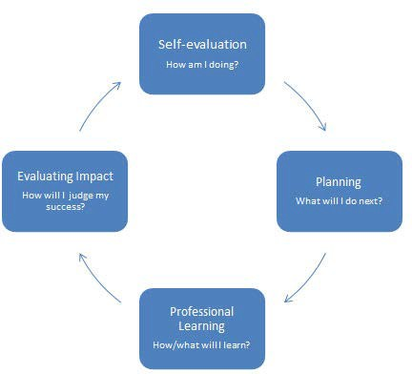

Dyslexia in the Classroom Reflective Tool 2016

10

This section should be filled in a year after you complete the ‘Dyslexia in the Classroom Reflective Tool’. Based on the areas outlined for development in the previous review, use the section below to help you evaluate and reflect on your actions to address your identified areas for development.

What were my areas for development? | What did I do to make improvements? What did I learn? | How am I doing now? | Next steps

Review date: __________________

Dyslexia in the Classroom Reflective Tool 2016

11

Dyslexia in the Classroom ReflectivPerToodoulcveedrsbioynA1b.0erdeenshire Council
GDT24038 October 2016

12

