1

# From mountain to sea

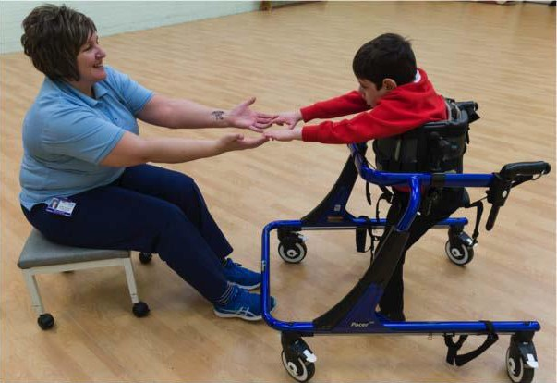

|  |
| --- |
| **Managing Accessibility Plans,**  **Personal Emergency Evacuation Plans and Risk Assessments** |
| September 2017 |

3

## Contents

#### Introduction 4

#### GIRFEC 4

#### 1 Managing Accessibility Plans (MAPs) 4

|  |  |  |
| --- | --- | --- |
| **Introduction** | **4** |  |
| **How does it link with other plans?** | **5** |  |
| **When should a MAP be used?** | **6** |  |
| **Accessing the MAP** | **6** |  |
| **Reviewing the MAP** | **6** |  |
| **Completing the MAP** | **7** |  |
| **Multi agency involvement** | **7** |  |
| **Staffing needs** | **7** |  |
| **Training needs** | **7** |  |
| **2 Personal Emergency Evacuation Plan (PEEP)** | **9** |  |
| **Introduction** | **9** |  |
| **Methods of assistance** | **9** |  |
| **Procedures** | **9** |  |
| **Individual or group planning** | **10** |  |
| **Review and update** | **10** |  |
| **3 Risk Assessment** | **11** |  |
| **Introduction** | **11** |  |
| **Content of a risk assessment** | **11** |  |
| (a) Identify and assess impact of the risk | 11 |  |
| (b) Manage the risk | 12 |  |
| **APPENDIX 1: Pro forma for Managing Accessibility Plan** | **13** |  |
| **APPENDIX 2: Pro forma for training needs for MAP** | **18** |  |
|  |  | 2 |

#### APPENDIX 3: Completed pro forma for MANAGING ACCESSIBILITY

PLAN 19

APPENDIX 4: Completed Pro forma for training needs for MAP 25

APPENDIX 5: Pro forma for PERSONAL EMERGENCY EVACUATION

PLAN (PEEP) 26

APPENDIX 6: Completed pro forma for PERSONAL EMERGENCY EVACUATION PLAN (PEEP) 28

APPENDIX 7: Pro forma for PUPIL RISK AUDIT and ASSESSMENT 31

APPENDIX 8: Completed pro forma - PUPIL RISK AUDIT and

ASSESSMENT 34

APPENDIX 9: GIRFEC information and the 5 questions 39

This guidance was written by Education and Children’s Services Additional Support Needs Team

|  |  |  |
| --- | --- | --- |
| **Version** | **Date** | **Reason for update** |
| 2.0 | 5th April 2017 | Previous MAP and CSP combined version – content no longer applicable. PEEP and Risk Assessment information included, and all document updates. |
| 2.1 | 14th July 2017 | Inclusion of exemplar for MAP |
| 2.2 | September 2017 | GIRFEC information and enable hyperlinks |

**Visit aberdeenshire.gov.uk**

3

## Introduction

The following guidance is to assist staff with the drafting of planning documentation:

* Managing accessibility plans
* Personal emergency evacuation plans
* Risk assessments

The appendices contain copies of blank proformas and also completed examples.

## GIRFEC

Children and young people have their needs assessed on an individual basis and support will be provided as required in line with [GIRFEC](http://www.gov.scot/Topics/People/Young-People/gettingitright). The Getting it Right for Every Child (GIRFEC) is a national approach to improving the Wellbeing of children and young people in Scotland.

Specific aims relevant to this guidance are:

* Improve outcomes for children, young people, and their families
* Put the child or young person at the centre of any assessment, planning and support, actively promoting their participation and engagement in any processes.
* Proactively seek the views of children, young people, and their families, providing information and support which encourages involvement.
* Achieve high standards of multi-agency working, based on a co-ordinated approach to identifying Wellbeing concerns, assessing need, and agreeing outcomes and actions.

Please refer to Appendix 9 for more information about GIRFEC and the 5 questions, together with [website links](http://www.girfec-aberdeenshire.org/).

Allied Health Professionals provide targeted interventions to secure outcomes as detailed in [Ready to Act](http://www.gov.scot/Publications/2016/01/1324/3) (participation and engagement, early intervention and prevention, partnership and integration, access, and leadership for quality improvement). There is a statutory requirement for education authorities and their partners to work together to ensure the wellbeing needs of the child/young person as detailed in the [Children and Young People (Scotland) Act 2014.](http://www.legislation.gov.uk/asp/2014/8/contents/enacted)

## Managing Accessibility Plans (MAPs)

### Introduction

Some children and young people in our establishments may have additional needs which require significant planned intervention, including those who have significant medical needs. The pro forma can be found in Appendix 1.

4

A MAP is a plan which includes consideration of:

* + Care and medical needs
  + Participation in trips and sporting activities
  + 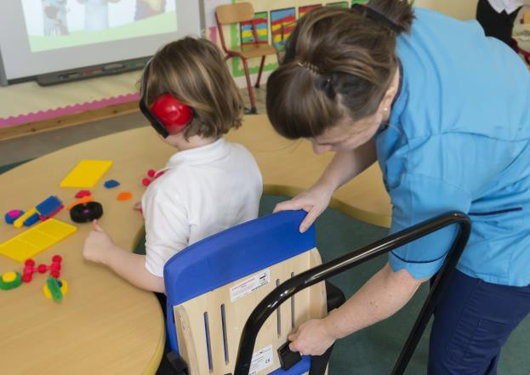Transport
  + Promoting positive behaviour
  + Physical accessibility
  + Communication of information
  + Equipment
  + Staffing
  + Other agency involvement
  + Parent/carer support
  + Staff training

Taking into account the need to consult with Allied Health professionals, parents/carers, school staff and others (e.g., moving and handling coordinator), it may take a few weeks to complete and implement a MAP depending on the requirements and possible adaptations or training required. Drafting of plans should commence as soon as an application to attend the school has been agreed.

A managing accessibility plan (MAP) is not to be confused with a multi-agency action plan (MAAP), but the latter may inform the content of the MAP if new strategies/equipment are identified to support a child/young person.

### How does it link with other plans?

The MAP is a freestanding document that can be used by school staff to manage aspects of accessibility to education provision. Completion of a MAP can also be triggered by information provided on the School Admissions Form.

The Individual Education Plan will address accessibility to the curriculum. The MAP will address accessibility through inclusion of information such as the equipment required, for example, specific braille materials, specialist resources to access teaching/learning in home economics etc.

The Individual Education Plan (IEP) will address issues surrounding access to the curriculum. If a MAP is required then the content should be shared and easily accessible to all supporting the child/young person. Reference should be made to the plan in the IEP.

The MAP may also contribute to the Child Plan for Looked-After-Children. As part of the Additional Support for Learning Act, some pupils will require a

Coordinated Support Plan (CSP) which may link to the MAP. This may address support for pupils where a multi-agency approach is required, or alternatively a Child’s plan is produced through the single agency or multi-agency action planning process.

3

### When should a MAP be used?

A pupil with additional support needs who requires significant planned intervention or has a significant medical need should have a MAP completed and all the issues arising from the plan addressed, preferably prior to the child commencing attendance at an educational establishment. Consultation should take place with parents/carers and other agencies involved with the pupil. It is important that plans are made to involve the pupil in the process, taking into account their age and stage.

However, it is recognised that schools would wish to be as supportive as possible to pupils and parents and may therefore choose, following full consultation with their Quality Improvement Officer, to enrol the pupil whilst the plan is being completed. In this case, interim arrangements will be required, and schools should ensure that the plan is completed and implemented as a priority.

##### It should be noted that only in exceptional circumstances should a pupil be enrolled whilst a support plan is being completed.

Where a pupil participates in an activity that requires a separate risk assessment, this should be completed and included with the completed MAP. The risk assessment should identify the measures put in place to ensure the safety of the pupil, staff supporting the pupil and other pupils participating in the activity.

Consideration should be given to involving other agencies as appropriate in the risk assessment.

Head teachers and school managers should also feel free to complete a MAP for pupils already attending school where it would help to manage their education provision e.g., looked after pupils or those requiring alternative education packages. The MAP may be used as supporting documentation for multi-agency review meetings.

### Accessing the MAP

All staff working with a pupil who has a MAP should have access to the plan and comply with the advice provided. Schools should establish a procedure for sharing the plan which should be treated as confidential by all staff.

An additional copy of the MAP should be kept in the Pupil Profile Record. A copy of the MAP should be given to parents/carers.

### Reviewing the MAP

All MAPs should be reviewed as and when appropriate but particularly at key stages **and at least annually** depending on the needs of the pupil and amended where necessary. For pupils with significant and complex needs, reviews may need to take place every six months. This should be indicated on the plan.

6

### Completing the MAP

All appropriate sections should be completed. Where sections are not completed they should be marked not applicable (N/A). The plan should be completed by the Head teacher or their appointed representative.

The MAP should identify:

1. *The measures already in place to support the pupil’s specific needs.*
2. *Further measures that are required and how these are to be achieved.*

Where advice is required on further measures, appropriate contacts are listed on the MAP. The MAP must be able to show that all reasonable steps have been taken to support the pupil without placing staff or other pupils at unreasonable risk. The MAP is available in electronic format to enable more space to be created for recording information. It can be found on the Aberdeenshire website at: [http://asn-](http://asn-aberdeenshire.org/planning-documentation/) [aberdeenshire.org/planning-documentation/](http://asn-aberdeenshire.org/planning-documentation/)

### Multi agency involvement

For pupils with significant and complex additional support needs consideration should be given to arranging a multi-agency meeting in order to complete the MAP. The meeting could include the Quality Improvement Officer, Educational Psychology Service, Business Support Officer, Community Paediatrician, Social Work, Health & Safety (Moving and Handling representative), Allied Health Professionals, School Nurse and Health Visitor and other professionals as appropriate. This should also include consultation with parents/carers.

Multi-agency meetings are not always easy to arrange quickly, an on occasion it may be more practical for the Head teacher or appointed representative to complete the plan in consultation with colleagues who are most easily available (this will probably include the parent/carer) and send copies of blank forms to other partners / colleagues for completion. The Head Teacher or appointed representative should then collate the final document.

### Staffing needs

To help schools effectively deploy their current staffing there must be a clear indication of number of hours required, role of staff member, specific goals for the pupil and how these will be achieved, and arrangements for reducing the level of support. The staged assessment model must also be taken into account, and there must be a clear indication of how each stage has been addressed. All of this information must be documented through an IEP.

### Training needs

Staff training may be required to address the specific needs of a pupil. Although this will be indicated in various parts of the MAP, it should be collated on the training needs pro forma (Appendix 2) and recorded on the forms in the authority policy for

[‘Supporting children and young people with healthcare needs and managing](http://asn-aberdeenshire.org/policies-and-guidance/)

[medicines in educational establishments’.](http://asn-aberdeenshire.org/policies-and-guidance/)

3

Schools should use this to manage the provision of appropriate training, through application to the authority’s Continuous Lifelong Professional Learning programme. Many opportunities for CLPL are advertised through ALDO.

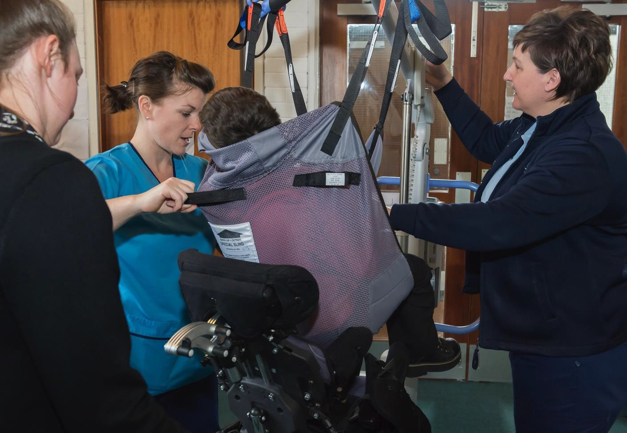

8

## Personal Emergency Evacuation Plan (PEEP)

### Introduction

For pupils who require assistance to exit the school building in the event of an emergency, a Personal Emergency Evacuation Plan should be completed. The child/young person, parents/carers, school staff/specialist staff and other agencies (NHS Grampian Allied Health Professionals) should all be consulted for their input. The authority also employs a specialist for ‘moving and handling’ who may be able to advise. As with Managing Accessibility Plans, input from health and safety officers, business support officer, Quality Improvement Officers and others may be necessary to ensure adaptations are in place for safe evacuation from the building.

Pupils with mobility and sensory needs in particular should be considered for a PEEP and arrangements made for their assistance in an emergency. Consideration must be given to how the alarm is raised and who would be responsible for going to the assistance of the child/young person and ensuring their safe removal from the building. Named individuals must be identified, and additional personnel included to cover possible staff absence. Responsibilities MUST be clearly communicated to personnel, and a copy of the PEEP given to the staff named in the document. A copy should also be retained in the Pupil Profile Record.

### Methods of assistance

Methods of assistance/guidance must be detailed and include how transfers would be made to enable evacuation to take place speedily and safely. Equipment should be listed in connection with safe evacuation, for example if a child is in a dynamic stander, hoist or classroom chair that equipment may be suitable for immediate evacuation. If not, use of evacuation mats on the floor, or chairs for removal downstairs must be considered and recorded as required.

### Procedures

The exact procedure must be detailed for each type of evacuation for example, evacuation using a wheelchair, from a therapy bench, classroom floor, sensory room, swimming pool, ball pool, etc. Please consider carefully the needs of children with hearing/visual impairments, and those with auditory/ other sensory hyper/hyposensitivity as introduction and practising of a routine at a time without a fire alarm sounding may be very beneficial. All schools are required to practice a fire drill termly to ensure safe and swift evacuation and identify further arrangements as required.

A list of the safe routes out of the school should be made for each pupil requiring a PEEP, considering their timetable and access to rooms/areas of the building.

In the event of a wheelchair user accessing an upper floor of a building, please ensure that a method of evacuation is identified as the lift cannot be used. Should a wheelchair user not be suited to the use of an ‘Evac’ chair from an upper floor, please seek advice from the fire-brigade regarding an agreed procedure and verify with the QIO.

Some secondary school buildings have a designated ‘safe space’ for wheelchair users who may require evacuation by the fire brigade due to lack of suitability of use

3

of an ‘Evac’ chair. Clear arrangements for personnel remaining in the building with the wheelchair user in an emergency must be agreed and recorded.

### Individual or group planning

As the name implies this plan is for individuals, however on occasion a school management team may wish to adapt it as a generic plan for evacuation by groups of children/young people from areas such as a swimming pool/showers, sensory room, soft play area, dining room or gym. The format must record how the alarm would be raised for the group, persons responsible for evacuation, and the nearest exit. In the case of a swimming pool consideration must be made to provision of silvered emergency blankets near to the exit for collection on the way out of the building.

A generic plan is not a substitute for an individual personal emergency evacuation plan for a child who has physical/sensory/other needs for which the procedure needs to be detailed to ensure their safe evacuation.

### Review and update

Personal Emergency Evacuation Plans must be reviewed annually, or earlier if there is a change to the child/young person’s timetable, equipment, health/mobility needs or following a request from parent/carer/child/young person/school staff or allied health professionals.

Risk assessments may also be required to ensure that risks are minimised in the event of an emergency evacuation.

Appendix 3 details a PEEP, and Appendix 4 illustrates a completed exemplar. A copy of the Word document format is available on:

<http://asn-aberdeenshire.org/planning-documentation/>



10

## Risk Assessment

### Introduction

A risk assessment should be considered in the following instances:

* **BEHAVIOUR:** where a pupil’s conduct poses a demonstrable and ongoing risk to the health, safety, and wellbeing of others at the school and/or presents a risk to their own safety

.

* **PHYSICAL RISK:** where limitations due to lack of mobility, hearing/visual impairment and/or other sensory needs there is a risk posed to the health, safety, and wellbeing of others at the school and/or the pupil’s own safety.
* **MEDICAL:** where a pupil’s medical/healthcare needs may pose risks to the health, safety, and wellbeing of others at the school and/or to the pupil’s own safety.

All risk assessments must be shared with personnel supporting the pupil and reviewed at a minimum annually or early due to changes in circumstances/by request.

### Content of a risk assessment

#### A risk assessment should:

* Involve the pupil where possible
* Involve all staff who works with the pupil (e.g., Class/subject teachers, Pupil Support Assistant, Additional Support for Learning Teacher, Educational Psychologist)
* Involve parents/carers
* Be conducted by a competent person
* Involve outside agencies where appropriate (e.g., NHS Grampian Allied Health Professionals, Social Work, 3rd Sector providers as part of a commissioned service)

#### All risk assessments must:

1. *Identify and assess impact of the risk*

One way in which you can identify the risks is to gather evidence that can be compiled via a risk audit. This should include:

* + BEHAVIOUR: The actual behaviour (observed actions), previous behaviour and relevant behaviour of others
  + PHYSICAL: The actual risk e.g., slips, trips falls, exit from school building onto main road and risk of being hit by a car etc.

3

* + MEDICAL: The actual risk which may arise from missed dose / over-dose of medicines, other child accessing medicine etc.
  + The potential of harm (no harm, harm, serious)
  + Pre-existing medical conditions and impact on control measures
  + In what situation does the risk occur (time of day, trigger points, pattern to behaviour) etc.
  + Who is likely to be injured or harmed?
  + What kinds of harm, injuries are likely to occur?

1. *Manage the risk*

From the risk audit you will be able to devise a risk assessment detailing control measures to remove / reduce the risk. There should be a clear rating of the risk level prior to implementation of control measures, and the rating once measures are in place. Further details can be added when new control measures are identified to further reduce risk

The outcome of the risk assessment should be disseminated to all staff, including support staff, supply, temporary and student teachers, and shared with parent/carer and child/young person.

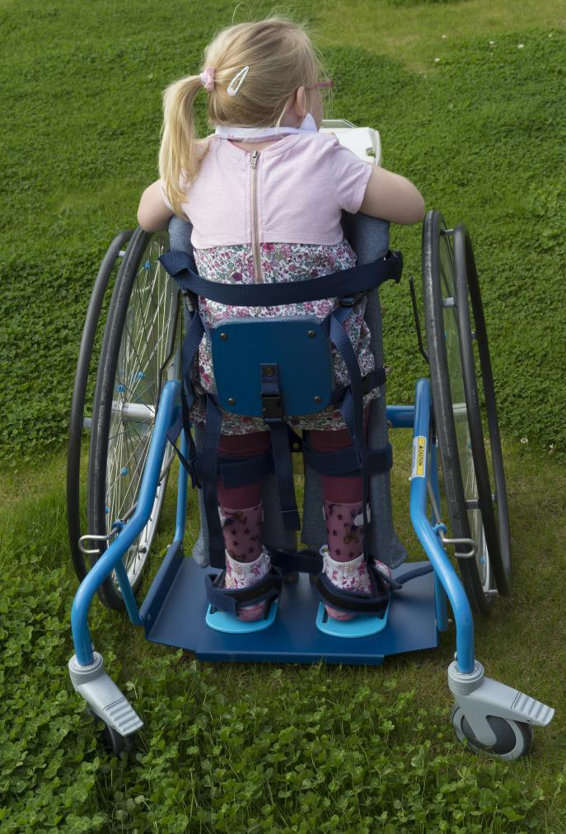The risk assessment should take into account the views of the pupil, staff, and parents/carers, and must be signed by the author, parent/carer and when appropriate by the pupil.

Appendix 5 details a risk assessment pro forma, and Appendix 6 illustrates a completed exemplar.

12

## APPENDIX 1: Pro forma for Managing Accessibility Plan

|  |
| --- |
| **Managing Accessibility Plan** |
| **Name of pupil:** |
| **Date of birth:** |
| **School attended:** |
| **Proposed date of enrolment:** |
| **Additional support needs:** |
| *Please give a brief description of the pupil’s additional support needs.*  **Health/Disability**  **Social/Emotional**  **Learning Environment**  **Family Circumstances** |

##### Under each heading below record:

1. ***Measures already in place.***
2. ***Further measures required and how these are to be achieved.***

|  |
| --- |
| **1 Mobility**  a)  b)  *Contact for advice: Occupational Therapist/Physiotherapist, Parent/carer, Pupil.* |

3

|  |
| --- |
| **2 Lifting and handling**  a)  b)  *Contact for advice: Occupational Therapist/Physiotherapist, Parent/carer, Pupil.* |
| **3 Person and Intimate Care** (e.g., diet, feeding, allergies, toileting) a)  b)  *Contact for advice: Occupational Therapist/Physiotherapist, school nurse/specialist nurse, Parent/carer, Pupil.* |
| **4 Emergencies** (e.g., emergency exits, health issues, severe weather closures). Should an individualised emergency plan be required, a Personal Emergency Plan should also be completed.  a)  b)  *Contact for advice: Health & Safety advisor, School Nurse, Occupational Therapist/Physiotherapist, Community paediatrician, Parent/carer, Pupil.* |
| **5 Sensory** (e.g., hearing or visual aids, sensitivities due to autism spectrum disorder)  a)  b)  *Contact for advice: Sensory Support Service, Educational Psychologist, Additional Support for Learning Teacher, Parent/carer, Pupil.* |

14

|  |
| --- |
| **6 Administration of medicines**  a)  b)  *Contact for advice: refer to Authority Poli*[*cy ‘Supporting children and young people*](http://www.aberdeenshire.gov.uk/media/18728/supporting-children-and-young-people-with-healthcare-needs-and-managing-medicines-in-educational-establishments-october-2016.pdf)[*with healthcare needs and managing medicines in educational establishments*](http://www.aberdeenshire.gov.uk/media/18728/supporting-children-and-young-people-with-healthcare-needs-and-managing-medicines-in-educational-establishments-october-2016.pdf)*’.*  *Also, Community Paediatrician, child’s General Practitioner, School nurse, Parent/carer, Pupil* |
| **7 Participation in trips/outings** (e.g., supervision, additional staff, physical access). This information is also to be recorded in an individualised risk assessment.  a)  b)  *Contact for advice: refer to Authority information on* [*‘Educational Excursions’*](http://www.aberdeenshire.gov.uk/schools/parents-carers/school-info/school-excursions/)*, Additional Support for Learning staff, Quality Improvement Officer, Pupil Transport Unit, Parent/carer, Pupil.* |
| **8 Participation in sporting activities (**e.g., equipment, supervision). This information is also to be recorded in an individualised risk assessment.  a)  b)  *Contact for advice: Occupational Therapist/Physiotherapist, Educational Psychologist, Community Paediatrician/School nurse, Parent/carer, Pupil* |
| **9 Transport** (e.g., escort, seating, type of transport, medical needs).  a)  b) |

3

|  |
| --- |
| *Contact for advice: Physiotherapist/Occupational Therapist, Quality Improvement Officer, Educational Psychologist, Pupil Transport Unit, Community Paediatrician, Parent/carer, Pupil.* |
| **10 Promoting positive behaviour** (e.g., for child who may exit premises: second higher-positioned door handle, adapted fire doors, visual supports. This information is also to be recorded in an individualised risk assessment.  a)  b)  *Contact for advice: Additional Support for Learning Teacher, Educational Psychologist, Quality Improvement Officer, Business Support Officer, Parent/carer, Pupil,* |
| **11 Physical accessibility** (e.g., accessible ramps, carpeting, decoration, blinds, lighting, fire evacuation, accessible toilets, changing facilities, hoists, water temperature controls).  a)  b)  *Contact for advice: Occupational therapist/Physiotherapist, Quality Improvement Officer, Business Support Officer, Sensory Support Service, Health & Safety officer, Parent/carer, Pupil.* |
| **12 Communication of information** (e.g., large print, preferred language, audio tape, sign, alternative communication aids).  a)  b)  *Contact for advice: Sensory Support Service, English as an Additional Language Service, Speech & Language Therapist, Parent/carer, Pupil.* |

16

|  |
| --- |
| **13 Equipment** (e.g., hoists, slings, standing frames, desks, chairs).  a)  b)  *Contact for advice: Occupational Therapist/Physiotherapist, Parent/carer, Pupil.* |
| **14 Other agency involvement**  a)  b)  *Contact for advice: Quality Improvement Officer* |
| **15 Parent/carer involvement support** (e.g., reinforcing school strategies, medical needs, homework, getting ready for school).  a)  b) |
| **16 Further comments:** |
| **17 Review date** *(minimum review annually)***:** |
| **18 Completed by:** *(list names of contributors and designation)* |

3

## APPENDIX 2: Pro forma for training needs for MAP

|  |  |  |  |  |  |  |  |
| --- | --- | --- | --- | --- | --- | --- | --- |
| **Pupil:** | | | | **Head teacher:** | | | |
| **Name of establishment:** | | | | | | | |
| **TRAINING NEED** | Disability awareness | Personal care | Curriculum | Communication and language | Equipment | Other training needs | Date completed |
| Promoted staff |  |  |  |  |  |  |  |
| Teachers |  |  |  |  |  |  |  |
| Specialists |  |  |  |  |  |  |  |
| Pupil Support Assistants |  |  |  |  |  |  |  |
| Clerical/ Admin Staff |  |  |  |  |  |  |  |
| Janitorial |  |  |  |  |  |  |  |
| Escorts |  |  |  |  |  |  |  |
| Pupils |  |  |  |  |  |  |  |
| Others |  |  |  |  |  |  |  |

*Please indicate the names of staff requiring training in each box in order that CLPL can be arranged by the CLPL Coordinator/Head teacher*

18

## APPENDIX 3: Completed pro forma for MANAGING ACCESSIBILITY PLAN

|  |
| --- |
| **Managing Accessibility Plan** |
| **Name of pupil:** Pupil M |
| **Date of birth:** February 2008 |
| **School attended:** X primary school |
| **Proposed date of enrolment:** August 2013 |
| **Additional support needs:** |
| *Please give a brief description of the pupil’s additional support needs.*  **Health/Disability**   * Cerebral palsy with diplegia resulting in difficulties with motor skills for the lower part of the body * Requires equipment to enable independent movement and some physical assistance from an adult to support transfers * Requires regular changes in position and exercise programme supplied by Allied Health Professionals for completion daily in school * Support with fine motor skills such as handwriting * May tire more quickly * Mild astigmatism and near-sightedness, wears glasses   **Social/Emotional**  **Learning Environment**   * Differentiation required for gym and physical activities * Planning for moving around   **Family Circumstances**   * Pupil M is fostered under a permanence order with long term carers in a very stable relationship |

##### Under each heading below record:

1. ***Measures already in place.***
2. ***Further measures required and how these are to be achieved.***

3

|  |
| --- |
| **1 Mobility**   1. Supported using equipment (Kaye walker), adults for transfers, and use of power chair. Can sit upright on therapy bench. Sits on floor but must not use W kneeling position. 2. Equipment to be supplied by home: Kaye walker. Training for independent use of powered wheelchair. Exercise programme to strengthen Pupil M’s mobility and increase independence. Training for PSA to support PE and sports activities. School to arrange via ASN team budgets ramp or means to access school garden. Disability sport training for PSA. Exercise programme from physiotherapist. Equipment from Occupational Therapy and Aberdeenshire Council.   *Contact for advice: Occupational Therapist/Physiotherapist, Parent/carer, Pupil.* |
| **2 Lifting and handling**   1. Training for staff from Mrs Y (authority moving and handling coordinator) –   Class teacher (Mrs P) and PSAs (Mrs G and Ms T) completed July 2013   1. Use of equipment training from Ms K (occupational therapist). Set up Excel spreadsheet for recording equipment and servicing dates. Advice from physiotherapist regarding exercise programme in conjunction with use of equipment - information kept beside PPR in filing cabinet.   *Contact for advice: Occupational Therapist/Physiotherapist, Parent/carer, Pupil.* |
| **3 Person and Intimate Care** (e.g., diet, feeding, allergies, toileting)   1. Accessible toilet adapted with toilet seat and back, steps to be moved into place. Toileting programme in place. Change of spare clothes provided by carers. Packed lunch will be provided by carers. 2. Accessible toilet in local sports hall for use at PE and on other occasions – ordered seat but still to arrive. Steps still to order. Pupil M needs support with opening packets and some support with eating and drinking, carer to liaise with PSAs to provide information. PSA hours to be arranged for taking Pupil M to the toilet and discreet system to be devised if PSA required but engaged in another classroom.   *Contact for advice: Occupational Therapist/Physiotherapist, school nurse/specialist nurse, Parent/carer, Pupil.* |

20

|  |
| --- |
| **4 Emergencies** (e.g., emergency exits, health issues, severe weather closures). Should an individualised emergency plan be required, a Personal Emergency Plan should also be completed.   1. School fire evacuation procedures in place and regularly practised. PSAs familiarised with procedures as are visiting specialist teachers. PEEP completed and copied in the classroom and the PPR - checked and agreed with carers, Allied Health professionals and Pupil M 2. Teacher of class responsible for ensuring Pupil M leaves the building safely assisted by the teacher or PSAs. Head Teacher/staff to keep information up to date and ensure new staff are familiarised with procedures.   *Contact for advice: Health & Safety advisor, School Nurse, Occupational Therapist/Physiotherapist, Community paediatrician, Parent/carer, Pupil.* |
| **5 Sensory** (e.g., hearing or visual aids, sensitivities due to autism spectrum disorder etc.)   1. Pupil M wears glasses and should sit facing the whiteboard / activities 2. Pupil M has difficulty with fine motor control and has a laptop, large font keyboard and suitable mouse provided by ASPECTS. Class teacher to keep information up to date.   *Contact for advice: Sensory Support Service, Educational Psychologist, Additional Support for Learning Teacher, Parent/carer, Pupil.* |
| **6 Administration of medicines**   1. None   b)  *Contact for advice: refer to Authority Poli*[*cy ‘Supporting children and young people*](http://asn-aberdeenshire.org/policies-and-guidance/)[*with healthcare needs and managing medicines in educational establishments’*](http://asn-aberdeenshire.org/policies-and-guidance/)*.*  *Also, Community Paediatrician, child’s General Practitioner, School nurse, Parent/carer, Pupil* |
| **7 Participation in trips/outings** (e.g., supervision, additional staff, physical access). This information is also to be recorded in an individualised risk assessment.   1. Pupil M to take part in as many school activities as possible. Staff available to assist Pupil M with transferring, toileting, and dressing. Risk assessments completed for local outings to the town and shared with carers and Pupil M. |

3

|  |
| --- |
| b) Risk assessment to be completed by the member of staff who is organising the trip before each activity. School to check accessibility, toilet facilities, equipment necessary, support with eating, lift facilities on bus. Information to be shared with carers and Pupil M prior to trip to ensure all needs are met.  *Contact for advice: refer to Authority information on* [*‘Educational Excursions’*](http://www.aberdeenshire.gov.uk/schools/parents-carers/school-info/school-excursions/)*, Additional Support for Learning staff, Quality Improvement Officer, Pupil Transport Unit, Parent/carer, Pupil.* |
| **8 Participation in sporting activities (**e.g., equipment, supervision). This information is also to be recorded in an individualised risk assessment.   1. Pupil M to take part in as many activities as possible. Staff and visiting specialists are aware of Pupil M’s condition and needs 2. PSAs have completed disability sport training. Risk assessment to be completed before each activity by class or specialist teachers and shared with carers, PSAs, and Pupil M.   *Contact for advice: Occupational Therapist/Physiotherapist, Educational Psychologist, Community Paediatrician/School nurse, Parent/carer, Pupil* |
| **9 Transport** (e.g., escort, seating, type of transport, medical needs).   1. Transport to activities by bus requires a coach with a mechanical lift and space to secure the wheelchair. Contact X Coaches as they have suitable coaches. Pupil M is currently transported to and from school by her carer. 2. PSA hours to be assigned to push Pupil M in her wheelchair to the sports hall for PE and other activities. Carer has offered to accompany Pupil M on long trips out of school if possible.   *Contact for advice: Physiotherapist/Occupational Therapist, Quality Improvement Officer, Educational Psychologist, Pupil Transport Unit, Community Paediatrician, Parent/carer, Pupil.* |
| **10 Promoting positive behaviour** (e.g., for child who may exit premises: second higher-positioned door handle, adapted fire doors, visual supports. This information is also to be recorded in an individualised risk assessment.   1. Refer to IEP for settling in targets. Otherwise, not applicable 2. Review meeting in June 2014. Consultation between all staff including ASL, PSAs and visiting specialists, carers, and Pupil M   *Contact for advice: Additional Support for Learning Teacher, Educational Psychologist, Quality Improvement Officer, Business Support Officer, Parent/carer, Pupil* |

22

|  |
| --- |
| **11 Physical accessibility** (e.g., accessible ramps, carpeting, decoration, blinds, lighting, fire evacuation, accessible toilets, changing facilities, hoists, water temperature controls).   1. Ramp access to main building, security rear entrance with level paving, decluttered classroom and corridors, widened classroom doorway, outdoor learning area with raised activity tables and level paving 2. Ramp to school garden, pathway to portacabin. Designated disabled parking space in lane opposite rear entrance – budget from ASN team and work commissioned through BSO   *Contact for advice: Occupational therapist/Physiotherapist, Quality Improvement Officer, Business Support Officer, Sensory Support Service, Health & Safety officer, Parent/carer, Pupil.* |
| **12 Communication of information** (e.g., large print, preferred language, audio tape, sign, alternative communication aids).   1. None at present   b)  *Contact for advice: Sensory Support Service, English as an Additional Language Service, Speech & Language Therapist, Parent/carer, Pupil.* |
| **13 Equipment** (e.g., hoists, slings, standing frames, desks, chairs).   1. Equipment - Powered wheelchair with upper body support (own), standing frame, beanbag(own), Leki chair, therapy bench, Kaye walker 2. Sloping table to support writing. Equipment for PE and playtimes. ICT equipment to support Pupil M’s writing and fine motor skills and access to areas of curriculum. Equipment for classroom activities e.g., scissors, grippers, ICT equipment. Contact ASPECTS for ICT support.   *Contact for advice: Occupational Therapist/Physiotherapist, Parent/carer, Pupil.* |
| **14 Other agency involvement**   1. Quality Improvement Manager/Officer (ASN), Head Teacher, Class Teacher, Additional Support for Learning Teacher/ Principal Teacher ASL, Allied Health professionals, Business Support Officer 2. Health and Safety, Educational Psychologist   *Contact for advice: Quality Improvement Officer* |

3

|  |
| --- |
| **15 Parent/carer involvement support** (e.g., reinforcing school strategies, medical needs, homework, getting ready for school).   1. IEP review meeting and informal meetings with carers, LAC reviews and other multi-agency meetings as required. Home school diary in use. 2. Physiotherapist visits to home and liaise between school and home re exercise programme. Class teacher differentiating tasks for homework as required. |
| **16 Further comments:** |
| **17 Review date** *(minimum review annually)***:** First draft completed and agreed August 2013 Review date: June 2014 |
| **18 Completed by:** *(list names of contributors and designation)*  Mrs S: Headteacher  Mrs D: Additional Support for Learning Teacher Mrs P: Class teacher  Mrs G and Ms T: Pupil Support Assistants Mr and Mrs B: Pupil M’s carers  Pupil M |

24

## APPENDIX 4: Completed Pro forma for training needs for MAP

|  |  |  |  |  |  |  |  |
| --- | --- | --- | --- | --- | --- | --- | --- |
| **Pupil:** Pupil M | | | | **Head teacher:** Mrs S | | | |
| **Name of establishment:** X primary school | | | | | | | |
| **TRAINING NEED** | Disability awareness | Personal care | Curriculum | Communication and language | Equipment | Other training needs | Date completed |
| Promoted staff | Mrs S |  |  |  | Mrs S |  | Jul 2013 |
| Teachers | Mrs P |  |  |  | Mrs P | Disability sports training | Jul 2013 |
| Specialists | Mrs D Mr L |  |  |  | Mrs D Mr L | Disability sports training | Sept 2013 |
| Pupil Support Assistants | Mrs G Ms T |  | Mrs G Ms T |  | Mrs G Ms T | Disability sports training | Jul 2013 |
| Clerical/ Admin Staff | Mrs C |  |  |  |  |  | Aug 2013 |
| Janitorial | Mr McL |  |  |  |  |  | Aug 2013 |
| Escorts |  |  |  |  |  |  |  |
| Pupils | All |  |  |  |  |  | Aug 2013 |
| Others |  |  |  |  |  |  |  |

*Please indicate the names of staff requiring training in each box in order that CLPL can be arranged by the CLPL Coordinator/Head teacher*

3

## APPENDIX 5: Pro forma for PERSONAL EMERGENCY EVACUATION PLAN (PEEP)

|  |
| --- |
| Name |
| Department |
| Building |
| Floor |
| Room Number |

#### AWARENESS OF PROCEDURE:

The child/ young person is informed of a fire evacuation by a staff member.

#### DESIGNATED ASSISTANCE:

(The following people have been designated to give the pupil assistance to get out of the building in an emergency).

|  |  |
| --- | --- |
| Name |  |
| Contact details |  |
| Name |  |
| Contact details |  |
| Name |  |
| Contact details |  |

In addition, the following will raise awareness:

* + Existing alarm system
  + Pager device
  + Visual alarm system
  + Other (please specify)

#### METHODS OF ASSISTANCE:

(E.g., transfer procedures, methods of guidance etc.)

•

26

**EQUIPMENT PROVIDED** (including means of communication):

•

#### EVACUATION PROCEDURE:

(A step-by-step account beginning from the alarm being activated)

•

#### SAFE ROUTE (S):

•

Line Managers signature

Date of initial assessment

**REVIEW** (minimum annually):

Date:

*Copied to: Pupil Profile Record, Class folder for all staff including subject teachers/ visiting specialists and supply teachers, Parent/carer. Copied to other personnel who contributed as required.*

3

## APPENDIX 6: Completed pro forma for PERSONAL EMERGENCY EVACUATION PLAN (PEEP)

|  |  |
| --- | --- |
| Name | Pupil M |
| Department | n/a |
| Building | X primary school |
| Floor | All on level ground floor |
| Room Number | Mrs Smith’s P4 classroom |

#### AWARENESS OF PROCEDURE:

The child/young person is informed of a fire evacuation by a staff member.

#### DESIGNATED ASSISTANCE:

(The following people have been designated to give me assistance to get out of the building in an emergency).

|  |  |
| --- | --- |
| Name | Mrs Smith / Supply Teacher / Mr Thom / Miss Jones / Mrs Gordon |
| Contact details | *Insert internal phone numbers* |
| Name | PSAs: Mr Long / Mrs Young / Miss Davies |
| Contact details | *Insert internal phone numbers* |
| Name | Head Teacher: Mr McAndrew |
| Contact details | *Insert internal phone number* |

In addition, the following will raise awareness:

* + Existing alarm system



* + Pager device
  + Visual alarm system
  + Other (please specify) Informed by staff member

#### METHODS OF ASSISTANCE:

(E.g., transfer procedures, methods of guidance etc.)

* Pupil M should be assisted in her wheelchair to the playground via the rear exit or ramped senior classroom exit

28

* Pupil M to be assisted out of the building in her standing frame / walker / Leki class chair (if being used)
* Pupil M to be pulled out of the building using an evacuation cushion / pod / mat or beanbag from the therapy bench or the floor
* If the walker / standing frame are difficult to manoeuvre then Pupil M to be assisted rapidly to the floor and the equipment above will be used

**EQUIPMENT PROVIDED** (including means of communication):

* Manual wheelchair
* classroom chair (Leki chair on wheels)
* standing frame (wheeled)
* walker (Kaye walker)
* mat (gym mat) for playground / floor
* bean bag for classroom floor
* Communication is verbal.

#### EVACUATION PROCEDURE:

(A step-by-step account beginning from the alarm being activated)

* When the fire alarm sounds, the class teacher will designate a PSA or leave what she is doing and go straight to Pupil M. (Other children in the class will receive verbal instruction to line up at the class door)
* The class teacher/PSA will push Pupil M in her wheelchair out of the school building using the nearest and safest route.
* When Pupil M is in her walker, standing frame or Leki classroom chair, the class teacher/PSA will push the equipment out of the nearest fire exit.
* When Pupil M is on the floor or the therapy bench, the class teacher/PSA will assist her to the evacuation cushion, beanbag or mat to pull her out of the classroom and through the nearest fire exit
* If in the toilet, Pupil M will be assisted out having first ensured clothes are in place, using the mobile toilet frame.
* Ramps are in position from every exit in the school, and once outside the building pupil M will be taken to the assembly point for her class in the front playground. If at the back of the building an adult will remain with her as moving over the grass area is difficult if in the Leki chair/standing frame. However, Pupil M will be removed away from the building.

3

#### SAFE ROUTE (S):

Pupil M will leave the school building via the rear entrance and be assisted around to the front of the building to the class assembly point.

If the rear exit is blocked then Pupil M will be assisted by an adult to leave the school building via the senior classroom fire exit and down the ramp to the assembly point.

If Pupil M is in the senior classroom the fire exit and ramp should be used to leave the building.

If Pupil M is in the GP room, she should be assisted out through the rear door as this entrance is the nearest fire exit.

If in the canteen or gym hall (PE), Pupil M will be assisted to leave through the nearest ramped exit and join other pupils at the assembly point.

Line Managers signature

Date of initial assessment:

**REVIEW:** (minimum annually)

Dates:

*Copied to: Pupil Profile Record, Class folder for all staff including subject teachers/ visiting specialists and supply teachers, Parent/carer. Copied to other personnel who contributed as required.*

30

## APPENDIX 7: Pro forma for PUPIL RISK AUDIT and ASSESSMENT

|  |  |  |  |  |  |  |  |  |
| --- | --- | --- | --- | --- | --- | --- | --- | --- |
| **Pupils Name:** | | | |  | | | | |
| **Year Group:** | | | |  | | | | |
| **Audit undertaken by:** | | | |  | | | | |
| **Describe the severity of the risk including whether risk is behavioural, physical, medical and any pre-existing medical conditions** | | | | | | | | |
| **EVIDENCE** | | | | | | | | |
| **Behaviour** | **When (Time of day;**  **potential triggers)** | | **Most at Risk** | | **Potential of Harm**  **(No Harm, Harm, Serious)** | **What happened** | | |
|  |  | |  | |  |  | | |
|  |  | |  | |  |  | | |
|  |  | |  | |  |  | | |
|  |  | |  | |  |  | | |
|  |  | |  | |  |  | | |
|  |  | |  | |  |  | | |
|  |  | |  | |  |  | | |
|  |  | |  | |  |  | | |
| Assessment completed by: | | .......................................................................... | | | | | Signed: |
| Date of assessment: | | .......................................................................... | | | | | Review date: |

3

# RISK ASSESSMENT

|  |  |  |  |  |  |  |  |  |  |  |
| --- | --- | --- | --- | --- | --- | --- | --- | --- | --- | --- |
| **Pupils Name:** | | | | | |  | | | | |
| **Year Group:** | | | | | |  | | | | |
| **Risk Assessment Undertaken By:** | | | | | |  | | | | |
| **Other individuals involved in writing risk assessment (parent/carer/child/AHP etc.):** | | | | | |  | | | | |
| **What health and safety hazards arise or could arise? (including trigger points, time of day they may occur, specific activities and any pattern to behaviour etc.)** | | | | | | | | | | |
| **Hazard / Risk** | **Person/s Affected** | **Risk level before controls are in place** | | | **Initial control measures** | | **New / further control measures required** | **Risk level with controls in place** | | |
| **H** | **M** | **L** | **H** | **M** | **L** |
|  |  |  |  |  |  | |  |  |  |  |
|  |  |  |  |  |  | |  |  |  |  |
|  |  |  |  |  |  | |  |  |  |  |
|  |  |  |  |  |  | |  |  |  |  |
|  |  |  |  |  |  | |  |  |  |  |

32

**List any activities which cannot be safely managed, as far as it is possible to foresee:**

|  |  |  |
| --- | --- | --- |
| Assessment completed by: | .......................................................................... | Signed: |
| Date of assessment: | .......................................................................... | Review date: |
| Parent/carer | .......................................................................... | Signed: |
| Date:  Pupil: Date: | ..........................................................................  ..........................................................................  .......................................................................... | Signed: |

3

## APPENDIX 8: Completed pro forma - PUPIL RISK AUDIT and ASSESSMENT

|  |  |
| --- | --- |
| **Pupils Name:** | Joe Bloggs |
| **Year Group:** | Year 6 – Primary School |
| **Audit undertaken by:** | Class Teacher, Support for Learning Teacher, Classroom Assistant |

**Describe the severity of the risk**

Joe’s behaviour can present serious injuries to himself, other pupils, and staff. There have been incidents of children having marks on their face, including bleeding. He has used playground equipment, stones, and classroom objects to throw at individuals.

|  |  |  |  |  |
| --- | --- | --- | --- | --- |
| **EVIDENCE** | | | | |
| **Behaviour** | **When (Time of day;**  **potential triggers)** | **Most at Risk** | **Potential of Harm**  **(No Harm, Harm, Serious)** | **What happened** |
| Scratching | Morning lesson | All pupils | Harm | Scratching other pupils, possibly linked to lack of understanding of how to approach peers to establish friendship |
| Kicking and hitting another pupil | Break time and after school | All pupils | Harm | Various instances in school, playground and on school bus linked to Joe being unhappy with others’ behaviours towards him. He proceeded to kick and hit pupils. These were not always negative behaviours as included he pupils whom he hurt as he thought the pupil would react by laughing |
| Biting pupil | Break time | All pupils | Harm | In playground, upset as pupil moved part of a small insect house he was building – reaction was to bite pupil’s head and another on arm |

34

|  |  |  |  |  |
| --- | --- | --- | --- | --- |
| Exiting classroom school | Ongoing  Ongoing | Joe | No Harm  Harm | Joe decided he did not want to do a task, or he wanted to do something else. He ran out of the classroom being supervised by teaching or non-teaching staff and left the school building by the fire door. |
| Not following instructions | Ongoing | Staff All pupils | No Harm | Joe chose not to follow instructions by staff, this included following classroom procedures, sitting at registration, returning equipment, completing tasks, following timetable etc. |
| Injuring staff | Ongoing | Staff | Serious | Joe behaviour escalated and there was a potential for him to harm himself and others. Staff used CALM (Figure 4 hold) to remove Joe to a place of safety. However, during this time Joe scratched, hit, kicked, and spat on staff members on several occasions. |
| Throwing objects | Ongoing | Staff All Pupils | Serious | Joe was upset and angry. His first response was to hurt anyone who he felt did wrong. He threw a chair, desk tidy, cushions etc. at pupils/staff before he ran out of the school playground to pick up some stones. Then he proceeded to throw them at the school building. He took sticks and branches from trees and bushes and used these to hit pupils and staff at break time. |

|  |  |  |
| --- | --- | --- |
| Assessment completed by: | .......................................................................... | Signed: |
| Date of assessment: | .......................................................................... | Review date: |

3

#### PUPIL RISK ASSESSMENT (EXEMPLAR)

|  |  |
| --- | --- |
| **Pupils Name:** | Joe Bloggs (Example 1) |
| **Year Group:** | Year 6 – Primary School |
| **Risk Assessment Undertaken By:** | Head Teacher |
| **Other individuals involved in risk**  **assessment:** | Class Teacher, Support for Learning Teacher, Classroom Assistant, Educational  Psychologist, Parents, Joe |

**What health and safety hazards arise or could arise from the behaviour of this pupil? (including trigger points, time of day they may occur and any pattern to behaviour)**

Joe can become disruptive during task transitions, he can exhibit aggressive behaviour towards students when he becomes anxious, he will regulate his reactions to the classroom environment. Joe’s reactions are triggered when there are changes in his schedule, classroom routine and during unstructured playtime.

Joe’s social and emotional skills are not developed to an age-appropriate level, he is the youngest in the family and is used to spending time outside school with much older children without adult supervision. Joe likes to be in ‘control’ of all choices and situations and tries to assume an ‘adult’ role.

|  |  |  |  |  |  |  |  |  |  |
| --- | --- | --- | --- | --- | --- | --- | --- | --- | --- |
| **Hazard / Risk** | **Person/s Affected** | **Risk level before controls are in**  **place** | | | **Initial control measures** | **New / further control measures required** | **Risk level with controls in place** | | |
| **H** | **M** | **L** | **H** | **M** | **L** |
| Aggressive behaviour: shouting, swearing, hitting, kicking, throwing objects | Staff All pupils | ✓ |  |  | Preparation and support changes in routine as detailed in IEP (Individual Education Plan)  Joe should signal to the teacher when he feels overwhelmed  Joe should use agreed words when angry not to sear or vent his anger out at the classroom environment | Information will be sent to Joe’s parents, which will include how often he signalled the teacher, the effectiveness of the redirection and the use of the desk chart  Joe’s behaviour will be monitored on a daily basis |  | ✓ |  |

36

|  |  |  |  |  |  |  |  |  |  |
| --- | --- | --- | --- | --- | --- | --- | --- | --- | --- |
|  |  |  |  |  | Staff to use statements to connect positive actions and provide verbal recognition when he is meeting his goals  A visual timetable will be on his table each day as well as the class timetable on the board to ensure Joe is clear on the routine for the day so he will have less anxiety  A desk chart should be created with stickers to reward replacement behaviour. If three stickers are received at the end of the day he will be able to select a favourite activity from the reward survey to complete during activity time | Incidents will be recorded on the audit checklist and information will be summarised on a weekly basis, which will be compared to previous weeks. It will note any changes to his behaviour |  |  |  |
| Aggressive behaviour shouting, swearing, hitting, kicking, throwing objects | Staff Children | ✓ |  |  | Story boards and discussions will be utilized with Joe to discuss the behaviour incident as soon as he is able to discuss the problem. With the aid of the teacher, the problem will be reviewed and supportive options for next time created  If Joe cannot transition without assistance a teacher will facilitate class changes. This may involve using tools such as handing him a visual card to demonstrate transition time  If Joe continues disruptive behaviour he will be asked to go to the ‘Quiet  Room’, he will allowed to return to the | Joe and his parents will be made aware that this behaviour is not accepted in the school  Joe’s parents have indicated that they are working with a therapist on self-regulation and behaviour management at home  Therapy is focusing on helping Joe recognize feelings and select appropriate responses. The therapist will consult and work with Joe’s staff to help maintain a consistent management plan and interventions |  | ✓ |  |

3

|  |  |  |  |  |  |  |  |  |  |
| --- | --- | --- | --- | --- | --- | --- | --- | --- | --- |
|  |  |  |  |  | classroom once he is calm. Teachers will explain to him his behaviour and why it is not acceptable. | A meeting with Joe’s parents, teachers and therapists will be arranged for every four weeks to review his progress and adjust  behaviour plan if necessary |  |  |  |

**List any activities which cannot be safely managed, as far as it is possible to foresee:**

If Joe does run out of the building he will be followed by a teacher or another adult to ensure his safety as far as possible. Staff and parents will spend time with Joe to ensure his understanding of dangers. Any adult following will do so from a distance in order to prevent further escalation and distraction for Joe if he is on the road. In the first instance Joe will be called back, but if the situation escalates then the police may be called to ensure Joe’ safety.

|  |  |  |
| --- | --- | --- |
| Assessment completed by: | .......................................................................... | Signed: |
| Date of assessment: | .......................................................................... | Review date: |
| Parent/carer | .......................................................................... | Signed: |
| Date: | .......................................................................... |  |
| Pupil: | .......................................................................... | Signed: |
| Date: | .......................................................................... |  |

38

## APPENDIX 9: GIRFEC information and the 5 questions

GIRFEC sets out a vision which aims to:

* Improve outcomes for children, young people, and their families.
* Put the child or young person at the centre of any assessment, planning and support, actively promoting their participation and engagement in any processes.
* Proactively seek the views of children, young people, and their families, providing information and support which encourages involvement.
* Promote shared language through a [National Practice Model](http://www.gov.scot/Publications/2015/02/1851/15) providing a consistent approach to safeguard, ensure and promote the Wellbeing of children and young people.
* Streamline assessment, planning and decision-making processes via a single planning framework – called the Child’s Plan – to ensure a consistent approach to how a range of extra support that is not generally available should be planned, delivered, and coordinated around an individual child’s needs and circumstances.
* Increase prevention and earlier intervention so all children and young people are supported to achieve their potential
* Achieve high standards of multi-agency working, based on a co-ordinated approach to identifying Wellbeing concerns, assessing need, and agreeing outcomes and actions.
* Maximise the skills of the Universal Services workforce, and focus targeted and specialist services to meet the needs of children and young people where higher thresholds of risk and need exist
* Embed individual and unique professional responsibility and accountability towards supporting children and young people
* Support proportionate and considered sharing of Wellbeing information, in line with Data Protection, other legislative requirements, confidentiality and the views of families.
* Ensure a [Named Person](http://www.gov.scot/Topics/People/Young-People/gettingitright/named-person) is available as a central point of contact for children, young people and parents, to provide advice, information, and support, and help to access other services if and when needed
* Identify a [Lead Professional](http://www.gov.scot/Topics/People/Young-People/gettingitright/lead-professional) where a Child’s Plan is in place, to co-ordinate and monitor progress of actions and improved outcomes.

#### The Five GIRFEC Questions

A child or young person’s Wellbeing is influenced by everything around them, and by different needs they will have at different points of their life. Wellbeing concerns may arise from a child or young person’s individual experiences or circumstance or be posed by the impact of a family member or significant person’s situation (this could include a non-resident partner of a parent/carer, or a peer).

3

When a Wellbeing concern is identified or raised for a child or young person, you should ask yourself the 5 GIRFEC questions:

#### What is getting in the way of this child or young person’s wellbeing?

1. **Do I have all the information I need to help this child or young person?**
2. **What can I do now to help this child or young person?**
3. **What can my service or organisation do to help this child or young person?**
4. **What additional help, if any, may be needed from others?**

If you don’t have all the information you need, you may need to gather further information either by speaking with the child or young person themselves, their parents, or carers, or from other people within your own, or other agencies. This will ensure you have as full a picture as possible to inform your own assessment and informs any Request for Assistance made to other agencies if needed.

Findings from recent Significant Case Reviews tell us that sharing the right information at the right time can help improve outcomes for children, young people, and their families. It can often help prevent low level concerns growing into more serious or entrenched difficulties. In the majority of cases, Wellbeing concerns should be openly discussed with the child, young person, family members or other person, including explicit discussions* around what information may need to be shared, why, and with whom.

*\*Unless there are child protection concerns*.*

#### Child Protection Prompt: If at any point concerns are raised which suggests a child or young person is at risk, of harm or neglect, or potentially at risk of harm or neglect, Child Protection Procedures must be followed without delay.

**Please refer to the** [**Aberdeenshire GIRFEC**](http://www.girfec-aberdeenshire.org/) **website for more information.**

40