Information for Parents & Carers
Outside Flap

FOLD
Back Page
Front Page

Nature Nurture sessions can be provided for children aged 5 to 11 years in Aberdeenshire schools. Sessions will be outdoors in settings near primary schools across Aberdeenshire.

Nature Nurture sessions are targeted interventions which may be identified for your child through child planning meetings.
Children may be invited to take part in nurture sessions by local teachers/practitioners

These are fun, safe outdoor sessions where your child can play in nature using local environments. Some children are likely to get even more from the experience if their parents are joining in the fun too.

Schools will let you know as a parent/carer that your child has been asked to take part and will provide feedback on how the sessions went well
Contact us

To find out more about Nature Nurture sessions ask your local Primary Head Teacher for more information

aberdeenshire.gov.uk

Role of Parent in Nature Nurture
- Talk to your child after their session: what did they enjoy? what did they do?
- Sometimes parents are invited to join in with sessions. Your role is to have fun with your child!

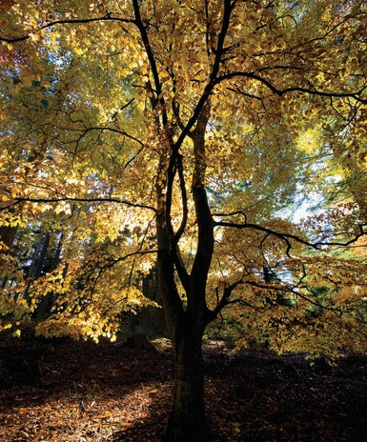
@aberdeenshire

Nature Nurture sessions for Children 5 – 11 years
FOLD

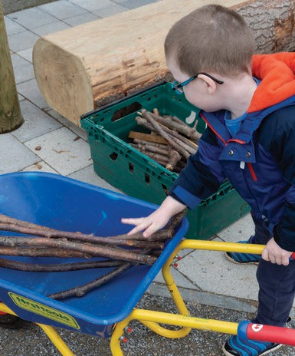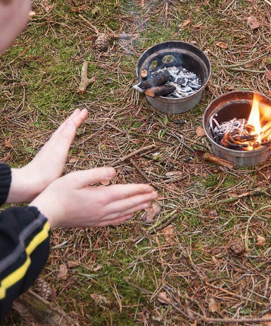
From mountain to sea

FOLD FOLD

Inside Front Cover

What are Nature Nurture sessions?
An opportunity to build relationships with others in nature and learn new skills

Nurture sessions may be one off or part of a longer group of sessions

They will involve group outdoor play sessions with other children from the local area

FOLD
Inside Middle

FOLD
Inside Flap

As a parent/carer you may be invited to take part in family group sessions

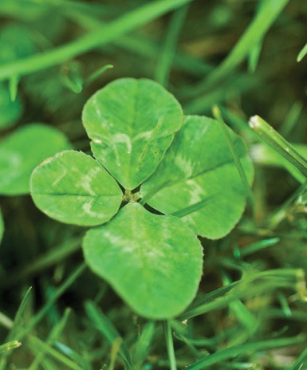

Nature Nurture Practitioners Guidance for Schools January 2023

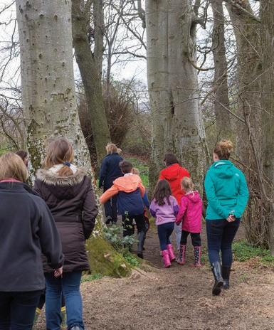What will my child learn?
  - Children will learn new fun skills in a safe, supported environment

  - They will develop coping skills to help manage their emotions and behaviour by taking part in activities with other children

  - The sessions will involve playing games with material found outdoors and learn more about being in nature

  - This will include den building and other craft skills such as fire building skills

FOLD

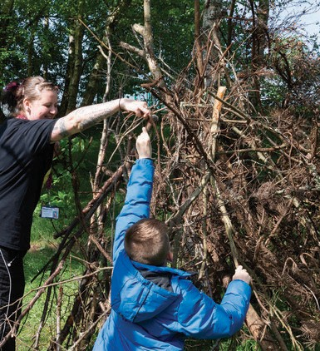

FOLD

