Booking a telephone interpreter: A Visual Guide
This guide takes you through every click of how to add a Skype meeting to your calendar, invite participants and then how to copy a link for the meeting into an email to request a telephone interpreter. There is a guide for if you are using the Outlook App or Outlook 365 on your browser.
Contents
You want to book a call for a future date and time 1
On the Outlook App: 2
On Outlook 365 on your browser: 7

You want to book a call for a future date and time
(For parent meetings etc.)
- Book the call through the EAL Service at least 5 days in advance by following the steps below:
- Confirm the parent’s availability – In the first instance you can send a translated letter (available from the EAL Service) to check their availability for a call at a given date and time. If that does not work, you may need the interpreter to call the EAL parent first to make sure they are free at a specific time and would have access to their phone.
- Set up a skype meeting for the appropriate time and date:

On the Outlook App:
4. Open your calendar and create a meeting on the required day and time:
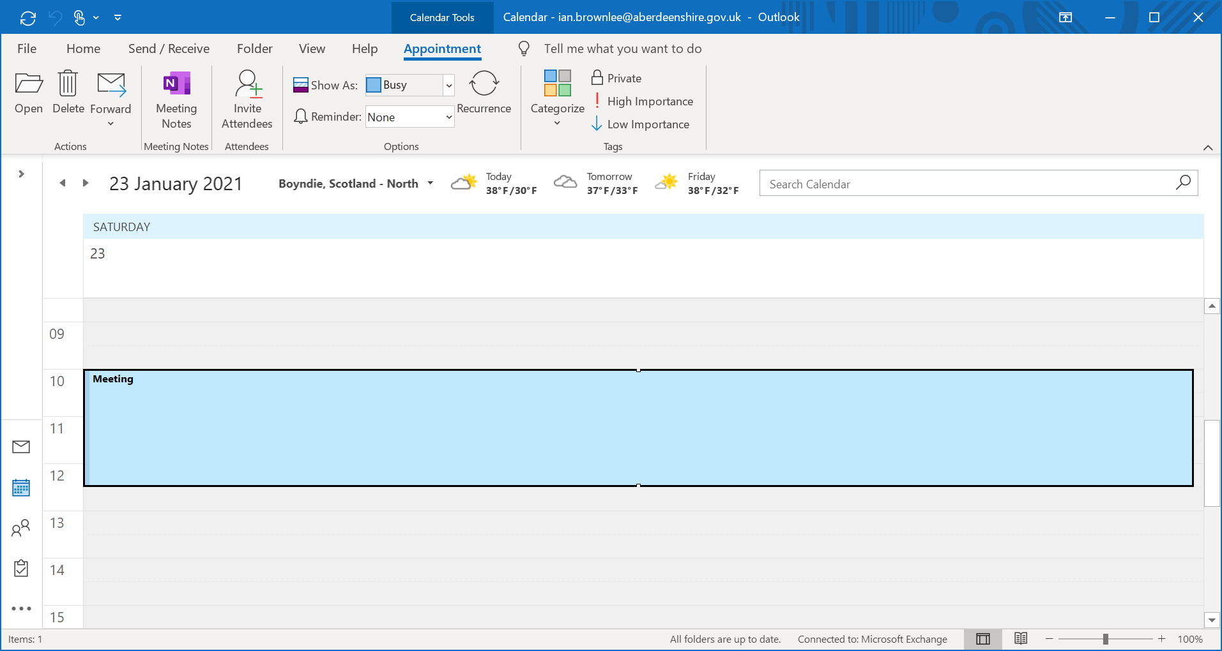
5. Double click on the meeting to open it. Then click on ‘Skype Meeting’
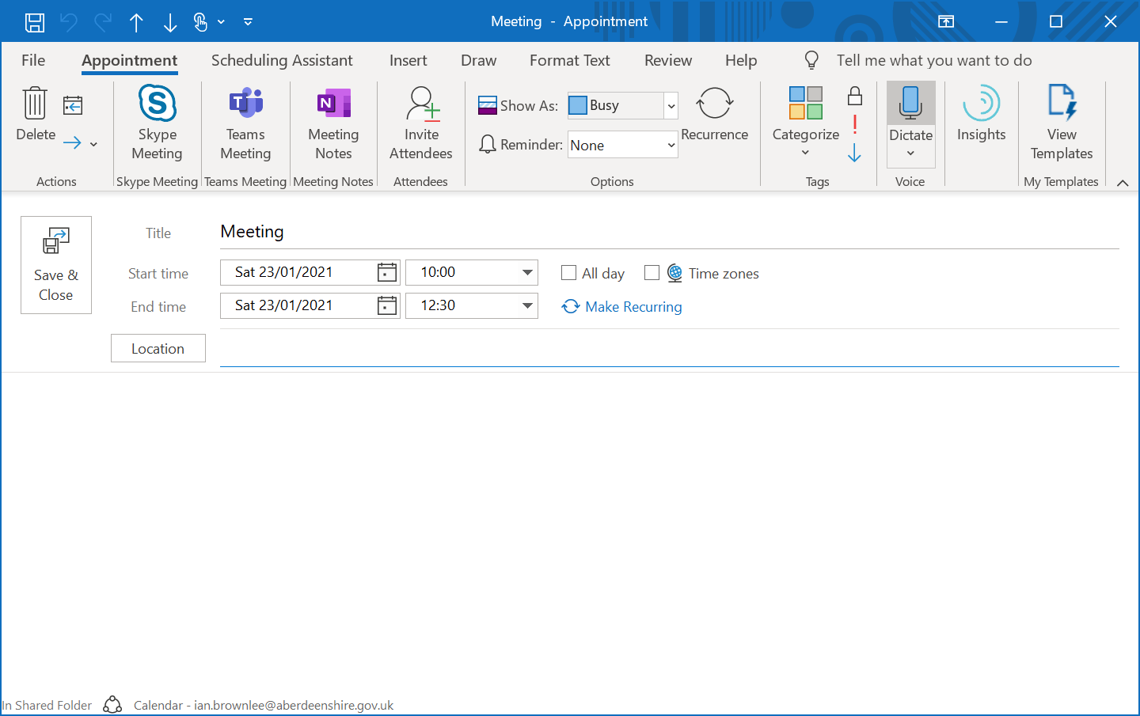

6. Add the names of any school staff who will be attending the meeting.
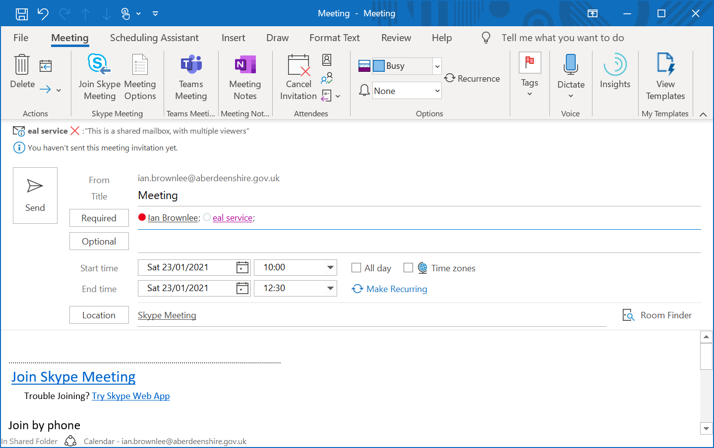

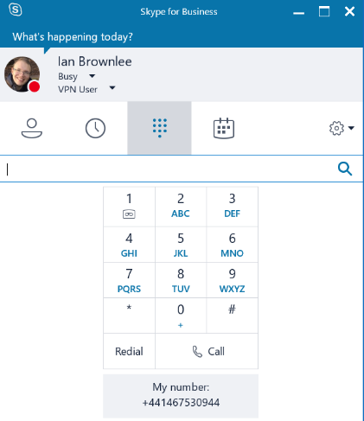
(One of the people on the call must be on an account that can dial to outside telephone numbers, likely admin or SMT).

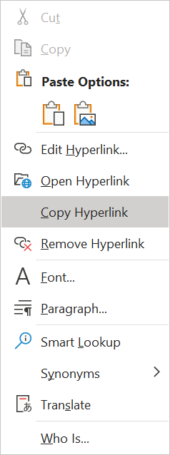
7. Right Click on the ‘Join Skype Meeting option’ and click on ‘copy hyperlink’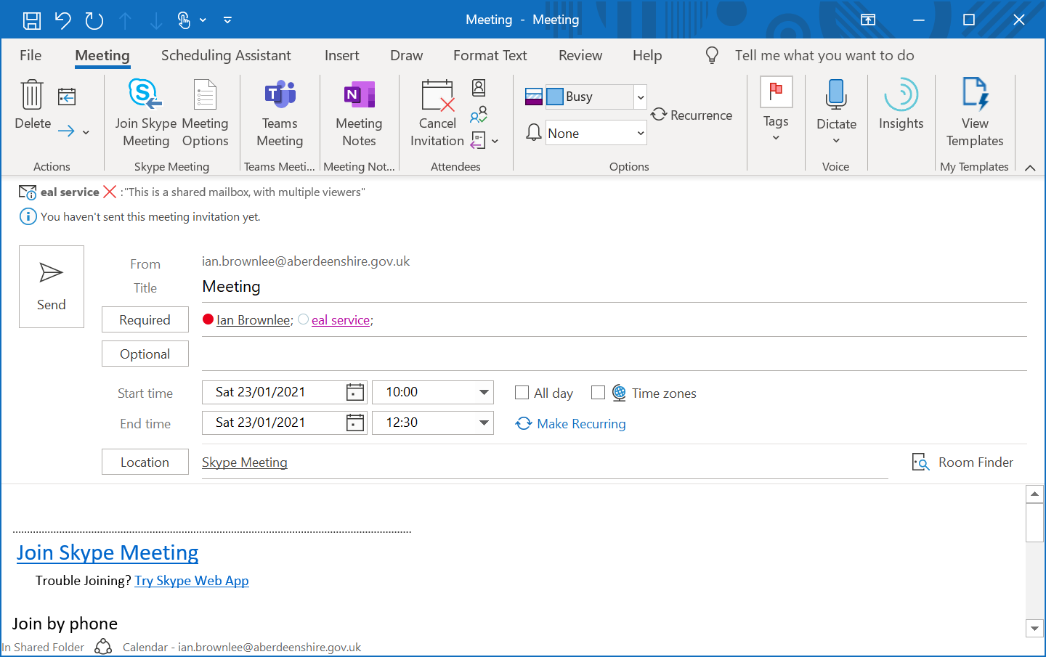

8. Press Ctrl and Click on this Link and an email template should open:
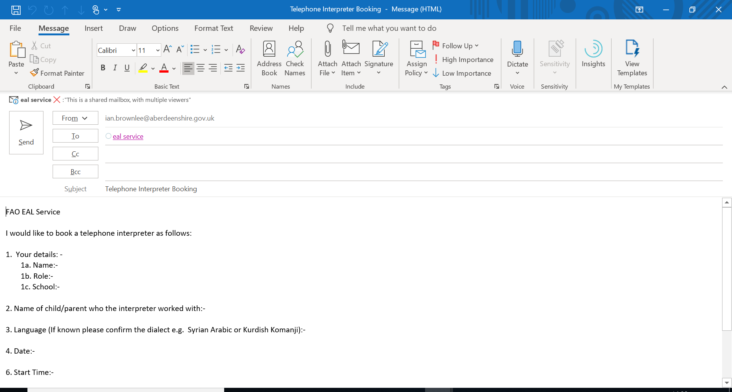

9. Send with completed details of your request, pasting the link for the skype meeting into the relevant question:

10. The EAL Service will get back to you to confirm the booking and give you a job number.
On the day
11. Join the skype meeting a little early to ensure you are there to welcome the interpreter:
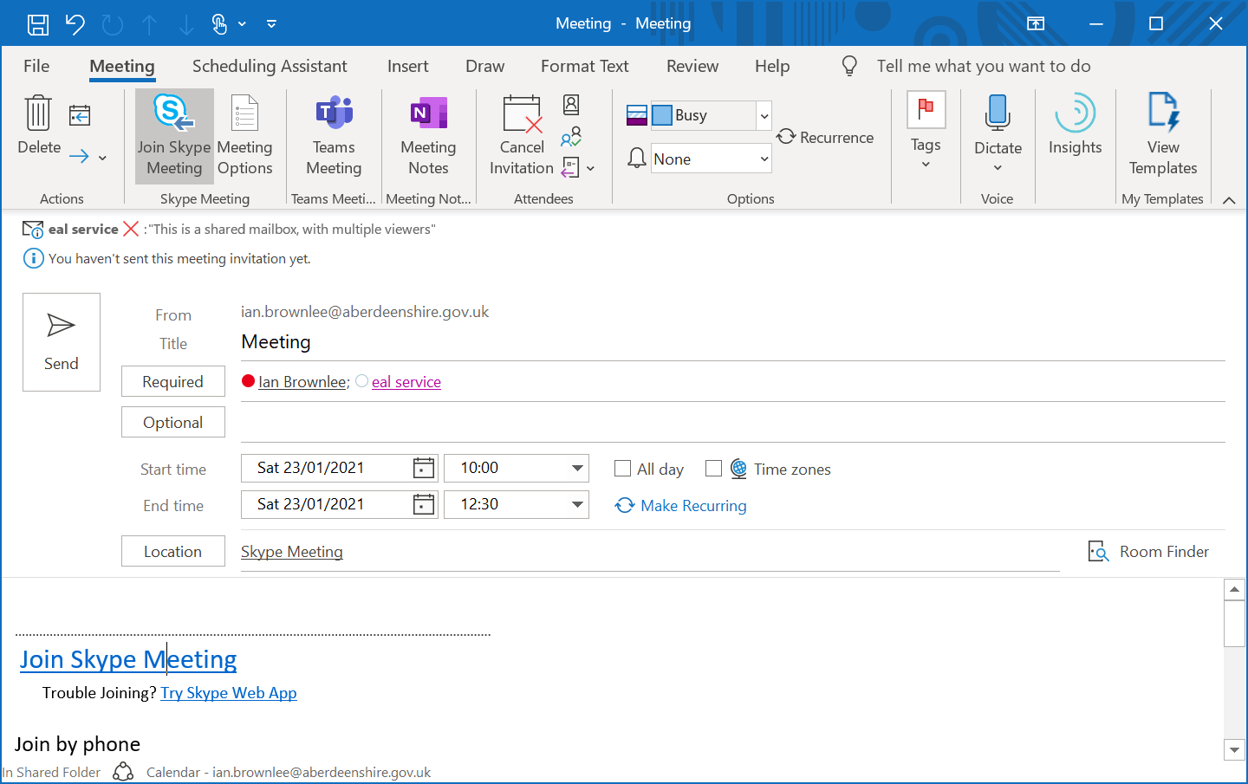
12. Please note the start and end time of the call.
13. Please press Ctrl and Click on this Link to open a receipt email template. Please send details of the call to the EAL Service so we can process payment.
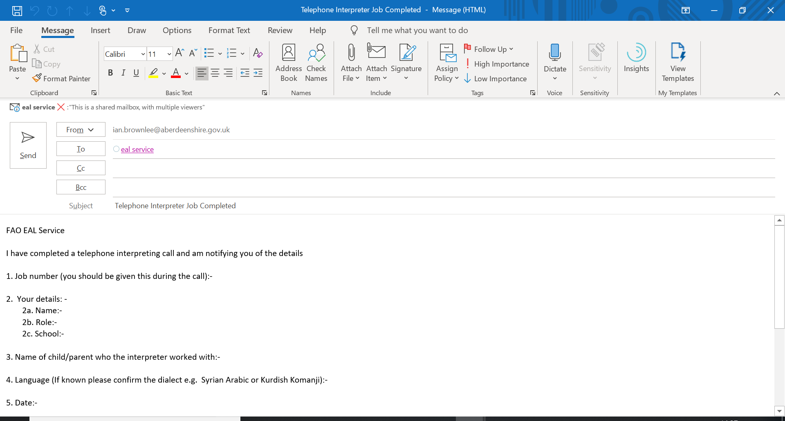

On Outlook 365 on your browser:
4. Open your calendar and create a meeting on the required day and time:
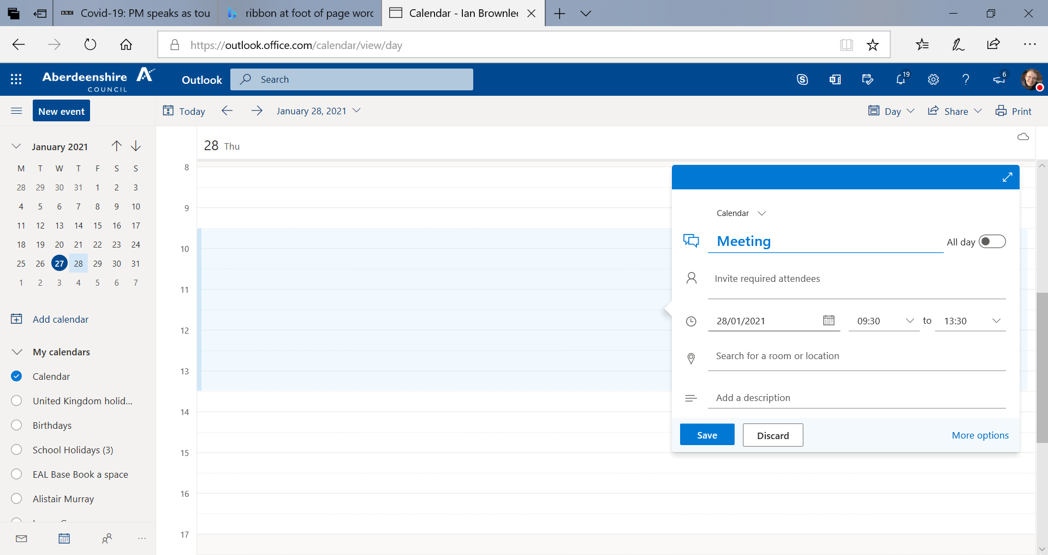

5. Add the names of any staff who will be attending the meeting.

(One of the people on the call must be on an account that can dial to outside telephone numbers, likely admin or SMT).

6. Make the meeting a Skype Meeting as below:

7. Send the meeting Invite by clicking on ‘Send’

8. Double click on the meeting on your calendar
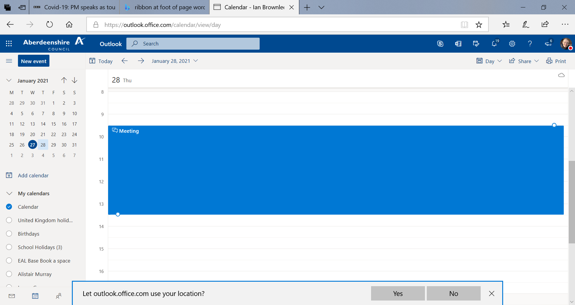

9. Copy the link to the meeting by right clicking on ‘Join online meeting’ and clicking ‘copy link’.
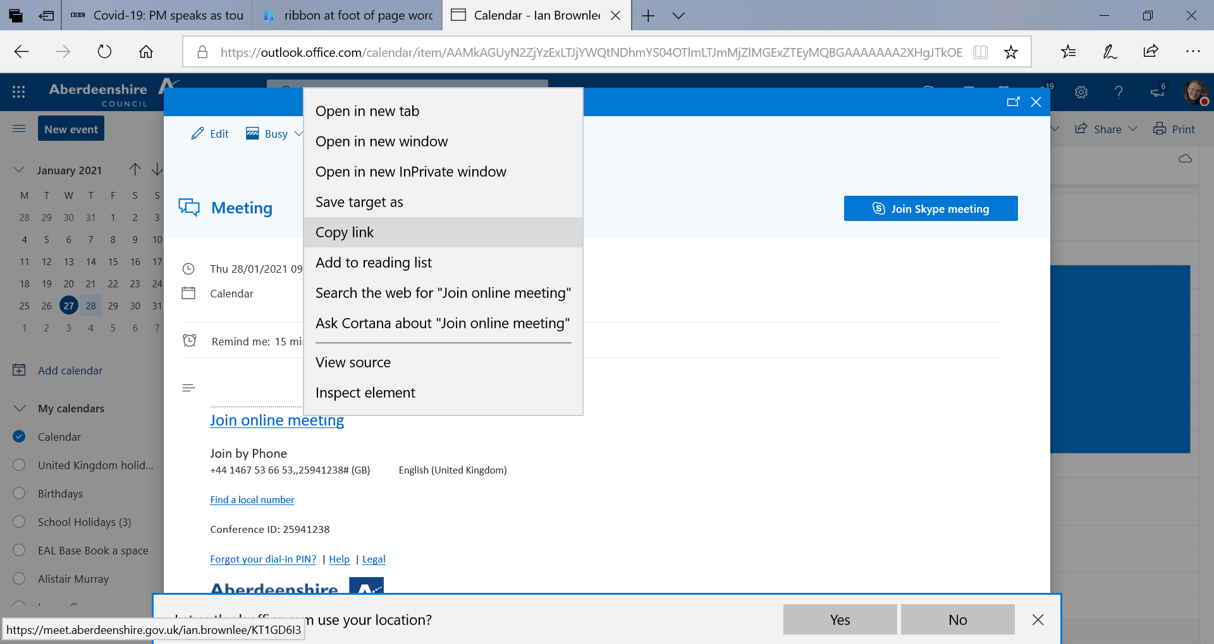

10. Press Ctrl and Click on this Link and an email template should open:

11. Send with completed details of your request, pasting the link for the skype meeting into the relevant question:

12. The EAL Service will get back to you to confirm the booking and give you a job number.

On the day
13. Join the skype meeting a little early to ensure you are there to welcome the interpreter:
14. Please note the start and end time of the call.
15. Please press Ctrl and Click on this Link to open a receipt email template. Please send details of the call to the EAL Service so we can process payment.

