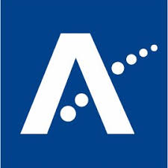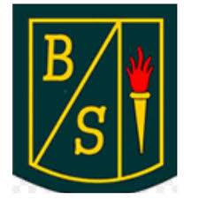
<Name of school> Primary School
Free School Meals

Dear parent/carer,
Due the current public health situation impacting our schools we are introducing an alternative approach to support you and your family applying for Free School Meals. Our aim is to inform you about the potential support we can provide for your children throughout their school experience and give assistance where necessary to apply for this.
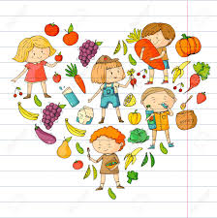
Aberdeenshire Council encourages ALL parents of pupils who qualify to apply for Free School Meals. If your child is in P1-P3 they will currently receive Free School Meals, however, it is encouraged that you do apply if you qualify as it is your right to make an application if you meet any of the criteria. A free school meal is a school lunch we provide free of charge to children from families on a low income. Further support is also available for your family such as School Clothing Grants which are currently £100 per child. Payment of grants will be made direct to your nominated bank account. If your child qualifies for Free School Meals they will also be eligible for a School Clothing Grant.
You can apply by going to this website www.aberdeenshire.gov.uk/fsmscg and completing the online form. Alternatively, please contact Aberdeenshire Council on 01467 533400. If you apply for Housing Benefit/Council Tax Reduction, the application form will also be used to claim for free school meals – you will not be required to complete a separate application. If your child is entitled to free school meals, you will be sent a letter confirming this. Schools are notified directly by the Free School Meals Team and details are updated accordingly.
Free School Meals are linked to the level of benefit/income a family receives, more information and brochures about this are available in the link provided: https://www.aberdeenshire.gov.uk/schools/school-info/assistance/free-school-meals/
Here at <name of school> Primary School we would like to provide support any way that we can and aim to work together with you to give children the best opportunities available to them. If you would like assistance to apply for Free School Meals, then we are happy to support this by phone call and/or email during the time of school closures. If you require any assistance please inform us with how we can help to this email: <school email address> addressed to <member of staff> and we will get in touch with you as soon as possible. There are a variety of ways we can help such as providing interpreters to assist, talk through the application forms, provide guidance with online applications etc.
All information is treated in the strictest confidence and is only held by Aberdeenshire Council. If you have a query regarding Free School Meals, you can also contact the Support and Advice Team via email on fsm@aberdeehshire.gov.uk or on 01467 533400.

<school name> Primary School

