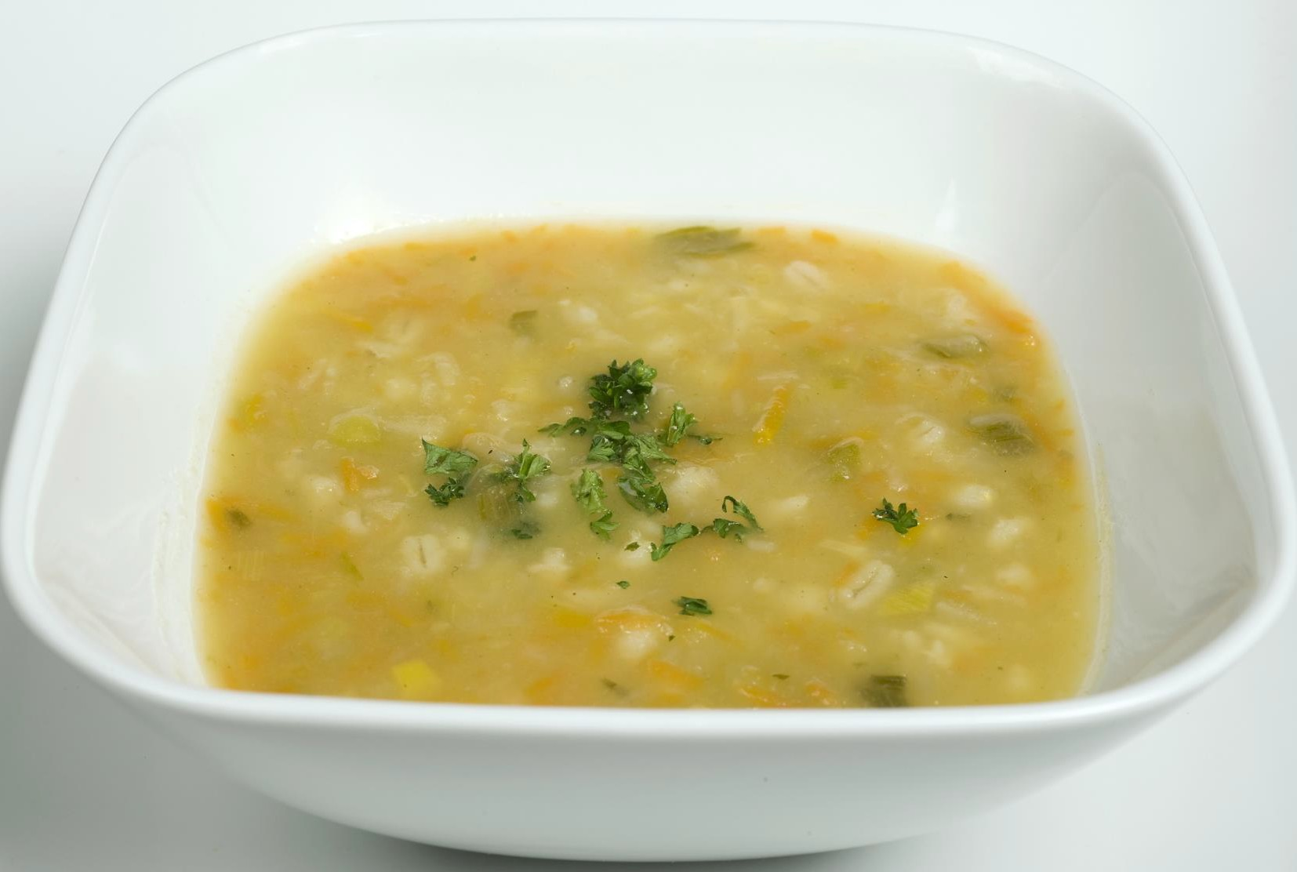
1

From mountain to sea

Supporting Children with Special
Dietary Requirements
Guidance for Schools, Parents and Pupils
September 2017

Contents
SECTION 1 2
Introduction 2
Purpose of the guidance 2
GIRFEC 2
Children with special dietary requirements 3
Principles 3
Support for children with special dietary requirements 4
SECTION 2: Roles and Responsibilities 5
Introduction 5
Roles and Responsibilities 5
SECTION 3: Procedure for Supporting Children with Special Dietary Requirements 7
Notification 7
Meeting and menu 7
SECTION 4: Examples of Special Dietary Requirements 8
SECTION 5: Religious / Cultural Beliefs 11
SECTION 6: Personal Preferences 13
APPENDIX 1: Summary of national food and drink descriptors for texture modification 14
Table 1: Fluids 14
Table 2: Foods 14
High risk foods: 16
APPENDIX 2: Admission Form D 17
Request for Special Diet 17
Details of Special Diet 19
Allergy Details 20
Additional Support Needs 22
Religious Needs 23
APPENDIX 3: Letter to Parent / Carer 24

Visit aberdeenshire.gov.uk

SECTION 1

Introduction
There is a well-established link between good nutrition and high attainment.
The Scottish Executive (November 2002) made recommendations for schools to provide attractive, nutritionally balanced meals for all children; in their vision ‘Hungry for Success – a whole school approach to school meals in Scotland’. This also aims to increase general uptake, eliminate stigma to taking free school meals, and provide an environment that is welcoming and comfortable.
Nutrition standards are described in the Health Promotion and Nutrition (Scotland)
Act 2007
‘Hungry for Success’ recommends development of a policy to cater for supporting children with special dietary requirements.

Purpose of the guidance
This guidance has been written to inform schools / parents / carers of the procedure for managing special dietary requirements in educational establishments and to put in place effective management systems to support individual pupils requiring medically prescribed diets.
Copies of forms are provided as part of this policy and can be photocopied for use by schools / parents / carers.
This guidance is not aimed at any particular sector of the Education and Children’s Services. Its advice will apply equally to local authority pre-five centres, partner provider pre-five centres, primary, secondary, and community resource hubs (all educational establishments referred to throughout this document as ‘schools’).
The guidance does not affect other aspects of food provision controlled by separate policies/guidance or legal requirements. The Service recognises these separate duties and has measures in place to fulfil them.

GIRFEC
Children and young people have their needs assessed on an individual basis and support will be provided as required in line with GIRFEC. The Getting it Right for Every Child (GIRFEC) is a national approach to improving the Wellbeing of children and young people in Scotland. Aims from GIRFEC which particularly apply in this guidance are:
- Improve outcomes for children, young people, and their families
- Put the child or young person at the centre of any assessment, planning and support actively promoting their participation and engagement in any process
- Proactively seeking the views of children, young people, and their families, providing information and support which encourages involvement

Everyday care and help specifies the child’s entitlement for people who provide care to have the ability to nurture including day-to-day physical and emotional care, food, clothing, and housing, meeting the child’s changing needs over time, and listening to the child and being able to respond.
Understanding by family’s background and beliefs specifies: family and cultural history; issues of spirituality and faith. Do the child or young person’s significant carers foster an understanding of their own and the child’s background – their family and extended family relationships and their origins? Is their racial, ethnic, and cultural heritage given due prominence?

Children with special dietary requirements
Schools may at any time have a child/ young person with a support need that requires a special / modified diet as part of the management of that condition. These guidelines clarify rights and responsibilities relating to the provision of meals for children who need to follow a particular diet for health / safety reasons.
Some children have very specific and exceptional dietary and feeding needs. Specific requirements may be included in individual health care plans to help identify the necessary safety measures to support pupils. Detailed procedures on how to draw up a health plan are included in the guidance document “Supporting Children and Young People with healthcare needs and managing medicines in educational establishments” which is available on the Aberdeenshire Council website.

Principles

Whole school approach | Social inclusion
- Children with special dietary needs should be offered a suitable, nutritionally balanced menu by the canteen, and appropriate ingredients  / recipes to ensure inclusion in Home Economics / other curricular activities  - The local circumstances, particularly in secondary, should be taken into account when students may choose to access food providers in the community  - Staff should aim to increase the range of foods eaten by children with selective eating habits  - Provision of special diets should be balanced by the need to maintain quality and variety for all other  children (those without special dietary needs) | - Whilst celebrating diversity, children should not be made to ‘feel’ different. Many alternative menu items may be provided by using modified ingredients, but the similarity of appearance can mask any difference.  - Children, parents, and carers should not be financially disadvantaged by the requirement for a particular diet – some suitable products may be purchased by the school catering service  - A small number of children diagnosed with psychological difficulties with food may not adapt their eating habits as quickly as other children  - Children on a special diet should be encouraged to seek medical supervision. However, requests for special diets due to food intolerances and allergies will be

3

- Management of special diets must be realistic for school catering, teaching, and support staff. | seriously considered even if without a medical opinion.

Support for children with special dietary requirements
Parents / Carers have prime responsibility for their child’s health and should provide schools with information about their child’s medical condition. This information can be captured using FORM D in the Primary and Secondary School Admissions Procedure. Form D is part of the admissions/enrolment forms that parents/carers complete and is included in this document for information. A GP, Community Paediatrician or school nurse may be able to provide additional background information for school staff.
Children may have had contact with dieticians / speech and language therapists / Paediatric Nurse Specialists from NHS Grampian and all of these agencies can provide more specific information, provided parents have agreed to this approach being made. Details should be available on FORM D.

SECTION 2: Roles and Responsibilities

Introduction
It is important that the responsibility for children’s safety is clearly defined, and that each person involved with children with special dietary requirements is aware of what is expected of them. Close co-operation between schools, parents, health professionals and other agencies will help provide a suitably supportive environment for children with special dietary requirements. A positive response to a pupil’s special dietary requirements will not only benefit them but can also positively influence the attitude of other pupils.

Roles and Responsibilities

Person | Responsibility
Head Teacher /  Principal Teacher of Guidance / Pastoral Care / Additional Support for Learning | - First point / lead contact for parents, supply all necessary information to support a request for a special diet  - Issue Form D annually to parents for verification / changes  - Jointly reach agreement with parent / carer and school catering service for school’s role in meeting the special dietary requirement  - Seek parent’s agreement to share information with necessary staff to ensure that classroom activities remain safe for the child  - Seek advice from the school doctor, nurse, dietician, speech and language therapist, Paediatric nurse Specialist, the child’s GP, or the Catering Manager where there is concern that the special diet cannot be met safely or appropriately  - Arrange for parents to discuss practicalities with the cook / catering supervisor  - Ensure catering staff are provided with a photograph of the child and their requirements to be displayed in the kitchen (discreetly)  - Ensure appropriate action is taken in the event of an emergency, as defined, and agreed in the Child’s Protocol  - Where relevant, ensure the dining room environment is autism friendly (avoiding sensory overload)  - Provide appropriate area for gastrostomy feeding and food / equipment storage when required
Parent / Carer | - Provide the Head Teacher with sufficient information about their child’s medical condition and dietary requirements (Form D in the Admissions Procedure)  - Check form D annually, and update at any time as required.  - Inform the Head Teacher of any changes to needs  - Plan with the Head Teacher for school related food requirements (other than lunches) e.g., home economics,  school trips etc.

5

- May provide to catering staff some ingredients of low microbiological risk; clearly labelled with name, best before / use by date
- Seek appropriate advice and support from medical personnel for the special diet
- Reinforce to their own child the need to follow the agreed protocol
Pupil | - Be aware of own requirements (appropriate to developmental level of pupil)  - Not exchange foods with other pupils (if food allergy / intolerance)
Cook / Area Catering Officer | - Discuss with parent the needs of the child, and ensure awareness of which ingredients can be provided by the catering service  - Keep written and updated records of all children relating to their special dietary requirements  - Ensure all catering staff are aware of how to provide the special diet, and ensure information available for relief staff  - Ensure that training is available to catering staff on texture / consistency modification (Appendix 1)  - Make reasonable adaptations to standard menus to ensure that selective eaters on the Autistic spectrum are catered for appropriately  - Maintain confidentiality (data protection)
Catering Service | - Ensure suitable ingredients are purchased by the schools  - Maintain updated information from suppliers regarding ingredients
Health service, General Practitioner, other Health professionals | - School Health Service can provide advice on health issues. The main contact is usually the School Nurse.  - A dietician may support and advise catering and parents/carers on provision of special diets, and train support staff in ways of increasing food acceptance  - Parents may consent to Catering Management contacting their child’s doctor / dietician directly about their child’s condition  - Other Health professionals may also be involved (through multi-agency meetings) in the care of children with dietary health care needs in school e.g., Speech and Language Therapists working with a child with swallowing difficulties or with those on modified consistencies, or a Paediatric Specialist Nurse for those with a gastrostomy  - Training available (from the Gastrostomy Nurse, at Royal Aberdeen Children’s Hospital) for staff supporting those children who require gastrostomy feeding
Additional Support for Learning Staff | - Communicate regularly with parents of selective eaters to establish the best approach to encouraging a wider range of food choices  - Encourage others to model healthy eating habits for selective eaters

Aberdeenshire Council | - Responsible for ensuring that there is provision in place for the delivery of special diets. This will usually be through the  School Catering Service.

SECTION 3: Procedure for Supporting Children with Special Dietary Requirements

Notification
Parents should notify their child’s head teacher that their child has a special dietary requirement, when he/she:
- Is a child registering for nursery or primary 1?
- Is a child moving from another school?
- Has a newly diagnosed condition
- Has an existing condition not previously notified
- There is a change in the child’s dietary requirements
This information should be recorded on FORM D and included in the child’s school health care plan / Pupil Personal Record. Relevant school Health personnel will be involved at this stage.
A copy of FORM D should be forwarded to the Area Catering Officer who will liaise with the school cook. A copy should also be given to the home economics department (secondary) and class teacher (primary) for food preparation information.

Meeting and menu
A meeting with the parent(s), head teacher / appropriate school staff as required, and catering representatives may be helpful to ensure that the caterers are advised of the specific nature of the dietary requirements and for the child to be made known to the cook. A photograph of the child subject to parental consent could be displayed on the kitchen side of the service area to inform all servery staff. Where this is not possible a risk assessment should be undertaken to ensure children requiring a special diet are correctly identified.
When it is agreed that the needs of the child can be safely met, a personally tailored menu will be issued to the child / parents /carers and caterer. This will indicate to the child / parents /carer and caterer the food choices suitable for the child and those that must be avoided. Parents should liaise with the Unit Supervisor / senior catering staff member to agree local arrangements for communication regarding those days that the child will attend for lunch. Supporting information on the specific requirement will be provided to the cook.
Subsequent tailored menus will be provided as the base menu changes.

7

SECTION 4: Examples of Special Dietary Requirements
This guidance provides some general information, but it is beyond its scope to provide more detailed medical advice and it is important that the needs of children are assessed on an individual basis. (FORM D).

Special diets | Guidance notes
Diabetes | - Diabetes is a condition where the person’s normal hormonal mechanisms do not control their blood sugar levels. About 1 in 2500 children of school age has diabetes. Children with Type 1 diabetes may need to have daily insulin injections, monitor their blood sugar and to eat regularly. There are an increasing number of children in Scotland with Type 2 diabetes (formerly known as non-insulin-dependent diabetes); however, the dietary needs of both forms of diabetes are broadly similar.  - Children with diabetes must be allowed to eat regularly during the day. This may include eating snacks during class-time or prior to exercise. Schools may need to make special arrangements for pupils with diabetes if school has staggered lunchtimes. If a meal or snack is missed, or after strenuous exercise, the pupil may experience a hypoglycaemic episode (a hypo) during which his/her blood sugar levels fall to a level which is too low.  - Staff in charge of physical education classes or other physical activity sessions should be aware of the need for pupils with diabetes to have glucose tablets or sugary drink to hand. (See Aberdeenshire’s guidance Supporting children with healthcare needs and managing medicines in educational establishments).  Dietary Management  - Children will have been taught to assess their insulin requirements to accommodate food consumed at snacks and meals. Meals provided by the School Catering Service will always contain several forms of starchy carbohydrate e.g., bread, potatoes, rice, pasta, potato wedges etc., as well as fruit. Children can request larger portions of these foods as necessary to meet requirements e.g., prior to a P.E. session.  - Foods provided by the School Catering Service are not specifically sugar free. However, parents would be welcome to speak to the cook and see recipes, to support their child in making informed choices.  - No special adaptations have been made to the existing school meals menu, as current medical advice indicates that children should be encouraged to eat a “normal” diet.
Coeliac disease | - Coeliac Disease is caused by a reaction to the gluten protein found in some cereals including wheat, barley, and rye and in some cases oats. If a person with coeliac disease eats foods  containing gluten, the lining of the bowel is damaged and mal-

(Gluten free diet) | absorption and growth problems result. The diet required is therefore life-long to prevent recurrence of symptoms.  - Another condition treated with a gluten-free diet is Dermatitis Herpetiformis.  - Gluten is present in a wide range of foods including flour, breakfast cereals, biscuits, pasta, and many manufactured foods. Parents sometimes prefer to send their child to school with a packed lunch. However, the School Catering Service can accommodate the requirements of a gluten free diet provided sufficient notice is given.  - Should a child inadvertently consume food containing gluten, it is not life threatening. However, the pupil may experience a recurrence of the original symptoms.  - Pupils requiring a wheat free diet can also be accommodated
Milk free diet | - Some children cannot digest milk and milk products and require a diet that excludes milk. The problem may be due to intolerance to the milk protein casein or a lack of the enzyme lactase resulting in the inability to digest the milk sugar, lactose. The latter is more likely to be a short-term situation whereas intolerance to milk protein is much longer term.  - Children require a diet that excludes all milk, cheese, yoghurt, and ice cream as well as many manufactured foods that contain milk products.  - The School Catering Service can accommodate a milk free diet provided sufficient notice is given.
Egg free diet | - Some children cannot tolerate the proteins in egg. To avoid symptoms, they require avoiding all egg and egg containing products. Egg is present in a wide range of foods such as pasta, biscuits, and cakes; in addition, egg products are used in many manufactured foods.  - The School Catering Service can accommodate an egg free diet provided sufficient notice is given
Nut free diet | - Peanuts, (sometimes referred to as monkey nuts or ground nuts), and all tree nuts are enjoyed safely by most people. For a small number of people an allergic reaction resulting in anaphylaxis/anaphylactic shock (extreme low blood pressure) means that even minute traces of peanut or any tree nut can cause severe allergic reactions.  - Doctors may use a grading system to categorise the severity of a child’s reaction. For children whose allergy is Grade 2 or worse (on a 0-6 scale, with 6 being the highest risk), a packed lunch and snacks from home are recommended.  - No peanuts will be used in the production of meals in any Primary, Secondary or community resource hub school in Aberdeenshire. However, some recipes may contain tree nuts or derivatives of tree nuts e.g., coconut milk, desiccated coconut, almond essence, unrefined groundnut oil and some products bearing the warnings “May contain a trace of nuts” or “Prepared in a factory that uses nuts” are used and therefore  no “nut free” guarantee can be given.

9

- If the school is informed that a child with a potential anaphylactic reaction attends, then these items can be labelled to highlight the specific potential allergen.
- In secondary schools manufactured products may be sold which contain nuts and should be labelled with warnings.
- Children should be encouraged to read food labels prior to consumption of these food items.
Children with high energy / high fluid requirements | - Dietary advice for some conditions such as Cystic Fibrosis or certain renal conditions may require additional calories or fluid to be consumed at meals or snacks or even in the classroom. This may be contrary to much of the healthy eating advice being promoted in school however it should be recognised that  diet is part of the long-term treatment for these conditions.
Children and young people with other additional support needs – Autistic Spectrum Disorder / Gastrostomy | - Children with additional support needs may have particular problems with food and eating. These could be any of the previously mentioned requirements, sensory issues with food (relating to texture, colour, smell, noise in the dining room etc.), and / or be due to oral motor difficulties. Children with Autistic Spectrum Disorders may be highly selective in food choices due to their need for structure and repetition in many aspects of their lives. These children are not being awkward of fussy –snack time and lunchtime can be extremely stressful. Increasing dietary choices can be a very difficult task requiring persistence and patience, and a collaborative and phased approach.  - Children with oral motor difficulties may need food consistencies to be modified for safety (Appendix 1)  - Children with a gastrostomy will require a specialist procedure and feeds. Their requirements will be met and monitored by trained personnel  - As far as possible, eating difficulties should not exclude a child from enjoying school meals / Home Economics lessons. Catering staff can provide meals of the necessary consistency or simply provide additional gravy / sauce or custard for a PSA to modify food at the table.  - Following consultation with the school and provided necessary criteria are in place, it may be possible for parents / carers to supply food for re-heating by the School Catering Service in order to meet very specific dietary requirements (e.g., for children with an extremely limited diet due to medical and sensory issues).  - Some children have difficulty reading or find it difficult to visualise what food will look like. Use of visual images by the school should be available to assist children to make choices independently.
Eating disorders | - Children with eating disorders e.g., Anorexia or Bulimia should be treated with great sensitivity, making provision appropriate to their requirements such as small portions, quiet dining area, and an earlier lunchtime to avoid large numbers eating  together etc. PSAs may benefit from additional training to support children with special dietary needs.

Special dietary products | - While the School Catering Service will endeavour to meet the needs of children, it will not provide special dietary products  e.g., gluten-free pasta or soya milk. Parents should provide these as necessary in liaison with the Unit Supervisor / senior catering staff member.

SECTION 5: Religious / Cultural Beliefs
This section provides some general advice for children whose dietary requirements arise from religious, cultural, or personal beliefs.
In most instances appropriate choices within the school lunch menu will accommodate the needs of the pupil. Religious and cultural requirements need to be considered in Home Economics and other curricular activities using food ingredients, and suitable alternatives offered. It may be forbidden or undesirable to handle certain foods, and exposure to cooking during times of fasting needs careful consideration.
Muslim community - Muslims may only eat meat which is ‘halal’ (permissible due to the way in which the animal is killed). They do not eat pork or pork products (gelatine). Fish with fins and scales are halal. Separation of forbidden and permissible foods is very important. Muslims may fast during Ramadan.
Jewish Community - Laws of ‘Kashrut’ govern the slaughtering of animals and types of dishes prepared for different events. Pork is forbidden, and other foods must be prepared in a particular way (kosher). Fish with fins and scales may be eaten. Meat and dairy products may not be eaten together and must be prepared separately.
Hindu Community - Orthodox Hindus are vegetarian, some may be vegan, and others do not eat onions or garlic. Less strict Hindus may eat mutton, poultry, fish and occasionally pork, but never eat beef. They may observe periods of fasting.
Sikh Community - Strict Sikh’s do not eat meat, although the religion does not specify vegetarianism. Those who are not vegetarian will eat mutton and poultry; but do not eat beef and may not eat pork. Animals have to be slaughtered by rites known as ‘jhatka’.

11

The following briefly describes specific dietary requirements of some local communities:

Food | Muslim | Jewish | Hindu | Sikh
Beef | Halal | Kosher | X | X
Lamb | Halal | Kosher | X | ✓
Pork / port products | X | X | X | X
Chicken | Halal | Kosher | X | ✓
Turkey | Halal | Kosher | X | ✓
Duck | Halal | Kosher | X | ✓
Fish | - (with fins / scales) | - (with fins / scales) | X | X
Shellfish | X | X | X | X
Cheese | ✓ | ✓ | ✓ | ✓
Vegetables | ✓ | ✓ | ✓ | ✓
Pulses | ✓ | ✓ | ✓ | ✓
Eggs | ✓ | ✓ | ✓ | ✓
Milk | ✓ | ✓  (meat must not be cooked with milk products) | ✓ | ✓
Fats / oils | Oil / ghee | - no pork fats | Oil / ghee | Oil / ghee

SECTION 6: Personal Preferences
Many young people make changes to their food intake in response to their own opinions and beliefs. A varied menu choice is available, but the service cannot guarantee to provide for all personal preferences. Provision is made for vegetarian diets by school canteens and can be accommodated in Home Economics / other curricular activities by offering alternative ingredients for recipes. Alternatives may be offered and enjoyed by all children.

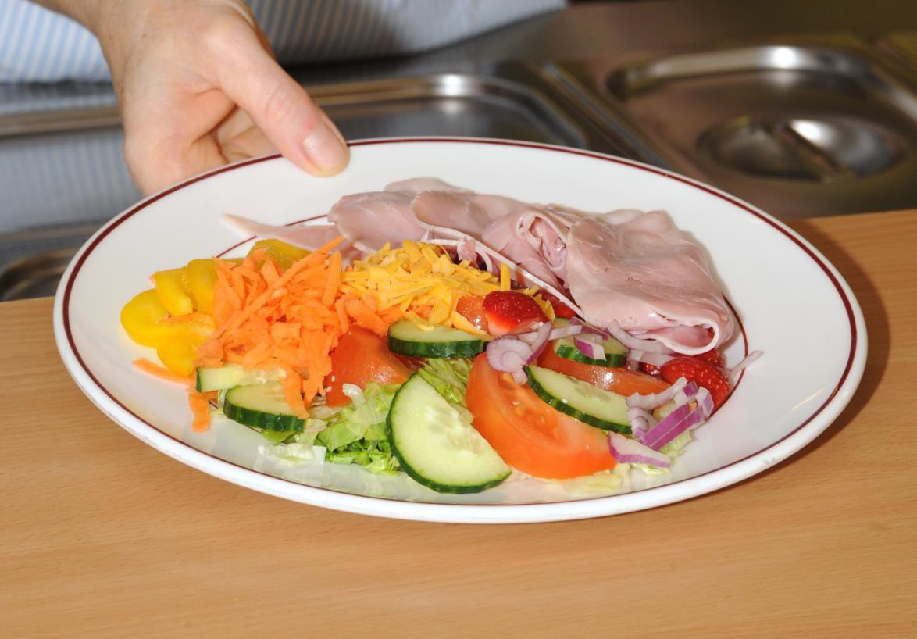

13

APPENDIX 1: Summary of national food and drink descriptors for texture modification

Table 1: Fluids

Texture | Description of Fluid Texture | Fluid Example
Thin Fluid | Still Water | Water, tea, coffee without milk, diluted squash
Naturally Thick Fluid | Product leaves a coating on an empty glass. | Full cream milk, Complan,  Build-up, commercial sip feeds
Thickened Fluids | Fluid to which a commercial thickener has been added to thicken the consistency.
Stage 1 =  (may also be referred to as Syrup) | Can be drunk through a straw  Can be drunk from a cup if advised or preferred  Leaves a thin coating on the back of a spoon.
Stage 2 =  (may also be referred to as Custard) | Cannot be drunk through a straw Can be drunk from a cup  Leaves a thick coating on the back of a spoon
Stage 3 =  (may also be referred to as Pudding) | Cannot be drunk through a straw Cannot be drunk through a cup  Needs to be taken with a spoon

Table 2: Foods

Texture | Description of food texture | Food Examples
A | - A smooth, pouring, uniform consistency  - A food that has been pureed and sieved to remove particles  - A commercial thickener may too added to maintain stability  - Cannot be eaten with a fork | - Tinned tomato soup  - Thin custard

B  (may also be referred to as thin puree / smooth diet) | - A smooth, uniform consistency  - A food that has been pureed and sieved to remove particles  - A commercial thickener may be added to maintain stability  - Cannot be eaten with a fork  - Drops rather than pours from a spoon but cannot be piped and layered  - Thicker than A | - Soft whipped cream  - Thick custard (or tinned)
C  (may also be referred to as thick puree / smooth diet) | - A thick smooth, uniform consistency  - A food that has been pureed and sieved to remove particles  - A commercial thickener may be added to maintain stability  - Can be eaten with a fork or spoon  - Will hold its own shape on a place, and can be moulded, layered, and piped  - No chewing required | - Mousse  - Smooth fromage fraise
D  (may also be referred to as easy chew or minced / mashed diet) | - Food that is moist, with some variation in texture  - Has not been pureed or sieved  - These foods may be served or coated in a thick gravy or sauce  - Foods easily mashed with a fork  - Meats should be prepared as texture C  - Requires very little chewing | - Flaked fish in a thick sauce  - Stewed apple and thick custard
E  (may also be referred to as soft, moist diet) | - Dishes consisting of soft, moist food  - Foods can be broken into pieces with a fork  - Dishes can be made up of solids and thick sauces or gravies  - Avoid foods which cause a choking hazard (See list of high-risk foods) | - Tender meat casseroles (approx. 1.5cm diced pieces)  - Sponge and custard

15

Normal | Any foods | - Includes all foods from "high risk foods" list

High risk foods:

  - Stringy, fibrous texture for example pineapple, runner beans, celery, and lettuce.
  - Fruit and vegetable skins including beans for example broad, baked, soya beans, peas, grapes.
  - Mixed consistency foods for example cereals which do not blend well with milk (muesli), mince with thin gravy, soup with lumps.
  - Crunchy foods for example, toast, flaky pastry, dry biscuits, and crisps.
  - Crumbly items for example, bread, crusts, pie crusts, pastry, crumble, dry biscuits.
  - Hard foods for example, boiled, chewy sweets and toffees, nuts, and seeds.
  - Husks for example sweet corn and granary bread.

Reference: "National Descriptors for Texture Modification in Adults" The British Dietetic Association, April 2009.

APPENDIX 2: Admission Form D

Request for Special Diet

This form is for parents to complete if your child has a special dietary requirement. The information provided will be used to inform the School (including Home Economics department) and School Caterers when providing meals for your child.

Section 1: Details of Pupil

Surname
Forenames
Address
 |  | Postcode
Male/female |  | Date of Birth
Class/form
Special dietary requirement

Section 2: Contact Details

Name
Daytime Tel No
Relationship to pupil
Address
Postcode

Section 3: Medical Details
I understand that by providing these details I am happy for School Catering to make contact for further information

Name | Designation | Address | Contact Tel. No
 | General practitioner
 | Community Paediatrician
 | Speech and Language Therapist
 | Paediatric Specialist Nurse
 | Other, please specify…

Parent/carer/child signature:

Signed: ......................................................................Date: ...........................................

Details of Special Diet

SCHOOL:
PUPIL NAME:
CLASS:

SPECIAL DIETARY REQUIREMENT / FOOD ALLERGIES
The School Catering Service, and other school departments are committed to making provision for medically prescribed diets, children with special educational needs which affect their diet, children requiring vegetarian options and children with religious or cultural restrictions. The following questions will help inform the School about how your child can best be supported.
Please complete the appropriate sections as necessary and name each one as they may be separated to go to the relevant staff / departments.

SECTION A
Does your child have a medically prescribed dietary requirement? YES / NO
If you have ticked YES please answer the following questions:

If NO go to Section B

- Which of these apply?

Allergy | Yes/no | PLEASE PROVIDE MORE DETAIL OF ALLERGIES ON PAGE 19
dairy free
egg free
wheat free
gluten free
nut free
diabetes
coeliac disease

- Any other requirements? Please give details

- Do you use any special dietary products with your child? YES / NO
Please give details

- Which of these products are prescribed?

- Do you have a prescribed diet plan for your child? YES / NO

- Who provides this for your child? Please provide contact details

............................................................................................................................

Written details from a Medical Practitioner/Dietician may be required to ensure that the Catering Service can safely meet the needs of your child

Allergy Details

SCHOOL:
PUPIL NAME:
CLASS:

SECTION A – ALLERGY DETAIL

The following information is required by the School Catering Service, the Home Economics department, and may be needed by staff teaching other curricular areas. Please provide as much detail as possible.

Foodstuff | Can be eaten? | Can be touched? | Can be in the room? | Possible symptoms of reaction | Action to be taken
Eggs
Cow’s milk & products
Tree Nuts
Peanuts

Sesame seeds
Wheat
Gluten
Shellfish
Fish
Soya
Vegetables – please specify
Fruit –
please specify
Pulses –
please specify
Other – please specify
Does your child carry allergy medication?
e.g. (EpiPen / Piriton / Inhaler / other? YES / NO Can your child self-administer their medication? YES / NO Medication carried:

IT IS THE RESPONSIBILITY OF PARENTS / CARERS AND THEIR CHILD TO ENSURE THAT THIS INFORMATION IS UPDATED AND THE SCHOOL IS AWARE OF SPECIAL DIETARY REQUIREMENTS.

Additional Support Needs

SCHOOL:
PUPIL NAME:
CLASS:

SECTION B
Does your child have a support need that affects their eating? YES / NO
If you have ticked YES please answer the following questions.

If NO, go to Section C

- Please indicate the need from the list below
  - Texture / Consistency modification
  - Limited food range
  - Reading menu
  - Help with eating/drinking
  - Help with food selection

- Any other requirements? Please give details

- What dietary modification do you follow at home? Please give details

Please provide further information that would be helpful

Religious Needs

SCHOOL:
PUPIL NAME:
CLASS:

SECTION C
Does your child have a religious need that may require modified food products?

YES / NO
Please indicate which products require substitution / omission

Please provide further information that would be helpful

APPENDIX 3: Letter to Parent / Carer

Education and Children’s Services Our Ref:
Your Ref:
Please ask for:
Direct Dial:
E-mail:

Date

Address

Dear Parent/Carer/Young person

SPECIAL DIETARY REQUIREMENTS

Thank you for providing information on the dietary requirement for your child/ your own needs. To ensure that your child’s/ your own dietary requirement can be safely met through the School Meals Service it may be helpful for catering staff to contact your child’s/ your own dietician/GP/private practitioner for further advice.

I would therefore be grateful if you would complete the attached form to enable this to take place.

Yours sincerely

Name and designation

Guidance written Education and Children’s Services Additional Support Needs Team

Version | Status | Issue date | Reason
1.0 | Guidance | 06.02.2013 | Guidance written
2.0 | Guidance | 17.06.2016 | Guidance review and update
2.1 | Guidance | July 2017 | Further update and transfer to new corporate design
2.2 | Guidance | September  2017 | Addition of information on GIRFEC approach and enable hyperlinks

