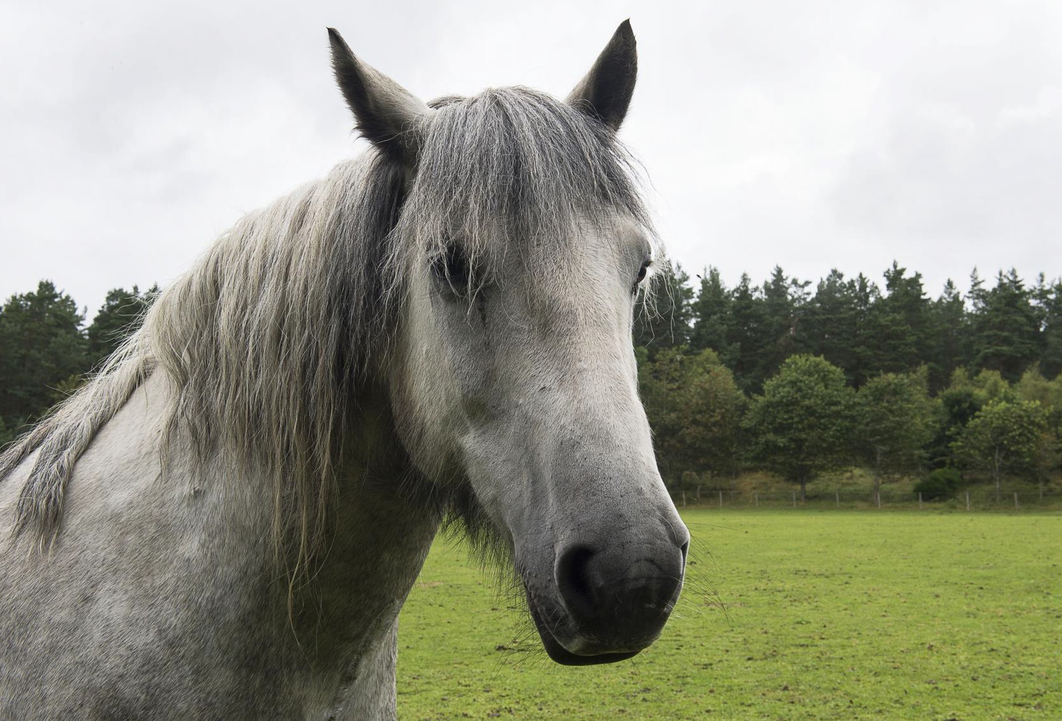
1

From mountain to sea

HORSE RIDING (RDA) FOR PUPILS
WITH ADDITIONAL SUPPORT NEEDS

Guidance to schools
December 2017

Contents
Introduction 3
GIRFEC 3
Benefits of Riding for the Disabled 3
Criteria for Selection of Pupils 4
Process of arranging access to RDA lessons 5
The RDA Tracker 5
Funding Arrangements 6
Riding for the Disabled Association lessons 6
Transport 6
Staff to support pupils 6
Moving and Handling 6
Risk Assessments 7
Appendix 1: GIRFEC information and the 5 questions 8
Appendix 2 Checklist and information for horse riding 10
Appendix 3 The RDA Tracker 12
Appendix 4 MOUNTING AND DISMOUNTING 14
Appendix 5 RISK ASSESSMENT POLICY 19
This guidance was created by Education and Children’s Services Additional Support Needs Team

Version | Status | Date | Reason for update
2.0 | Guidance | 2013 | Previous documents out of date
3.0 | Guidance | May 2017 | Update due to agreement with staff to act as education representatives for RDA and new terminology/designations
3.1 | Guidance | September 2017 | GIRFEC information and enable hyperlinks
3.2 | Guidance | December 2017 | Update including risk assessments and handling information from RDA
Visit aberdeenshire.gov.uk

Introduction
A number of pupils with additional support needs attending Aberdeenshire schools participate in horse riding through the Riding for the Disabled Association (RDA).
The purpose of this guidance is to ensure equity of provision for all pupils by providing information and advice to schools on criteria for selection of pupils, the process for arranging access to RDA through the Authority and with individual RDA centres, and arrangements for funding.

GIRFEC
Children and young people have their needs assessed on an individual basis and support will be provided as required in line with GIRFEC. The Getting it Right for Every Child (GIRFEC) is a national approach to improving the Wellbeing of children and young people in Scotland.
Specific indicators relevant to this guidance are:
- Improve outcomes for children, young people, and their families.
- Increase prevention and earlier intervention so all children and young people are supported to achieve their potential
- Achieve high standards of multi-agency working, based on a co-ordinated approach to identifying Wellbeing concerns, assessing need, and agreeing outcomes and actions.
Please refer to Appendix 1 for more information about GIRFEC and the 5 questions, together with website links.
Allied Health Professionals provide targeted interventions to secure outcomes as detailed in Ready to Act (participation and engagement, early intervention and prevention, partnership and integration, access, and leadership for quality improvement). There is a statutory requirement for education authorities and their partners to work together to ensure the wellbeing needs of the child/young person as detailed in the Children and Young People (Scotland) Act 2014.

Benefits of Riding for the Disabled
The walking horse produces 1000 movements in three dimensions in 10 minutes. This requires the rider to make an active response to the movement in order to stay in balance. The movement of the horse is the same as the movement of normal walking, therefore it stimulates the activity of the muscles used in walking. Where sitting balance is achieved the rider’s hands are freed for skilled activity and social skills can be developed. This allows the rider to become proactive, to affect the movement of the horse and to achieve an increasing degree of independence.
Where children and young people have a physical disability, the movement of the horse will therefore improve balance and coordination. For those with multiple disabilities, the effect of the movement of the horse will have a positive effect in normalising movement. However, if the rider does not have head / trunk control or has a reduced degree of head / trunk control, advice would be sought from the RDA ACPTR qualified physiotherapist for the Region. There are some conditions for which riding would be detrimental, and therefore not appropriate.

Children and young people with learning delays and difficulties can also benefit from riding. Balance and coordination must be learnt together with a requirement for concentration on the task to achieve a positive outcome. The enjoyment and motivation from these achievements are important in developing confidence and positive self-esteem.
Children and young people with Autism Spectrum Disorder benefit from riding due to the fact that the environment in which riding takes place is conducive to the development of social skills. The riders work with helpers and instructors who are interested in the welfare of the horse as well as the rider and can share this enthusiasm. Riders are expected to show respect for the horse and to acknowledge the help they are getting from the volunteers. These are important social skills.
In the first instance youngsters may find it easier to establish a form of communication with a horse which does not respond verbally. This skill in turn supports development of communication with human adults and peers. Youngsters can be taught to notice the non-verbal communications from horses such as ears back or forwards, eyes calm, head up or down and learn the meaning behind these subtle messages. The ability to understand body language is very important to human interactions.

Criteria for Selection of Pupils
Participation in horse riding should enable pupils to benefit more fully from the education provision available to them.
Recommendation for participation should be on a multiagency basis and may include advice from the education psychologist, community paediatrician, occupational therapist, physiotherapist, Child and Adolescent Mental Health Services (CAMHS), social work or another agency working with education to meet the needs of the child / young person.
All pupils participating must therefore have an Individual Education Plan (IEP) which clearly specifies an objective for which horse riding is an appropriate resource.
The IEP should specify:
- The target/s supported by horse riding
- The duration and frequency of riding lessons
- Clear success criteria
- How these are to be monitored
Review of the targets should be in line with IEP review, and a decision to continue or cease the riding will be made in response to progress.
Due to the demand for places at RDA sessions, it is unlikely that a child/young person will continue to ride for more than 2 years other than in exceptional circumstances.

Process of arranging access to RDA lessons
There are two components to this:
  - Agreement and funding of the RDA place with the authority
  - Application to the local RDA centre for a place for the pupil to attend
Agreement with the authority would be recorded through submission of the checklist in Appendix 2, which should be passed to the education representative for the RDA group to which the pupil is applying. For each RDA group there is an educational representative who is either a PT ASL (academy) or DHT in a primary/special school/community resource hub.
The checklist enables the authority to keep track of the number of pupils, duration of individual support and the distribution of places according to needs throughout Aberdeenshire. This is in-line with the Additional Support Needs (Education) (Scotland) Act 2004 amended 2009, and The Equalities Act 2010.
Application to individual RDA centres is then progressed by the school contacting the local centre, and submitting necessary RDA paperwork which is sourced from their website: http://www.rda.org.uk
Current forms from the RDA consist of an application for riding/vaulting, and a medical form to be completed by parents/GP. Please see: http://www.rda.org.uk/runningyourgroup/ to obtain the forms.
A child / young person may be put on a waiting list by the RDA if all places are taken at that time.
If there is a high priority for a place due to an urgent additional support need, the school may also contact the local education representative who can negotiate with the RDA and other schools using the RDA facility to try to make a place available as soon as possible.

The RDA Tracker
RDA have produced their own tracker to describe progress in the following six areas: communication, physical changes, relationships, horsemanship, confidence, and enjoyment. Schools will have targets for pupils in one or more of these areas, but horsemanship/enjoyment alone would not be appropriate. The child’s additional support needs would require targets in areas such as communication, social skills, posture/movement, confidence and/or self-esteem.
School IEP targets are positively worded for each child and begin from a current point of achievement. School targets for communication, relationships and physical skills are likely to have been devised in collaboration with allied health professionals. School staff must share their objectives for each child with the RDA coordinator and volunteers in order to ensure that everyone is clear about the aims of the sessions, and schools are responsible for tracking and monitoring progress against the specific IEP target.
Understanding by RDA volunteers should have been facilitated by the development of the tracker and education staff can now be confident of using terminology that is understood by both schools and RDA supporters.

A copy of the tracker is in Appendix 3

Funding Arrangements
There are three aspects to funding:
- Riding for the Disabled Association lessons
- Transport
- Staff to support pupils
To ensure equity for all schools the following arrangements are in place:

Riding for the Disabled Association lessons
These will be fully funded by the Authority. Invoices should be sent to: The Quality Improvement Manager (Additional Support Needs) Aberdeenshire Council,
Woodhill House, Westburn Road, Aberdeen AB16 5GJ

Transport
This will not be funded by the Authority (other than in exceptional circumstances when a decision may be taken at authority level by a Quality Improvement Officer for an individual circumstance), as all support will be directed towards supporting the cost of lessons.
Schools may wish to offer financial support for transport to children from low-income families whose parents are in receipt of benefits, should this be required to permit attendance. This will be at the discretion of the head teacher and sourced from school funds.

Staff to support pupils
Schools may choose to allocate a member of the support staff from their team to accompany youngsters, at the discretion of the headteacher.

Moving and Handling
The RDA guidance on their Moving and Handling of children/young people may be found in Appendix 4 and on their website.

Risk Assessments
The RDA policy and proformas for risk assessment may be found in Appendix 5 and on their website. Your local RDA group should provide you with a copy of their completed risk assessment.

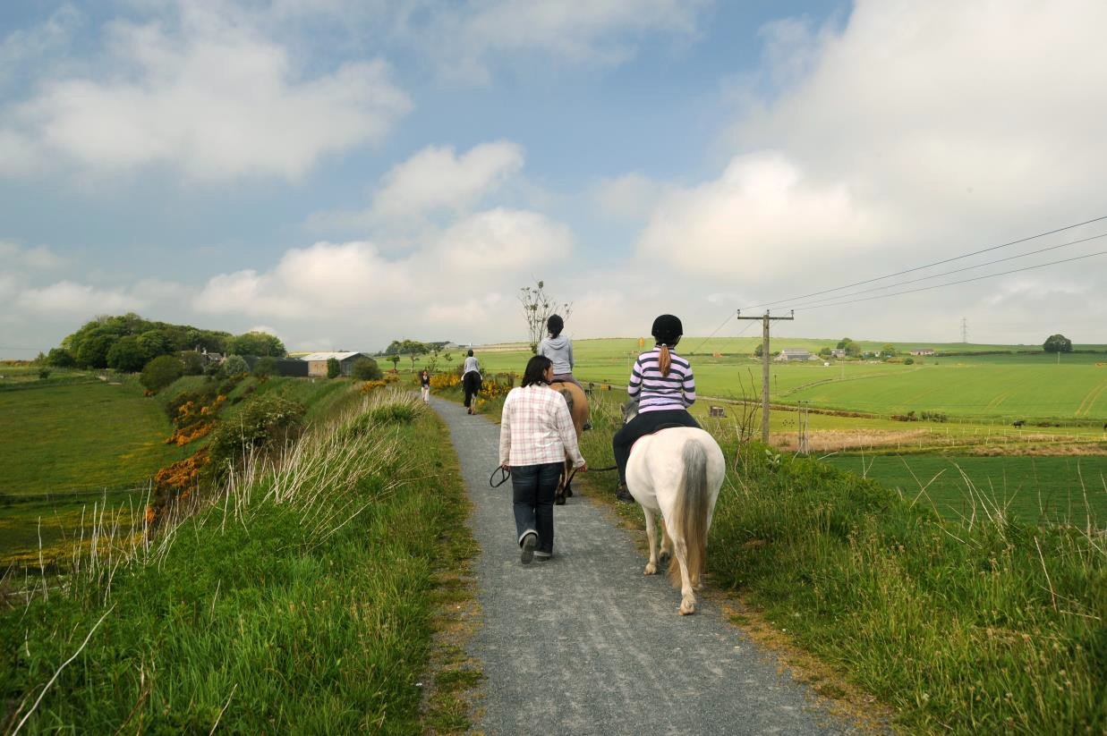

Appendix 1: GIRFEC information and the 5 questions

GIRFEC sets out a vision which aims to:

  - Improve outcomes for children, young people, and their families.
  - Put the child or young person at the centre of any assessment, planning and support, actively promoting their participation and engagement in any processes.
  - Proactively seek the views of children, young people, and their families, providing information and support which encourages involvement.
  - Promote shared language through a National Practice Model providing a consistent approach to safeguard, ensure and promote the Wellbeing of children and young people.
  - Streamline assessment, planning and decision-making processes via a single planning framework – called the Child’s Plan – to ensure a consistent approach to how a range of extra support that is not generally available should be planned, delivered, and coordinated around an individual child’s needs and circumstances.
  - Increase prevention and earlier intervention so all children and young people are supported to achieve their potential
  - Achieve high standards of multi-agency working, based on a co-ordinated approach to identifying Wellbeing concerns, assessing need, and agreeing outcomes and actions.
  - Maximise the skills of the Universal Services workforce, and focus targeted and specialist services to meet the needs of children and young people where higher thresholds of risk and need exist
  - Embed individual and unique professional responsibility and accountability towards supporting children and young people
  - Support proportionate and considered sharing of Wellbeing information, in line with Data Protection, other legislative requirements, confidentiality and the views of families.
  - Ensure a Named Person is available as a central point of contact for children, young people and parents, to provide advice, information, and support, and help to access other services if and when needed
  - Identify a Lead Professional where a Child’s Plan is in place, to co-ordinate and monitor progress of actions and improved outcomes.

The Five GIRFEC Questions
A child or young person’s Wellbeing is influenced by everything around them, and by different needs they will have at different points of their life. Wellbeing concerns may arise from a child or young person’s individual experiences or circumstance or be posed by the impact of a family member or significant person’s situation (this could include a non-resident partner of a parent/carer, or a peer).

When a Wellbeing concern is identified or raised for a child or young person, you should ask yourself the 5 GIRFEC questions:

What is getting in the way of this child or young person’s wellbeing?

Do I have all the information I need to help this child or young person?

What can I do now to help this child or young person?

What can my service or organisation do to help this child or young person?

What additional help, if any, may be needed from others?
If you don’t have all the information you need, you may need to gather further information either by speaking with the child or young person themselves, their parents or carers, or from other people within your own, or other agencies. This will ensure you have as full a picture as possible to inform your own assessment and informs any Request for Assistance made to other agencies if needed.
Findings from recent Significant Case Reviews tell us that sharing the right information at the right time can help improve outcomes for children, young people and their families. It can often help prevent low level concerns growing into more serious or entrenched difficulties. In the majority of cases, Wellbeing concerns should be openly discussed with the child, young person, family members or other person, including explicit discussions* around what information may need to be shared, why, and with whom.
*Unless there are child protection concerns*.

Child Protection Prompt: If at any point concerns are raised which suggests a child or young person is at risk, of harm or neglect, or potentially at risk of harm or neglect, Child Protection Procedures must be followed without delay.

Please refer to the Aberdeenshire GIRFEC website for more information.

Appendix 2 Checklist and information for horse riding

Name of child / young person
School attended
Date of Birth
Factors giving rise to the additional support needs
Date of commencement of RDA lessons (or proposed date)

Plans in place: There MUST be a target provided in a full IEP (not a personal learning plan or group plan)

Individual Education Plan Risk assessment

Managing Accessibility Plan Other, please specify

Transport provided by:
Parent / Carer School

Other, please specify

Support staff provided by school to accompany child / young person
Yes No

RDA centre to be attended:
Deeside RDA group, Aboyne Buchan RDA group, Ellon

Gordon RDA group, Inverurie Moray RDA group, Elgin

Strathbogie RDA group, Oyne Aberdeen RDA group, Milltimber

Frequency of participation
Weekly Fortnightly

Duration
Block of lessons (4-5 weeks) Two terms

One term (minimum 8 weeks) Academic year

Appendix 3 The RDA Tracker

Communication
- No attempt to communicate by any means (sound, touch, eye contact, gesture) with pony or people
- Attempts to communicate, positively or negatively by any means
- Communication is basic, quite limited but consistent and with clear intention
- Able to communicate and respond to communication from others
- Communicates own wants, needs, and experiences freely and with clear intention. Understands and responds to what is communicated to them if it is age and ability appropriate.

Confidence
- Lacks confidence, won’t try or engage, blocks coach
- Willing to have a go, with guidance and support
- Trying to learn, needs lots of reminding and support
- Doing well, benefits from reminding and support, progressing towards independence
- Realistic and confident in their abilities, takes on new challenges and will move out of their comfort zone appropriately. As independent as their condition allows

Enjoyment
- Reluctant to get on pony
- Showing signs of enjoyment e.g., smiling, laughing, relaxing
- Looks forward to sessions: keen to ride on arrival
- Positive about own experience, people, and ponies at sessions and when not at RDA
- Riding is a favoured activity

Horsemanship
- No knowledge of how to relate to or communicate with pony using riding aids
- Shows understanding of how to relate to or communicate with pony using riding aids
- Implementing communication with pony using riding aids when prompted
- Implementing communication with pony using riding aids with little or no prompting
- Riding with sensitivity to and control of pony

Physical changes
- Able to stay placed in sitting position with assistance at leg from two side- helpers at walk
- Able to stay in balanced position at walk while supporting self, e.g., propping (leaning) on horse, saddle, or thighs with no assistance from side-helper/s
- Able to sit independently at walk e.g., hands free or holding reins
- Able to ride independently at walk
- Able to stay in a balanced position independently at trot

Relationships
- Not interested in other people or ponies, no interaction
- Interested, wants contact with people and/or pony
- Responds well to contact from others, initiates contact with people and/or pony
- Takes others, including pony, into account, tries to cooperate
- Will encourage or help others, shows appreciation of help, enjoys relating

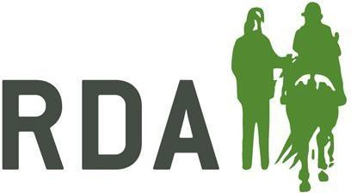
Appendix 4 MOUNTING AND DISMOUNTING

A disabled rider should be able to mount at the beginning and dismount at the end of a riding lesson in a dignified manner that is safe for the rider, the horse, and the helpers.

GOVERNMENT REGULATIONS
1. In recent years there has been great emphasis on manual handling of people and on work related stress injuries. The Manual Handling Operations Regulations (1992) came into force in Great Britain on 1 January 1993. These regulations come under the Health and Safety at Work Act (1974) and implement the European Directive on manual handling of loads.

The Health and Safety at Work Act (1974)

  - The aim of the 1974 Act is to promote and achieve standards of health and safety in the workplace. The message is that everyone, whether employer, employee, or volunteer, is responsible for safety.
  - The specific duties of employers (Section 2.2) can be summarised as:
- Providing and maintaining equipment and safe systems of work.
- Ensuring safety in the use, handling, storage and transport of articles and substances.
- Providing information, instruction, training, and supervision of employees.
- Maintaining a safe place of work with safe access and egress.
- Providing maintaining a safe and healthy working environment.
  - RDA volunteers have the same duties as employees (Section 7), namely, to cooperate to ensure their own safety and that of other people at all times and to be willing to receive any training necessary to carry out their work safely.

Manual Handling Operations Regulations (1992)

  - These regulations, of which assessment is the key part, establish a clear hierarchy of measures.
- Avoid hazardous manual handling.
- Make a suitable and sufficient assessment of any manual handling operation that cannot be avoided.
- Reduce the risk of injury from these operations as far as is reasonably practical.

RISK ASSESSMENTS FOR MOUNTING AND DISMOUNTING

- A risk assessment of the mounting and dismounting process (a careful examination of all the factors that could cause harm to those involved.) must be carried out in every case by the Instructor, Physiotherapist, or other trained, knowledgeable person. Risks must be reduced to a practical minimum for every situation. If the risk cannot be reduced to an acceptable level the rider must not be allowed to mount.

- The risk assessment enables the Group Instructor to:
  - Identify high risk factors and take steps to reduce the risk.
  - Plan and record a mounting procedure for each rider to reduce risks to a practical minimum.
  - Reassess the procedure and modify it as necessary.

- Risks can be reduced by:

  - Providing suitable equipment - blocks, ramps, hoists etc.
  - Training helpers (specialised help is available from the Coaching Committee or ACPTR).
  - Getting specialist help and advice for particularly difficult or unusual riders.
  - Liaising with carers, teachers, and physiotherapists about normal practice for moving and handling particular riders.

- Social Services, Education Authorities and Health Services now insist that detailed written risk assessments should be done for every activity that involves moving and handling their clients. As a result, some riders have had to stop riding, because they have 'failed' a risk assessment, and some RDA Groups have been asked to provide a written risk assessment for each rider. However, the Manual Handling Operations Regulations (1992) state that ‘only those activities carrying a significantly high-risk need be recorded’. They give guidelines for carrying out and recording risk assessments as follows:

The Task (the mount)

  - Does the mount involve the helper in any of the following factors that could pose a risk of injury?
    - Holding/manipulating the rider at a distance from their body.
    - Twisting or stooping.
    - Reaching upwards.
    - Excessive lifting or lowering distances.
    - Excessive carrying distances. (f) Excessive pushing or pulling.

The Load (the rider)

- Can the rider be described in any of the following ways?
  - Heavy, bulky, unwieldy, or difficult to grasp.
  - Likely to move suddenly or unpredictably.
  - Uncooperative or frightened.
  - In pain.

The Environment (mounting area and facilities)

  - Does the mounting area have any of the following characteristics?
    - Space restraints that prevent good posture.
    - Uneven or slippery surfaces.
    - Variations in levels.
    - Mounting facilities at the right height for the horse being used.
    - Affected by weather conditions (e.g., in a windy area of the yard).
    - Poor lighting that makes handling of the riders difficult.
    - Excessive local distraction and disturbance.

  - What mounting facilities are available? Are they the right size and in good condition?
    - Blocks.
    - Ramps/platforms.
    - Pits.
    - Hydraulic lifts.
    - Hoists.
    - Naturally occurring features.

Capability of Helpers

  - Does the mounting/dismounting process
    - Require unusual strength or height?
    - Create a hazard for those who with a health problem or pregnant?
    - Require specialised training? (The mounting team MUST be suitably trained).
  - Are the helpers involved well trained? Do they have a positive attitude?
  - Is the mounting/dismounting process well supervised?

Other Factors

  - Are horses well trained, in good condition and suitably matched to riders?
  - Is there a frequent turnover of horses in the Group?
  - Is the working atmosphere in the Group efficient, effective, and well-led?

METHODS FOR MOUNTING

Riders may mount from either side of the horse.

  - Direct lift from wheelchair to pony. This method should not be encouraged. It is only suitable for mounting very small children on small ponies.

  - Conventional mount from a mounting block or other raised surface. If possible all riders should be taught by a riding instructor to mount in the conventional manner, perhaps with assistance or modification.

  - Rider unable to put their foot into a stirrup and spring up into the saddle in the conventional way. The rider can turn with their back to the horse and then sit on the saddle and swing their right leg over the horse's neck

  - A direct wheelchair transfer from a platform or other raised surface onto the saddle through standing. A turntable can be used to assist this transfer.

  - A direct transfer from a wheelchair to the saddle for a non weight- bearing rider. This is usually done with the use of a sliding board and is only suitable for riders who are independent in other areas of their life.

  - Hoist from wheelchair to horse. An access or toiletting sling or handimove is best for easy removal once the rider is mounted.

METHODS FOR DISMOUNTING

Riders should normally dismount directly to the ground (not onto blocks, ramps, etc.).

- Conventional dismount. The rider leans forward to the off-side of the horse, swings their right leg over behind the saddle and then slides down into standing facing the horse.

- The rider swings their right leg over the horse's neck, rolls onto their front and slides down facing the horse. The horse takes the weight, and the rider is leaning against something solid.

- The rider lifts their right leg over the horse’s neck and, if unable to roll over, slides down to standing between two helpers. In this type of dismount the rider’s weight can go onto the helpers and they can stumble forwards on landing, putting themselves and the helpers at risk. Riders should be taught (and assisted) to roll over whenever possible.

- A direct transfer from the horse to a wheelchair for a rider who is unable to stand. In this case dismounting to a platform or other raised surface will be necessary and a sliding board might be needed.

A direct manoeuvre off the horse using a hoist.

- Advice on mounting and/or dismounting - If you want help or advice you should contact any of the following.

  - RDA Regional or County Physiotherapist or Instructor.
  - RDA Coaching Committee (contact via RDA National Office).
  - The Physiotherapist or Occupational Therapist connected with the rider in their school/hospital/home.

RECOMMENDED READING

- HSE (1992). Manual Handling Operations Regulations 1992: Guidance on Regulations HMS0 - available from good book-shops.

- Handling people: equipment, advice and information (1994) - available from The Disabled Living Foundation, 380-384 Harrow Road, London W9 2HU.

- Code of Practice for Patient Handling - available from the Royal College of Nurses.

- Charity and Voluntary Workers - a Guide to Health and Safety at Work (1999) - available from HSE Books, PO Box 1999, Sudbury, Suffolk CO10 6FS.

Appendix 5 RISK ASSESSMENT POLICY

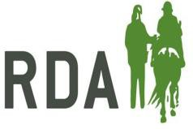
What is Risk Assessment?

- The RDA Health and Safety Guidelines says that all RDA centres “must have a written risk assessment to be reviewed annually by their management committee” but just what is a risk assessment, what does it do and how do we prepare one?

- A risk assessment is a straightforward way of examining what, in your activities, could cause harm to people and weighing up whether or not the right precautions have been taken to prevent harm.

- The terms ‘hazard’ and ‘risk’ are worth understanding:

‘Hazard’ simply means something that could cause harm.
‘Risk’ is the chance, high or low, that somebody will be harmed by the hazard.

- The important things that you will need to decide are whether a hazard is significant and whether you have sufficient precautions so that the risk from it is small.

- Before starting to assess risk it is important to be sure that you have done all the things that the law specifically says you must do. Such as preventing access to dangerous parts of any machinery or making sure that any lifting equipment has been examined at the required intervals. Then move on to the risk assessment.

Simple Steps to Risk Assessment

- Look for the hazards. Examples of some of the sorts of hazards that you might find at RDA centres are given below but there may be others. For this reason, it is important that the assessment is done by someone who has good knowledge of the particular centre and its activities. Write down the hazards that you have noted.

- Decide who might be harmed and how. Who could be affected by the hazard? Workers, volunteers, riders, helpers, visitors, spectators, members of the public?
Even people who may not be supposed to be there such as inquisitive children. Remember that people may not always act or behave in the way that you might wish or expect.

- You should now have a list of hazards appropriate to your centre. You should also a clear idea about who could be affected by each of them. You now need to decide what, if anything, you need to do about them. This is the ‘assessment’ part of risk assessment.

- For each of the hazards that you have identified, consider how likely it is that it could actually cause harm and how serious that harm could be. The aim is to make all risks small. Even if you have already taken some precautions against some hazards, look at them again.

In general, the more likely that something is to cause harm and the more serious the possible consequences then the more pressing is the need for action. If something is unlikely to cause harm and the severity of that harm would be very minor then it is unlikely that more precautions would be needed.

- If you find that there are things that need doing then draw up an ‘action list’ and give priority to things that could have the most serious consequences or where the likelihood is highest. Ask yourself:

  - Can we get rid of the hazard altogether?
  - If not, how can we control the risks so that harm is unlikely?
  - To try to control the risks use the following options, in order
    - Try a less risky option.
    - Prevent access to the hazard.
    - Organise activity to reduce exposure to the hazard.
    - Use personal protective equipment.
    - Try to limit the effect of the hazard.

- Record your assessment. You need to record the significant results of your assessment; the hazard list and action list are the start or your records. You should also record when and how any action was taken and you can make reference to other documents such as the RDA website, rider assessment etc. These simple records will help you keep track of what you have done and the things that you still need to do.

- Keep your assessment up to date. Your activities may vary over time, if so identify the hazards that you can deal with them. After that, make an effort to spot and deal with any additional hazards. You should also update your assessment if there have been any significant changes, such as new activities or changes to the site. In any event you should review your assessment from time to time (at least annually) to make sure that the precautions are still appropriate and working effectively.

Examples of Possible Hazards at RDA Centres

- Remember that centres will vary enormously. They vary physically from large equestrian centres to a paddock borrowed for short intervals, they may undertake different ranges of activities and there may be differences in the client bases. Not all of the hazards noted here will exist at all centres, certainly there will be some found at some centres which are not mentioned here. Don’t forget activities ancillary to the riding activities such as an office, if there is one, or accommodation at centres offering holidays. You know your

centre best so you are best placed to identify the hazards and to deal with the risks.

- Some of the hazards may already be included and addressed within other RDA policies, some precautions may be best tackled consistently across the association (for example rider capability assessment procedures), some hazards may be peculiar to a limited number of centres, some hazards and precautions might need specialist advice (e.g., veterinary) to assess or tackle properly.

Examples of Hazards.
(Examples of possible relevant issues)

Riders (clients or volunteers) falling from horseback. (During instruction, performance, competition, turning out. Nature of ground surface on route taken.
Individual riders’ physical capabilities. Tack, clothing & safety gear employed. Use of leaders and side walkers).

Falls during mounting. (Mounting aids & methods, nature of ground surface, riders’ physical capabilities).

Strain injury when assisting mounting. (Mounting aids & methods, riders’ physical capabilities, training, and instruction of helpers).

Faulty, unsuitable, or badly fitted tack. (Tack inspection, selection & identification. Fitting and adjustment. Cleaning & maintenance routines).

Injury during vaulting/vaulting practice. (Condition of vaulting/practice area. Individual capability. Supervision, instruction, and assistance).

Falls from carriages. (Physical condition of driving route, condition of carriage. Supervision, instruction & assistance).

Carriage collision or overturning. (Physical condition of driving route, condition of carriage. Supervision, instruction & assistance. Organisation and arrangement of driving activity).

Slips trips and falls on the same level. (Uneven ground or floors, trailing hoses, or cables, slippery or wet areas, possibility of spillages, impact of adverse weather).

Falling from a height. (Maintenance, haylofts, storage areas, other access to elevated areas. Use of ladders, permanent means of access, guard rails.
Contractors coming onto site).

Hazardous substances. (e.g., cleaning agents or veterinary medication. Warning labels on packaging. Storage & use, access, existence of alternative substances, methods of preventing exposure, methods of controlling exposure, protective clothing, or equipment. Contaminated sharps disposal).

Pesticides. (Fungicides, herbicides, insecticides, rodenticides, wood preservatives. Warning labels. Safe storage, methods of disposal, competence of users).

Dust and other airborne substances. (Can cause asthma, respiratory sensitisation, allergic reaction, rhinitis, lung damage, infection & other harm. Dust prevention, dust limitation techniques, controlling exposure, levels of ventilation, location of dust generating activities, number of people exposed).

Zoonoses. (Diseases transmitted from animals to man. Ringworm - by skin contact, especially through cuts & abrasions, symptom identification, treatment of infected animals, personal protective equipment, personal hygiene facilities. Leptospirosis - contracted via rat urine either directly or indirectly via e.g., animal feeds or bedding.
Pest control, care of cuts & abrasions, personal protective equipment & personal hygiene facilities. Tetanus - can be passed from horses to humans via droppings or bites. Vaccination & care of cuts & abrasions).

Electrical wiring and equipment. (Age of the electrical system & when it was last inspected. Examination/testing of fixed or portable equipment. Routine checks made by staff. Fault protection, circuit breakers, residual current devices.
Equipment used in wet areas. Use of safe low voltages. Use of extension leads. Modifications to installation & equipment. Vulnerability to damage).

Failure or malfunction of lifting equipment. (Thorough examination at required intervals, routine checks by staff. Observance of safe working loads & safe methods of use. Ground surface on which equipment used. Training & supervision for users).

Violence. (Intruder security, disposition of clients. What is known about past incidents or aggressive behaviour or threats).

Lone Working. (Tasks requiring more than one person, monitoring lone workers to ensure they remain safe, raising the alarm in case of illness, accident, or emergency).

Fire. (Flammable substances, materials, and structures. Highly flammable substances including fuel. Possible sources of ignition, smoking rules. Fire-fighting, procedures, and evacuation. Special provision for those with physical or mental limitations).
Inadequate lighting. (Sufficient light for safe working or riding activity, location and
/or protector of light fittings, suitability of switches, especially if outside).

Vehicle movement onto, from or within site. (Avoid pedestrians/riders and vehicles using the same area. Avoiding need for reversing. Designated walkways. Supervision of children or less aware clients. Lines of sight within the site and on entry/exit. Speed limitation. Restricting vehicular access).

Machinery. (Tractors, power take offs, grass cutters, straw cutters, feed rollers, horse walkers, pressure washers. Maintenance regimes and routine checks, preventing access to moving parts, safety of any electrical machinery. Training and supervision for users).

Ancillary equipment. (Equipment incidental to the core activities e.g., DIY, catering, mechanical handling, boilers etc. Physical condition, electrical safety, inspected where necessary, instruction and training on use, restriction to authorised personnel). Manual Handling. (Consider the task, load, environment & individual capability. Not just lifting & carrying. Can it be avoided? Assess to reduce risk of injury. Train for handling that can’t be avoided).

Being kicked, bitten, trapped, or crushed by a horse. (Who has access to the horses and in what circumstances? Suitability of the animals. Confined spaces, loading/unloading horse boxes. Experienced handlers. Adequate instruction, supervision & training for all).

Use of spectator seating. (Ground conditions, location, load capacity, integrity & erection, falls from tiered seating, safe access & egress for spectators).

Unauthorised access. (To stabling, storage, arenas, riding areas, machinery, equipment, hazardous substances, electrical installations. Prevention, awareness, reducing risks arising from access).

Falling items. (Collapse of stacked items such as bales, items falling from high level storage, maintenance activities, contractors on site. Likely results of impacts from horses, people, or vehicles).

Parts of the premises that might cause injury. (Sharp edges or projections, low headroom, finger traps in gates, shutters, doors etc. Drainage or inspection chambers and covers).

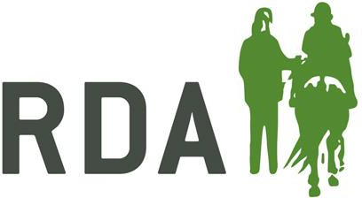
RISK ASSESSMENT TICK FORM FOR RDA ACTIVITIES
REGION:
COUNTY:
GROUP:
VENUE:
DATE:
COMPLETED BY:

RIDING/DRIVING AREA |  |  |  |  |  | REMARKS
INDOOR SCHOOL |  | SURFACE |  | SIZE
OUTDOOR SCHOOL |  | SURFACE |  | SIZE
FIELD |  | SIZE OF  RIDING AREA |  | FENCIING TYPE
GATE

OTHER
TYPE OF EQUIPMENT |  | CONES |  | POLES
OTHER

MOUNTING FACILITIES |  | REMARKS
FIXED BLOCK
MOVABLE BLOCK
RAMP
HOIST
OTHER
POSITION

WAITING AREA |  | REMARKS

HORSES/PONIES/DONKEYS |  | REMARKS
NUMBER USED

CONDITION
TEMPERAMENT & AGE
SUITABLILITY FOR RIDERS /
DRIVERS
ADEQUATELY SCHOOLED

 | TACK |  | REMARKS
SUITABLE AND WELL-FITTING
HEADCOLLAR UNDER
BRIDLE WITH ROPE
COUPLING AND LEAD
ROPE
SUITABLE FOR RIDER
FIT OF SADDLES
USE OF CORRECTLY
FITTED & CLEAN NUMNAHS
SAFETY STIRRUPS
TOE CAPS
SPECIAL EQUIPMENT
CONDITION OF TACK
 | HELPERS |  | REMARKS
GREEN CARD HOLDERS

HOW MANY WITH UP TO DATE BASIC FIRST AID
ENOUGH HELP FOR RIDERS PRESENT
SUITABLE ATTIRE FOOTWEAR & GLOVES

RIDERS |  | REMARKS
SUITABLE CLOTHING TROUSERS OR JODPURS
CORRECTLY FITTED HATS COMPLYING WITH RDA STANDARD
FOOTWEAR WITH HEEL
SUPERVISION WHEN NOT MOUNTED, SAFE WAITING AREA, USE OF TIME

GENERAL OBSERVATIONS  INCLUDING |  | REMARKS
ACCIDENT & INCIDENT BOOK AVAILABLE

FIRST AID BOX CORRECTLY STOCKED
KNOWLEDGE OF & PRACTICE OF ACCIDENT PROCEDURE
KNOWLEDGE OF FIRE DRILL IN YARD
KNOWLEDGE OF CORRECT USE OF HOIST
- PERSON IN CHARGE
- HELPERS
- EQUINES
GENERAL OBSERVATIONS  Continued |  | REMARKS
PHYSIOTHERAPIST INVOLVEMENT

DATE OF VISIT
- RIDER’S PHYSIO
- COUNTY PHYSIO
- REGIONAL PHYSIO
SPECIALISED ACTIVITIES
- BACK RIDING (Physio involved?)
- VAULTING
- RIDING OUTSIDE “RIDING ARENA”
- HIPPOTHERAPY
LIST AVAILABLE SHOWING MAXIMUM WEIGHTS EACH PONY CAN CARRY

SIGNED APPLICATION FORMS FOR
EACH RIDER/DRIVER (updated as needed)
RIDERS’/DRIVERS’ RECORDS KEPT
RIDRS’/DRIVERS’ RECORDS UP TO
DATE, Including:
- WEIGHT
- PROFICIENCY TESTS
- AIMS
- MOUNTING PROCEDURES
- HORSES RIDDEN
- INSTRUCTORS’ LOGBOOK SIGNED AND UP TO DATE
- ASSESSMENT SHEET COMPLETED AND SIGNED IN LOGBOOK
INSTRUCTOR HOLDS
LOGBOOK / RDAGI / RDAI / RDASI

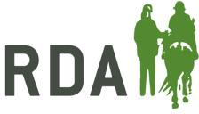30 |

RDA RISK ASSESSMENT SHEET

Risk Assessment for RDA activities:  At  On (Date): | Group/Event Organisers Name and Address  Post Code: Telephone:
Site Assessment undertaken by (signature):  On (Date): | Assessor’s name (printed)  Assessor’s contact telephone number: | Page | Of

 | First | Second | Third
Hazard  No | List significant hazards here: | List groups of people who are at risk from the significant hazards you have identified | List intended controls

