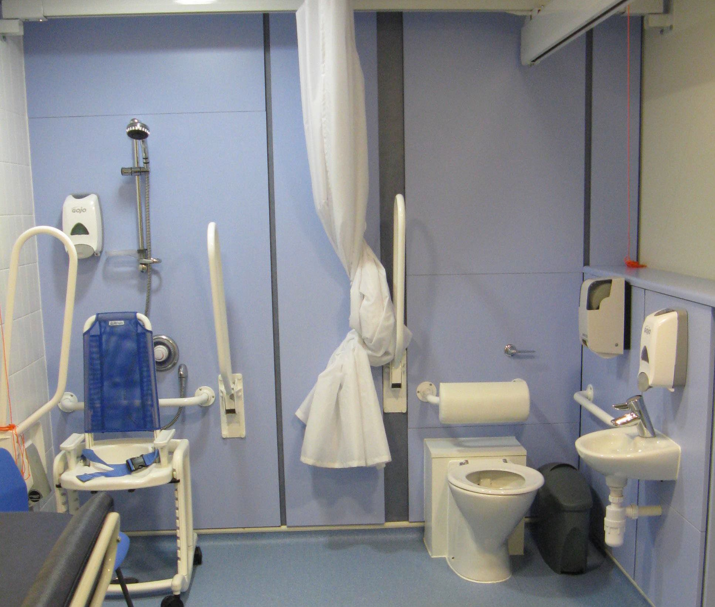

From mountain to sea

Intimate Personal Care
Guidance for schools, parents, children, and young people

March 2023

2 |Intimate Personal Care

Contents
Introduction 3
Aims 3
GIRFEC 3
Partnership and collaboration 4
Definition of Intimate Care 4
Roles and Responsibilities 5
Facilities 7
Best Practice 7
Appendix 1: Individual Pupil Protocol for a child/young person with intimate care needs 9
Appendix 2: Staff Training Records 12
Appendix 3: Risk assessment for the delivery of intimate care 14
Appendix 4: General procedures 16
Supported Eating (including gastrostomy/jejunostomy feeding) 16
Adult Supported Dressing (Including swimming) 16
Dental Hygiene 16
Toileting and Menstruation 17
Therapy Programmes/Moving and Handling Procedures 18
Massage and Intensive Interaction 19
Body Signing and Sun Care 19
Appendix 5: GIRFEC information and the 5 questions 20
References 21
Visit aberdeenshire.gov.uk

Introduction
The purpose of this guidance is to set out a framework in which staff who provide intimate care to children with additional support needs can offer a service and an approach which acknowledges the responsibilities and protects the rights of everyone involved.
The additional support needs of children and young people may arise from a variety of reasons, including learning disabilities, physical, visual, hearing or speech and communication impairments. The children / young people may attend Early Learning Centres, mainstream primary and secondary schools, community resource hubs and enhanced provision centres. Intimate personal care is undertaken with children who require changing as they have not achieved full continence, and some may also have specific additional support needs.
When an educational establishment (hereafter referred to as school) is supporting a child / young person with intimate care needs, the appropriate training can be provided by request to NHS Grampian specialist nurses teams.
This guidance applies to everyone involved in the intimate care of children / young people and should be read in conjunction with:
- Aberdeenshire ASN Guidance
- Aberdeenshire council’s Child Protection guidance

Aims
The aims of this guidance are:

- To safeguard the dignity, rights and well-being of children and young people
- To provide guidance and reassurance to staff
- To ensure that parents /carers are involved in planning the intimate care of their child / young person
- To provide a consistent approach to supporting children and young people with intimate care
- To ensure the specific needs of children / young people are met

GIRFEC
Children and young people have their needs assessed on an individual basis and support will be provided as required in line with GIRFEC. The Getting it Right for Every Child (GIRFEC) is a national approach to improving the Wellbeing of children and young people in Scotland. Aims from GIRFEC which particularly apply in this guidance are:

- Achieve high standards of multi-agency working based on a co-ordinated approach on identifying Wellbeing concerns, assessing need, and agreeing outcomes and actions
- Proactively seeking the views of children, young people, and their families, providing information and support which encourages involvement
Please refer to Appendix 5 for more information about GIRFEC and the 5 questions, together with Aberdeenshire GIRFEC Website.
Allied Health Professionals provide targeted interventions to secure outcomes as detailed in Ready to Act (participation and engagement, early intervention and prevention, partnership and integration, access, and leadership for quality improvement). There is a statutory requirement for education authorities and their partners to work together to ensure the wellbeing needs of the child/young person as detailed in the Children and Young People (Scotland) Act 2014.

Partnership and collaboration
The Child’s Planning Meeting will be the process for partnership and collaboration with a focus on the Child's Plan and the actions within the plan. Schools must closely involve parents/carers and the child/young person in the preparation of intimate care protocols as the primary source of information.

NHS Grampian staff who are part of the Team Around the Child will be consulted on the drafting of the protocol (Appendix 1) and provide any specialist training if required by school staff (e.g., gastrostomy feeding). It is essential that regular consultation with parents/carers and other agencies is scheduled for updating information and ensuring best practice. All intimate care procedures should be risk assessed (Appendix 3).
The Head Teacher must ensure that a record is kept of staff training for procedures (Appendix 2) and that updates are completed in line with the needs of the pupil9s) and best practice.
Protocols for administration of medicines, including emergency medication such as buccal midazolam are in the appendices of the Aberdeenshire council policy Supporting children and young people with healthcare needs and managing medicines in educational establishments.

Definition of Intimate Care
Intimate Care is any care which involves washing, touching, or carrying out an invasive procedure that most children/young people would carry out for themselves but which some are unable to do due to physical disability, additional support needs associated with learning difficulties, medical needs or needs arising from the child’s stage of development.

Intimate Care may involve help with drinking, eating, dressing and toileting. Help may also be needed with changing stoma bags, catheterisation, and other such processes. It also includes the administration of invasive medication. Within some therapy interventions there may be aspects of intimate care involved

Examples include:
- Washing
- Showering
- Dressing and undressing (including swimming)
- Supported eating (including tube feeding)
- Administering medication (e.g., injecting insulin)
- Toileting and menstruation
- Moving and handling
- Massage/intensive interaction
- Dental hygiene
- Care of tracheostomy
- Applying topical medicines (e.g., sun creams, eczema creams, barrier creams)
- Suctioning

In most cases Intimate Care will involve procedures to do with personal hygiene and the cleaning of equipment associated with the process. In the case of a specialised procedure only a person suitably trained by NHS Grampian staff and assessed as competent should carry out the procedure and NHS should provide a protocol for staff to follow.

Staff supporting pupils must be aware of the need to adhere to Child Protection practice in order to minimise the risks for both children /young people and staff. It is important that staff are supported and trained so that they feel confident in their practice in following specific pupil protocols.

Roles and Responsibilities

Roles
The Head Teacher is the Named Person and is accountable for all aspects of health and safety in the school although some aspects may be delegated to other teaching staff.

When a child/young person is identified as having intimate care needs (and some aspects referred to school nurses and other health staff), the Head Teacher is responsible for ensuring the following actions:
- Child protection training for all staff
- Assessing all the needs of the tasks to be carried out with the child/young person, parents/carers, and all professionals
- Working with relevant professionals to ensure all protocols are up to date and accurate
- Organising training for staff in intimate care and for any specific interventions required
- Organising training around any specific equipment use.
- Organising refresher training if required

These guidelines deal specifically with intimate care but at this stage any relevant Moving and Handling needs/responsibilities or training around administration of medicine, (Supporting children and young people with healthcare needs and managing medicines in educational establishments) would also need to be considered.
Aberdeenshire Council has public liabilities insurance and provided procedures are followed in line with documentation the Council will indemnify staff who undertake intimate personal care with children and young people. This insurance includes all aspects of meeting healthcare needs.

Management responsibilities
- Management in schools will work in consultation with the parents/carers and NHS Grampian professionals in the development of individual Intimate Care protocols. In addition, management need to work with the Team Around the Child for the development of individual Intimate Care protocols for children with Additional Support Needs.
- To ensure that staff receive on-going training in good working practices as part of the Child’s Plan which complies with health and safety regulations such as hygiene procedures; moving and handling; awareness of medical conditions and associated first aid/ child protection procedures; and other aspects of Intimate Care. The Lead Professional will have the role of managing the Plan.
- To keep a record of training undertaken by staff and to ensure that any refresher training opportunities are provided where required.
- To ensure that all relevant/ appropriate staff are familiar with the school’s Individual Intimate Care protocols and that they receive the appropriate training/assistance from experienced staff to provide the children and young people they are supporting with the Intimate Care as outlined in their individual protocols.
- Provision of wipes, gloves, aprons, and any cleaning materials for staff use

Staff responsibilities
- Staff must be familiar with the Intimate Care procedures. This means that the protocol must be shared with and followed by all staff involved in supporting the child/young person.
- Staff must adhere to health and safety and intimate personal care procedures and must report any health, safety, and welfare concerns to management within their establishment.
- Designated staff will liaise with parents/carers and other appropriate services over the development and implementation of the agreed Intimate Care protocol.

- Designated staff, as part of the Child’s Plan will liaise with Parents/ Carers and other professionals regarding specific aspects of Intimate Care (e.g., physiotherapy, speech therapy) to ensure the intimate care protocol is meeting the needs of the child / young person
- Designated staff will take part in training for any aspect of Intimate Care Support.

Parent/Carer responsibilities
- Provision of disposable nappies/pull-ups, wipes, and any creams for the school to use in changing the child/young person
- Provision of catheters and all other equipment
- Provision of one or more changes of clothes as appropriate to needs in case of toileting accidents
- Provision of plastic bags for returning of soiled clothes securely
- Washing of soiled clothes
- Provision of towels, shower gel and shampoo if showering is required

Child/young person responsibilities
- To work with the supporting adult, demonstrating as much independence with the process as possible
- To communicate (if able) with the supporting adult in order to ensure that needs are met

Facilities
Facilities appropriate to the individual needs of the child and the intimate care required should be made available within the school. This includes access to accessible toilets, plinths, and equipment for toileting needs; and to appropriate PE/swimming changing facilities. At all times the dignity and wellbeing of the child/young person must be prioritised.
For physical adaptations to buildings Head Teachers are first advised to discuss with their QIO. Following this discussion, they can refer to Learning Estates: LearningEstates@aberdeenshire.gov.uk

Best Practice
All staff providing support should use best practice guidelines:
- The child / young person should be allowed to care for him / herself as far as possible to foster independence. Targets may be part of an IEP as well as within the Child’s Plan for the child / young person to develop their skills
- Facilities should be available which are appropriate to the child or young person’s age and individual needs
- Supporting adults should show awareness and be responsive to the child / young person’s reactions and use relevant language, signs, symbols, photographs, or objects to communicate before, during and after the care process. Staff should work in a reassuring, supportive and focused manner.
- Supporting adults should use the opportunities during personal care to teach the child / young person to develop independence in personal care skills where possible.
- Supporting staff should ensure that there are regular communications with parents/carers regarding achievements of targets and information about personal care i.e., how well a child has eaten, bowel movement, menstrual cycle. Depending upon the sensitivity of the information, it may be relayed via a home-school diary or through a telephone call, sealed note, or personal contact.
- Supporting staff should understand parental and cultural preferences and take these into account, and some of this information may form actions within the planning documentation. They must maintain confidentiality and dignity for the parent/carer to ensure compliance with the Equalities legislation in the dissemination of information

Appendix 1: Individual Pupil Protocol for a child/young person with intimate care needs

Name of Pupil

Additional support need
Date of Birth

Contact Information

Family contact 1
Name
Phone No: (home) (work) Relationship
Family contact 2
Name
Phone No: (home) (work) Relationship
General Practitioner
Name Phone No
Clinic/Hospital Contact
Name Phone No
Protocol prepared by:
Date
Name
Designation
Agreed with:
- Parents / carer
- Community paediatrician / GP / specialist nurse
- School nurse

To be reviewed by date:

Describe condition and give details of pupil’s individual requirements:

Equipment required

Details of the process to be followed:
Arrangements for changing:
Arrangements for toileting:
Other arrangements (e.g., showering):

Agreed time/s for the procedure/s

Possible risks with the procedure/s and action to be taken in an emergency

I give permission to the school/centre to provide appropriate intimate care to my child e.g., changing, toileting, showering, or other.
I agree that the information contained in this protocol may be shared with appropriate individuals involved with the care of Name of pupil
Signed Parent or Guardian (or pupil if above age of legal capacity)

Date
Information of those responsible for the plan

Designation | Name
Head Teacher / PT ASL
Class Teacher / EYLP

NHS Grampian should provide protocols for any medical procedures- this document should not be used in place of them but is to be used alongside the NHS protocols.

Appendix 2: Staff Training Record- to display completed training

Staff Member | Training | Date | Refresher Date | Training | Date | Refresher Date | Training | Date | Refresher Date

Appendix 2: Individualised Staff Training Record

Head Teachers- Please ensure staff have this form when attending training so they can request the trainer completes the document:

Record of Medical Training for Education Staff
Staff Member Name
Designation
School
Type of Training Received
Date Training Completed
Training Provided by

Trainer Declaration
I, the assessor, confirm that the training has been completed on the topic named above and to the best of my knowledge has been understood by the learner.

Trainer Signature
Trainer Print Name
Date of Training
Suggested Review Date

Trainee Declaration
I have received the training on the topic named above. I confirm that I understand the procedure on which I have received the training and feel confident in using that procedure.

Staff Signature
Staff Member Print Name
Date of Training

A copy of this completed form is to be provided to Aberdeenshire Council Member of Staff. Original to be kept by Head Teacher / PT ASL

Appendix 3: Risk assessment for the delivery of intimate care

Department: Education & Children’s Services | Pupil Risk Assessment for Intimate Care
Pupil: | Diagnosis: | School:
Risk Assessment Undertaken By (list all contributors):

Procedure | Hazard / Risk | Person/s Affected | Risk level before controls are in place |  |  | Control Measures |  |  | Risk level with controls in place
 |  |  | L | M | H |  |  |  | L | M | H
Date risk assessment completed: |  |  |  |  |  |  | Review date:

Appendix 4: General procedures

Supported Eating

Any pupil requiring assistance with oral feeding advice / training must be sought from the Speech Therapist to ensure the pupil’s specific needs are met, and to ensure staff are fully aware of the process of feeding and their role as supporting adult. Speech therapy will also provide a protocol for staff to follow when supporting a child/young person with feeding.

Gastrostomy / Jejunostomy feeding

A gastrostomy is a surgical opening through the abdomen into the stomach. A feeding device is inserted through this opening allowing a child to be fed directly into their stomach. A jejunostomy is where a child is fed directly into the jejunum (the small bowel). These types of feeding devices may be used for medicines or fluids as well as feeds. Schools will be provided with documentation by NHS to support pupils who are fed this way. Any staff supporting a pupil in his manner must have completed training by NHS.

Adult Supported Dressing (Including swimming)

Ensure facilities provide privacy and modesty e.g., separate toileting and changing areas for boys and girls or at least adequate screening.

Pupils should be encouraged to dress/undress themselves independently.

There should be a clear plan, appropriate to each individual for un/dressing for those who require supervision.

When using Public Facilities e.g., staff should be aware in advance of the nature of the facilities, and to ensure the dignity of each participant in the activity and to ensure appropriate equipment is in place e.g., hoist, plinth

Dental Hygiene
The Child Smile tooth brushing programme has developed National Standards for Tooth brushing during Early Years and Childhood.

The Child Smile website contains much useful information.

Toileting and Menstruation

Guidelines
Provide facilities, which afford privacy and modesty. Screening should be provided where necessary e.g., when an individual requires nappy changing.
There should be sufficient space, heating, and ventilation to ensure the individual’s safety and comfort.
There should be appropriate and specialised toilet seats provided for the size and physical needs of the child or young person. NHS Grampian occupational therapists will advise as required and resources may be purchased via the Principal Educational Psychologist/ Service Manager Inclusion Equity and Wellbeing by the Occupational Therapist completing an equipment request supported by a quotation of the item(s). To order please use: ecs.asnadmin@aberdeenshire.gov.uk
Staff must receive training in good working practices, which comply with health and safety regulation, such as wearing of appropriate disposable gloves for certain procedures and methods of dealing with body fluids.
Ensure that adequate facilities are provided. Such as toilet paper, liquid soap, paper towels, bin for disposal of soiled pads.
Supplies of suitable cleaning materials must be provided for cleaning and disinfecting areas.
Items of protective clothing such as disposable gloves and aprons must be provided and readily accessible.
Supplies of fresh clothes should be available when required for the child / young person.
Some children may only have a single or infrequent occurrence of soiling. Where a child has the need to be assisted regularly there should be an intimate care protocol in place. This protocol should be written in collaboration with the parents/ carers and professionals involved and wherever possible with the child or young person. This protocol should be based on a risk assessment of all aspects of the task to be carried out. This protocol should be reviewed regularly especially when any circumstances change.
It is acceptable for a single member of staff to change a child providing they ensure that:
- Staff member is agreeable to doing it unaccompanied
- Another member of staff is aware of what is happening.
- The event is recorded and initialled by the member of staff who changes the child. The status of the change should be recorded e.g., wet / soiled. Any issue or problem, such as nappy irritation, which may have arisen or been noticed should also be recorded- this information must be shared on a daily basis with the parent/carer.
- The task has been risk assessed as being safe for one person to carry out
It may be necessary, however, to have more than one member of staff to help while toileting a child or young person because of health and safety or other considerations. Children who are heavier and with physical disabilities may require hoists and a hydraulic changing table and these should be provided. Staff must be trained in the use of these aids and equipment. In all instances of using a hoist; two staff must be attending for the procedure.
After use staff must always clean the changing area using a disinfectant spray, alcohol-based wipes and dry the surface. Nappies must be discarded in a separate lined nappy bin and soiled nappies should be double bagged before being put into the bin.

If a child has repeated accidents or appears delayed in toilet training, discussion should be held with the parents/carer and, if necessary, the Incontinence Team should be included to

support the child / young person, Parents/Carers and supporting adults with continence advice.

Moving and Handling Procedures
For some children and young people, they require Moving and Handling support as part of their intimate care support. Moving and Handling training must be completed to ensure the safety of all. Regular consultation with all parties is recommended, to identify any changes required and on-going training to be given as and when required. Any agreed moving and handling procedures should be always followed which will be detailed on the Moving and Handling Plan and Risk Assessment. It is the responsibility of individual staff to continually assess the risks involved and update the Moving and Handling Plan and Risk Assessment as required. Any concerns staff identify should be discussed with the Head Teacher or PT ASL. Allied Health Professional Staff may be required to contribute to a child’s Moving and Handling Plan as part of their role within the multi-disciplinary team.

Where moving and handling occurs in the context of an intimate care activity the Allied Health Professional would be expected to consider the Intimate Care Guidance as part of any contributions to the child’s moving and handling plan.

Therapy Programmes
In terms of therapy programmes, an Allied Health Professional would provide guidance as required to Education staff regarding implementation of any therapy programme. The method of communication around therapy programmes would be agreed with the Education establishment.

Massage

Massage should only be used with a child or young person where it is an agreed approach and is included within the Individual Education Plan, Communication Passport, Pupil Behaviour Support Plan and Risk Assessment or other planning document. Any use of massage should be recorded.
Massage is often used with children and young people as a means of communication, promoting calmness and/ or regulation. Staff must remain vigilant to the child / young person’s response as it may not suit certain children /young people and this must be respected, and alternative strategies must be sought.
Massage is often considered as a means of relaxation and of experiencing touch in a positive context. Massage should be carried out within a relationship of trust, built up gradually with staff who already know the child or young person and who can interpret his/her behaviour and respond appropriately.
Parents/carers, Health and Education personnel involved should agree all aspects of any massage programme being administered.

Intensive Interaction
Intensive Interaction is an approach to helping people with significant and complex needs to learn more about communicating and relating. In carrying out Intensive Interaction activities the member of staff attempts to create enjoyable and understandable interactions with the other person.
Intensive Interaction should be carried out within a relationship of trust, built up gradually with staff who already know the child or young person and who can interpret his/her behaviour and respond appropriately.
The Speech and Language Therapist can provide guidance on Intensive Interactions if required.

Intensive Interaction should only be used with a child or young person where it is an agreed approach and is included within the Individual Education Plan, Communication Passport, or other planning document.

On Body Signing
For some individuals with significant and complex needs and/or severe and multiple sensory impairment Body Signing, involving repeated touching, may be the recommended means of communication. The usual procedures for involving parents/carers in planning, recording consent, and reviewing methods and progress should be followed.
The Speech and Language Therapist can provide guidance for On Body Signing if required.

On Body Signing should only be used with a child or young person where it is an agreed approach and is included within the Individual Education Plan, Communication Passport, or other planning document.

Sun Care
For younger children and children / young people who do not have the capability to apply sun cream due to an additional support need; Parents/carers are expected to apply sun cream to their children BEFORE bringing them to school. Parents should be asked to supply a clearly labelled sunhat for their child/ren.

Education staff are not permitted to apply sun creams unless specific consent has been given in writing. In these instances, Parents are required to provide the sun cream for their child’s use.
Consent should be gained from parents/carers at enrolment or whenever the need arises.

Appendix 5: GIRFEC information and the 5 questions

What I need from people who look after me: Everyday care and help
This is about the ability to nurture which includes day-to-day physical and emotional care, food, clothing, and housing. Enabling healthcare and educational opportunities. Meeting the child’s changing needs over time, encouraging growth of responsibility and independence. Listening to the child and being able to respond appropriately to a child’s likes and dislikes. Support in meeting parenting tasks and help carers’ own needs.

The Five GIRFEC Questions
A child or young person’s Wellbeing is influenced by everything around them, and by different needs they will have at different points of their life. Wellbeing concerns may arise from a child or young person’s individual experiences or circumstance or be posed by the impact of a family member or significant person’s situation (this could include a non-resident partner of a parent/carer, or a peer).
When a Wellbeing concern is identified or raised for a child or young person, you should ask yourself the 5 GIRFEC questions:

What is getting in the way of this child or young person’s wellbeing?
- Do I have all the information I need to help this child or young person?
- What can I do now to help this child or young person?
- What can my service or organisation do to help this child or young person?
- What additional help, if any, may be needed from others?

Sharing information at the right time often prevents low-level concerns escalating into more serious or entrenched family difficulties and can help to improve outcomes for children. In most situations, any wellbeing concerns should be openly discussed with a child/young person (in line with their age and understanding) and family, with explicit advance discussion around what information may need to be shared, for what purpose, and with whom.

Where a child or young person is believed to be at risk of significant harm or neglect, Child Protection Procedures must be followed without delay.

Where you don’t have all the information you need, you may need to gather more information by speaking with a child or young person themselves, a parent/carer, colleagues within your own or other services, or the Named Person or Lead Professional.
Communication helps provide as full a picture as possible for assessment, can aid decision- making, and helps clarify whether a Request for Assistance would benefit a child or young person through accessing extra support.

All agreed multi-agency templates/proformas are available in the Aberdeenshire GIRFEC Toolkit

References

Children and Young People (Scotland) Act 2014 Scottish Government (2014) http://www.legislation.gov.uk/asp/2014/8/contents/enacted

Getting it right for every child (GIRFEC) Scottish Government (2012) http://www.gov.scot/Topics/People/Young-People/gettingitright

Ready to Act – A transformational plan for Children and young people, carers and families who require support from allied health professionals Scottish Government (2016)
http://www.gov.scot/Publications/2016/01/1324/3
Getting it Right for Every Child Aberdeenshire: GIRFEC Aberdeenshire | Getting it Right for Every Child in Aberdeenshire – Getting it Right for Every Child in Aberdeenshire (girfec- aberdeenshire.org)

With thanks to NHS Grampian for assistance with medical information / techniques, and to Highland Council for permission to review and adapt their documentation.
This guidance was written and u[dated by Aberdeenshire Education and Children’s Services Inclusion, Equity and Wellbeing Team

Version | Status | Date | Reason for update
1.0 | Draft guidance | September 2017 | New guidance
2.0 | Draft Guidance | September 2017 | Update to Named Person information
3.0 | Guidance | October 2022 | Removing links that don’t work. Removing specific medical strategies that need to be documented through NHS protocols
4.0 | Guidance | March 2023 | Updated content of Appendix 4 related to massage and therapy programmes

