Addressing Dyslexia – toolkit launch 8th March 2017

Venue: The CALL Centre, Moray House, University of Edinburgh
The launch was made by presentations from the following:
James Brown – Dyslexia Scotland’s young ambassador.
James was identified as having dyslexia at 9 years old and is a teacher. He had poor skills in maths and English, but really noticed the effect of identification after the age of 12 years old when the additional time he was allocated for exams greatly reduced the pressure he felt when completing tasks (prior to this age he was feeling pressured by school work).

James found the volume of work for GCSEs very stressful, but emerged as an independent and resilient learner due the support he received and to taking responsibility for own learning methods. He went on to read Geography at university using the strategies and skills he had developed at school, and then to undertake teacher training. James employs the same strategies in his classes to create a pressure free environment, and also uses lots of visual supports to allow students to learn and enjoy his subject.
James stated that the new dyslexia toolkit is really important for assisting with the identification of dyslexia, and is clear that having consistent support over a number of years is important for those with a learning difference.

John Swinney – Depute Principal First Minister
John Swinney acknowledged the need for proper support for every young person to achieve in our society and stated the need for everyone to be effective to ensure that children and young people attract the support that they require in order to fulfil their potential. He spoke of the need to equip others with the knowledge and support to assist those with dyslexia – in initial teacher education and beyond. He referred to an important element of the new dyslexia toolkit being the development of training modules (online, free) to deliver part of the Dyslexia Scotland’s recommendations from the review of 2014. The purpose of the refresh was to deliver an improved user experience – navigation, structure and design as result of the information gathered. John Swinney announced that the Scottish Government will be increasing its grant to Dyslexia Scotland to £200k per year.
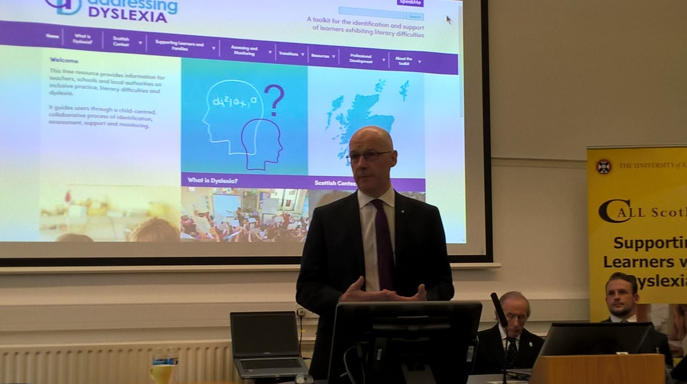

Sir Jackie Stewart – President of Dyslexia Scotland
Sir Jackie spoke of the lack of recognition for dyslexia from many years ago and the huge amount of damage which resulted from the classroom to the playground – and that this still affects him to this day. He is clear that the biggest challenge is to get every single teacher to use the Addressing Dyslexia Toolkit. It was first launched about 7 years ago but there are insufficient teachers who have engaged with it.
Sir Jackie explained that when a person has dyslexia they have to find other ways of doing business – in his case sport was his life-saver. However, he spoke of the huge percentage of the prison population who cannot read/write and posed the question as to how many of them have dyslexia?
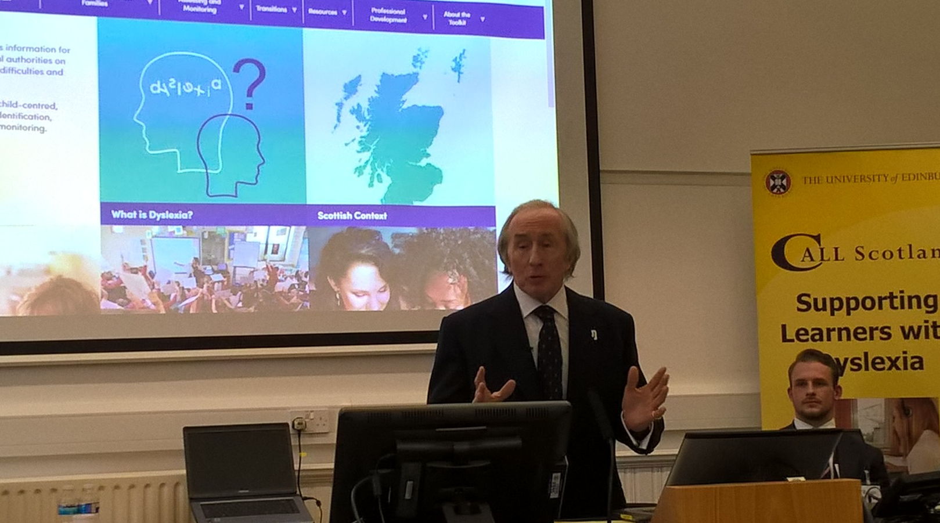

If literacy skills are lacking, then crime pays because people cannot apply for jobs. The lucky people are those who find a way around dyslexia – more education at earlier stages for the new generation of teachers would make a huge impact.

Addressing Dyslexia toolkit:
The following points were shared as part of the refresh:
- The toolkit is now aimed at schools, local authorities and teachers – the parent part of the site is reduced although undoubtedly parents will access the site to check information.
- The toolkit is a work in progress – more resources will be added over time
- The toolkit has been revised to make it more accessible due to improved technology, including access on Smart phones (layout may change slightly according to the device).
- Navigate on the home page is from the top bar and from squares. The top bar menu is still to be finished.

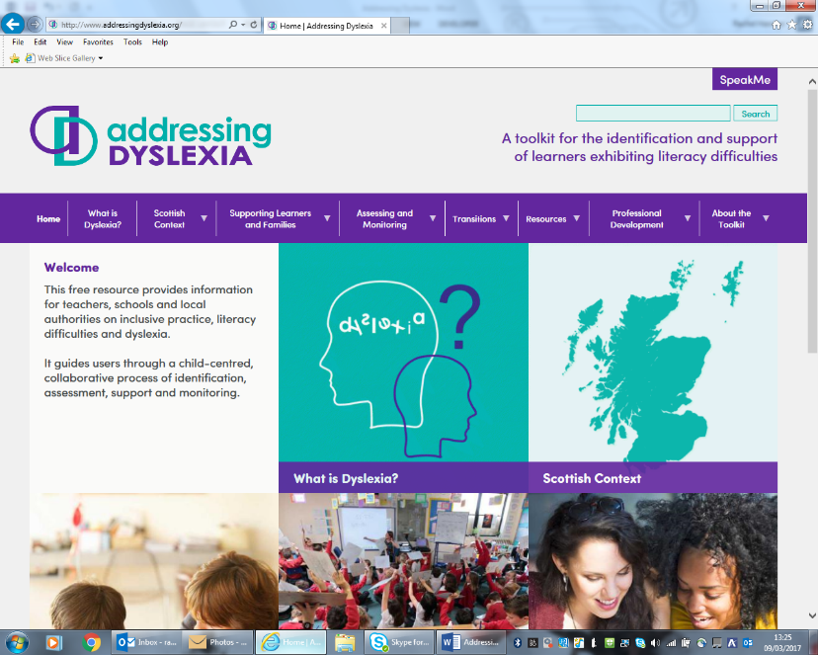

- 2014 review: Making sense: education for children and young people with dyslexia in Scotland. There were 5 recommendations:
- Teachers, support staff, learners and parents should have aces to up-to-date practical advice and guidance on dyslexia
- Teachers, support staff and local authority staff should have access to a wide range of high quality career long professional learning opportunities at school, local and national level related to meeting the needs of children and young people with dyslexia.
- Initial teacher education and postgraduate awards and courses should give a high priority to developing knowledge and skills in relation to dyslexia and additional support needs
- Schools, local authorities and national partners should take action to improve the quality of educational outcomes for children and young people with dyslexia
- The availability and use of reliable information on children and young peoples’ needs, development and achievement should be improved
- The new toolkit aims to support a much wider range of pupils, with a focus on dyslexia.
- It includes the 2009 Scottish working definition of dyslexia
- Identification and assessment – the toolkit supports a holistic and collaborative approach to identification and assessment as part of a dynamic process within learning.
- New toolkit has different sections: what is dyslexia?, Scottish context, supporting learners and families, assessing and monitoring, transitions resources, professional development, about the toolkit (films and launch presentations still to be updated). Under the last heading, the further information and references will include some of the information from the former toolkit which doesn’t fit under the new headings, so that this is not lost.
- Under supporting learners and families there is a new heading of effective communication – there is a need for all to understand the importance of good communication. This includes a short film clip from Sharon Hall, chair of Dyslexia Scotland North East.
- Supporting professional learning – training modules (free online resource). Framework for the 3 modules focused on GTCS teachers, but anyone can access these. The first module takes about 1 -1 ½ hours. The second module will be more in depth and the target audience is ASL teachers (but all can access). Managers are encouraged to access this, as will student teachers. A ‘mozilla’ badge will be produced upon completion that can be added to a teacher’s CV. The third module will hopefully be piloted in August 2017, to take teachers through working towards professional recognition, and the GTCS will be involved. Part will also be covered by Dyslexia Scotland, so that the two will provide accreditation – GTCS of professional learning and Dyslexia Scotland of satisfactory completion. The first level will be equivalent to high school level, the second to advanced high school level or early university undergraduate level, and the third will be equivalent to university undergraduate level.
- There is a link within toolkit to the national assessment hub and information
- Next steps for the toolkit will be on focused tasks, monitoring of the website, populating the toolkit with further information, dissemination events, and evaluation for continuous improvement. From 27th April 2017 there are to be GLOW professional learning sessions
- If anyone using the toolkit has suggestions to make, please email them to: toolkit@dyslexiascotland.org.uk
- It may help to consider a case study when navigating the toolkit for the first time.
- The third online learning module will expand information on assessment in due course.
- SpeakMe at top right hand corner gives an accessibility bar with a lot of options.
- The new toolkit could be a very useful resource for secondary trained colleagues working in ASL in primaries as there are resources for teaching literacy, and these could be accessed as part of their CLPL.

Finally, please access the new resource and check out the information available at:
http://www.addressingdyslexia.org/

