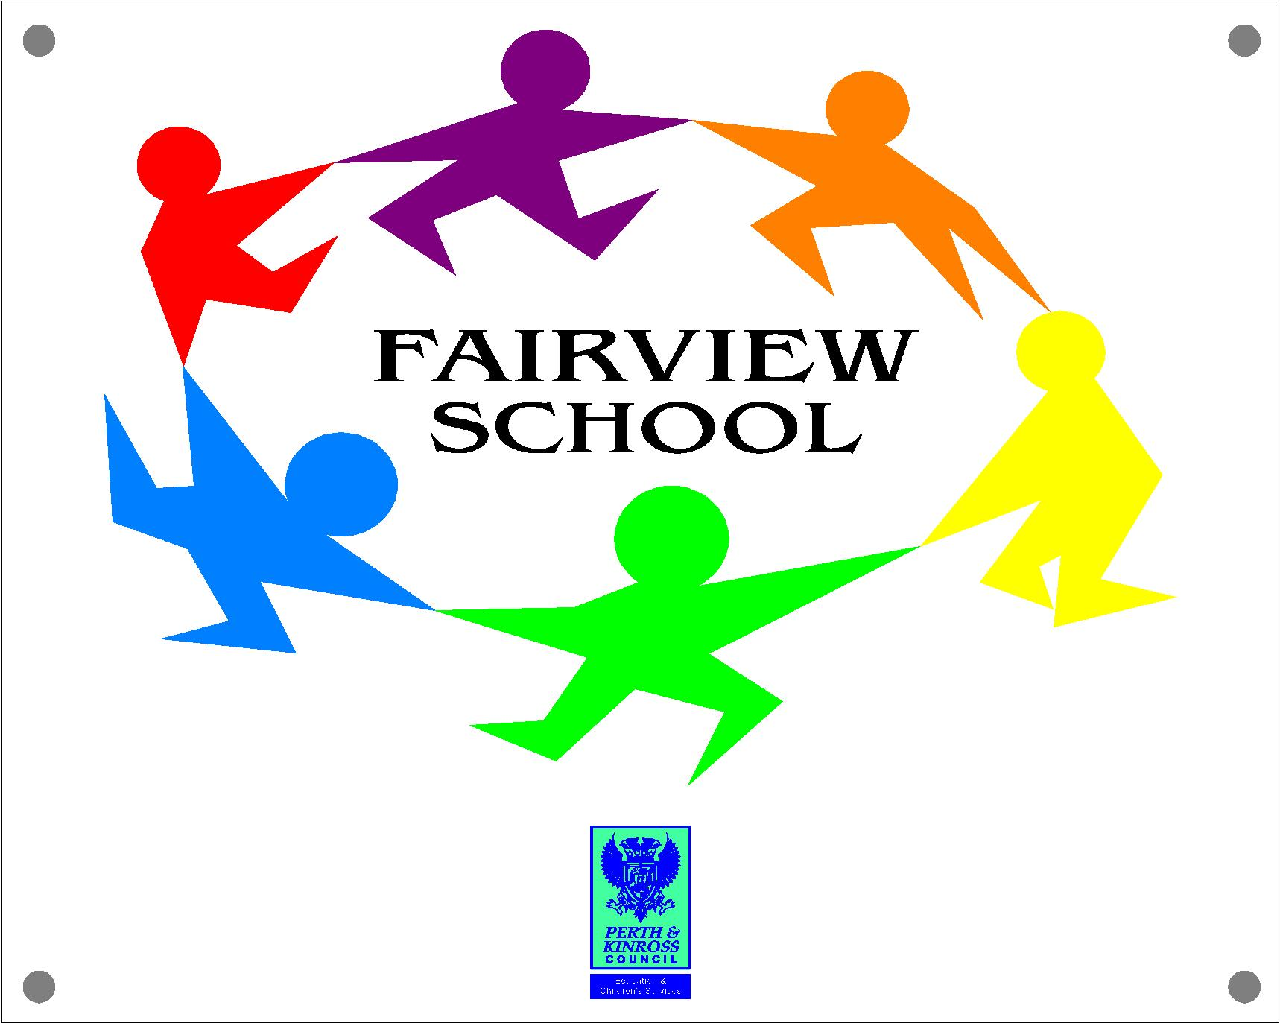 Curriculum for Excellence

Social Sciences

Three year Cycles for Secondary Classes

Year | Historical Focus | Geographical/Modern Studies Focus | Science Focus
One  2010/11 | Local – Perth 800 | Weather | Space
Two  2011/12 | Scottish castles/homes | Transport | Living and growing
Three  2012/13 | Choice - TBA | Our local area | Green energies

